Game Design Document

*GameVerse*

*GameVerse*

## 

# Team

**

| **Name** | **Roles** | **E-mail** |
| --- | --- | --- |
| Vishakha Nerkar | **Captain**, Analytics | nerkar@usc.edu |
| Shalin Suthar | UI, Physics | ssuthar@usc.edu |
| Akshay Jain | Mechanics, Physics | jainaksh@usc.edu |
| Venkatesh Dharmaraj | Note Taker, Gameplay | vdharmar@usc.edu |
| Meghana Putta Swamy | **PM**, Analytics | mswamy@usc.edu |
| Sai Gurunadh Pamarthi | Mechanics, Physics | pamarthi@usc.edu |
| Vardhan Jekin Shah | UI, Mechanics | vardhanj@usc.edu |

# Important Links

**For Class Submission**

| **GitHub Repository** | [*Link*](https://github.com/VishakhaNerkar/GameVerse) |
| --- | --- |
| **Prototype WebGL Link** | [*Link*](https://play.unity.com/mg/other/build-a8q) |
| **Midterm Video** | [*Link*](https://youtu.be/Ocp_W1abQVI) |
| **Midterm WebGL Link** | [*Link*](https://play.unity.com/mg/other/gameverse-midterm) |
| **Final Video** | [*Link*](https://www.youtube.com/watch?v=SqwgM9vU0pY) |
| **Final WebGL Link** | [*Link*](https://akj2018.github.io/GameVerse_Final_Build/) |

**For Internal Use**

| Documentation  *(e.g. wiki, github doc)* | [*Link*](https://github.com/VishakhaNerkar/GameVerse) |
| --- | --- |
| Communication  *(Discord, slack, zoom, etc)* | [*Link*](https://discord.com/channels/1060054045366173716/1067234586880393289) |
| Task Tracking  *(Class Spreadsheet, Trello, Git, etc)* | [*Link*](https://docs.google.com/spreadsheets/d/14Jj4cYcg0Hmtq_io8J1Yxeeo2FV8DxA6cmSwUXjF9io/edit#gid=752929956) |

# Game Overview

## Logline

A 3-D puzzle-solving game where all the characters with either of different colors or shapes in the game need to cross the gates to reach the finish line within the time and lives constraint.

## Short Description

In this game, the player needs to make all the characters reach the finish line by thinking of the right strategy. The arrow keys allow the player to move up, down, right and left. The player can switch between the characters with the help of the space bar. There are different characters in the game, either color based or shape-based. The color-based character can only cross the color-based gates if their color matches the front face of the gate. Whereas the shape-based characters can only cross the shape-based gates if their shape matches the shape of the gate. Switches are provided to the player to operate these gates. Every button in the game operates different gates differently. There are also enemies introduced after the initial levels. The player must also tackle the enemy by strategically avoiding them to reach the final level. Additionally, the players are provided various mechanisms like Shield Powerup, shooting bullets to break glass walls, and swap positions between the shape characters to play the game strategically.

## Other Key Items

* **Target Audience**
  + Players of all ages can play this game, especially players who are interested in a platformer and puzzle-based games will love this game.
* **Innovation/Unique Selling Points**
  + Multiple characters with different abilities and limitations that require players to switch between them to progress, adding an element of strategy to the game.
  + The introduction of enemies that shoot bullets adds a new layer of challenge and danger to the game.
  + The use of buttons to operate gates adds a new element to the puzzle-solving mechanics and adds complexity to the game.
  + The timer that decreases once the game starts adds pressure and urgency to complete levels quickly.
  + The game challenges players to think creatively and develop problem-solving skills.
  + 'Collaborative strategy planning' - make all characters work together to develop and implement a cohesive plan for achieving a common goal (reaching the finish line).
* **Key Features**
  + Puzzle-solving mechanics that require strategic thinking to progress through levels.
  + Multiple characters with different abilities and limitations.
  + Color-based and shape-based gates that only allow characters with the corresponding color or shape to pass through.
  + Buttons that open and close or rotate different gates in different ways.
  + Enemies that need to be avoided to reach the final level.
  + Strategic thinking to find the right combination of characters, switches, and gates to progress through the levels.
  + Increasing difficulty levels provide a challenging experience for players.
  + Unique mechanisms like firing bullets to break glass walls, collecting bullets through the shield, and swapping the player positions.
* **Genre**
  + Hybrid of 3-D platformer and puzzle-based game.
* **Platforms**
  + This game is built on the Unity platform. Players can access the game through WebGL and GitHub build links

# Detailed Design

## Game Element

1. Player
2. Action
   1. Keyboard ‘↑’ - Move forward
   2. Keyboard ‘↓’ - Move backward
   3. Keyboard ‘→’ - Move Right
   4. Keyboard ‘←’ - Move Left
   5. Spacebar - Switch between characters
   6. ‘Z’ Key - To fire Bullets
   7. ‘1’ Key - To use shield mechanism
   8. ‘2’ Key - To swap between player positions
3. Environment
   1. Colour-based gates: allows a character with the same color of the face of gate
   2. Shape-based gates: allows a character with the matching shape of gate
   3. Black gates: Don’t allow any character to pass through unless it’s pulled off.
   4. Buttons: Operate gates.
   5. Enemies:
      1. move top to bottom, left to right, and rotate in a 90 or 360-degree fashion.
      2. shoots bullets
   6. Timer: decreases once the game starts
   7. Health: Represented as hearts. Each time the player gets hit by a bullet, a life will be deducted.

## Game Mechanics

Player:

* *Press ‘*↑’ to move forward
* *Press ‘* ↓’ to move backward
* Press ‘→’ to move right
* Press ‘←’ to move Left
* Press the ‘spacebar’ to switch between characters
* Press the ‘Z’ key to fire bullets and break glass gates
* Press ‘1’ key to use shield to protect from bullets and collect bullets fired by enemies
* Press ‘2’ key to swap between shape character positions
* Hit the buttons to operate the gates
  + Brown buttons operate color-based gates
  + White buttons operate shape-based gates
  + Black buttons operate black gates

Enemies:

* Move top to bottom, left to right, and rotate in a 90 or 360-degree fashion
* Fire bullets

## Levels

***Level 1***

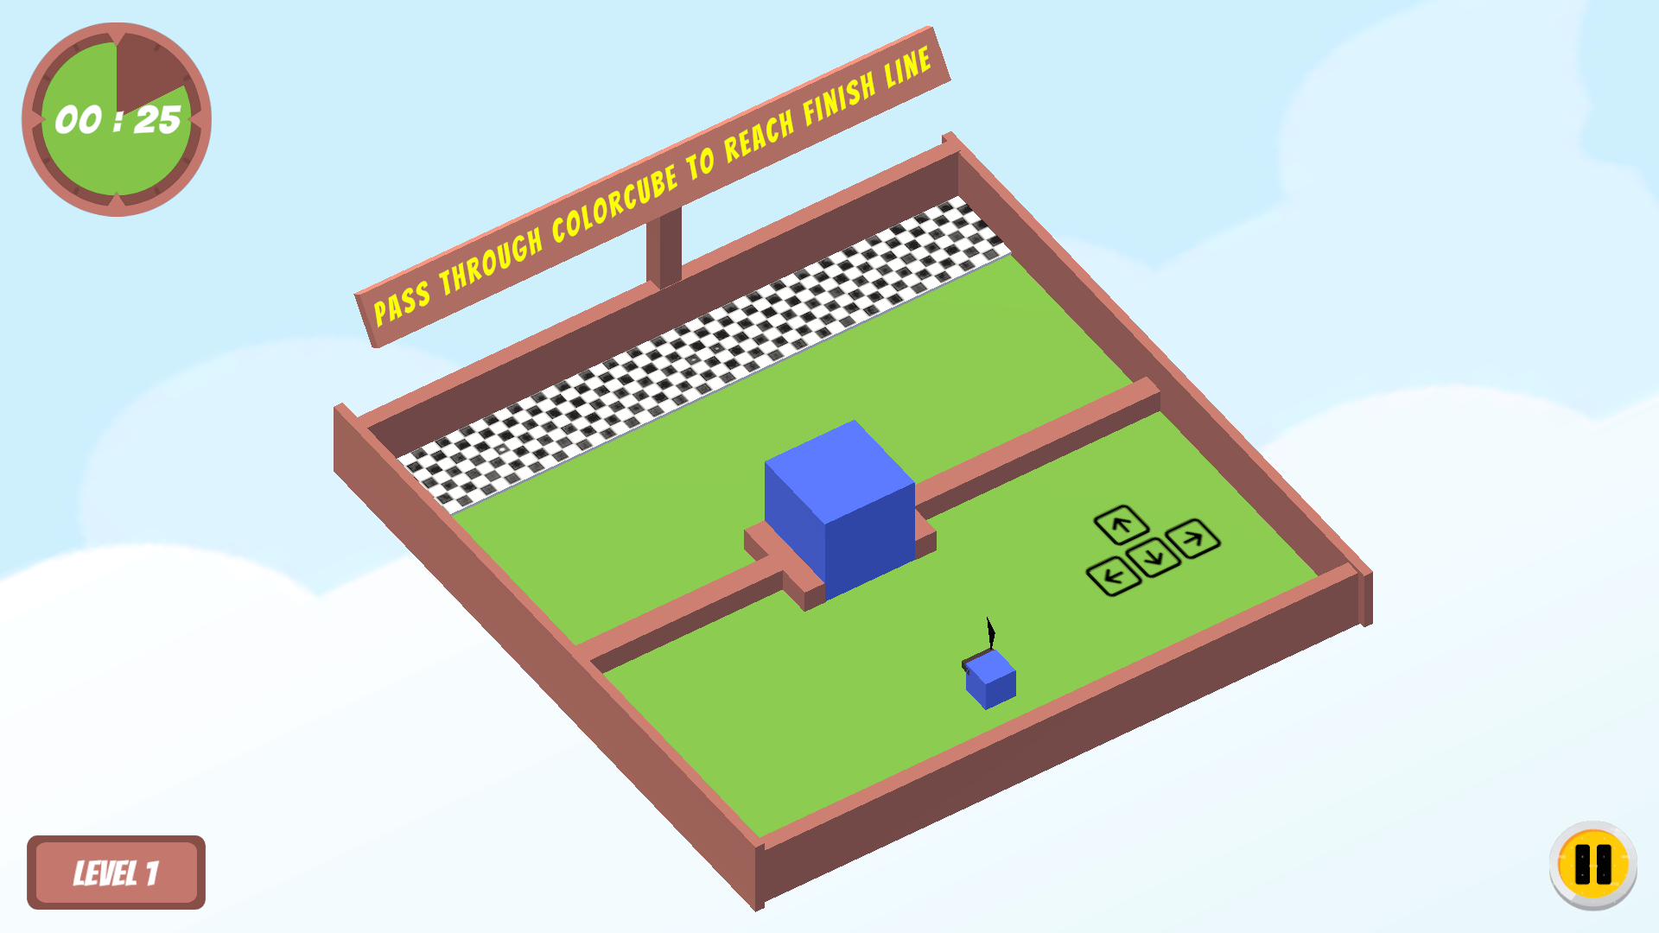

This level is used to get the player familiar with basic movements like moving forward, backward, left and right. By playing this level, the player can know very basic knowledge of the game. The player can understand the goal of this game that they need to reach a finish line by passing through the cubical gate within the time limit.

***Level 2***

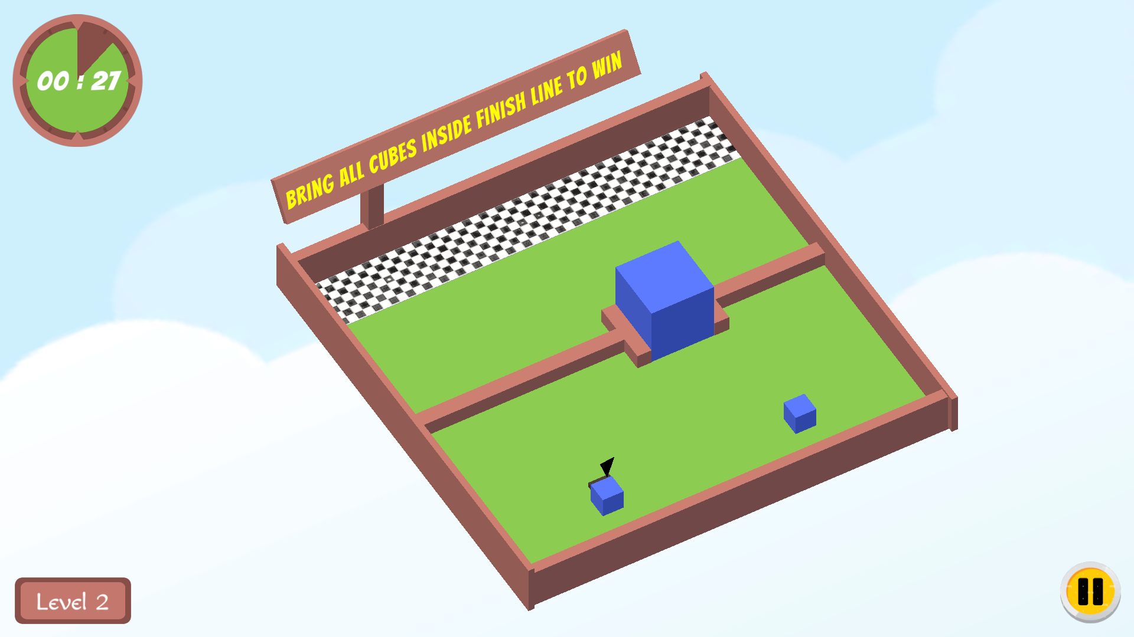

In this level, switching between the character mechanism is introduced. This level contains two cubical characters who must reach the end by passing through the color-based gate within the time limit.

***Level 3***

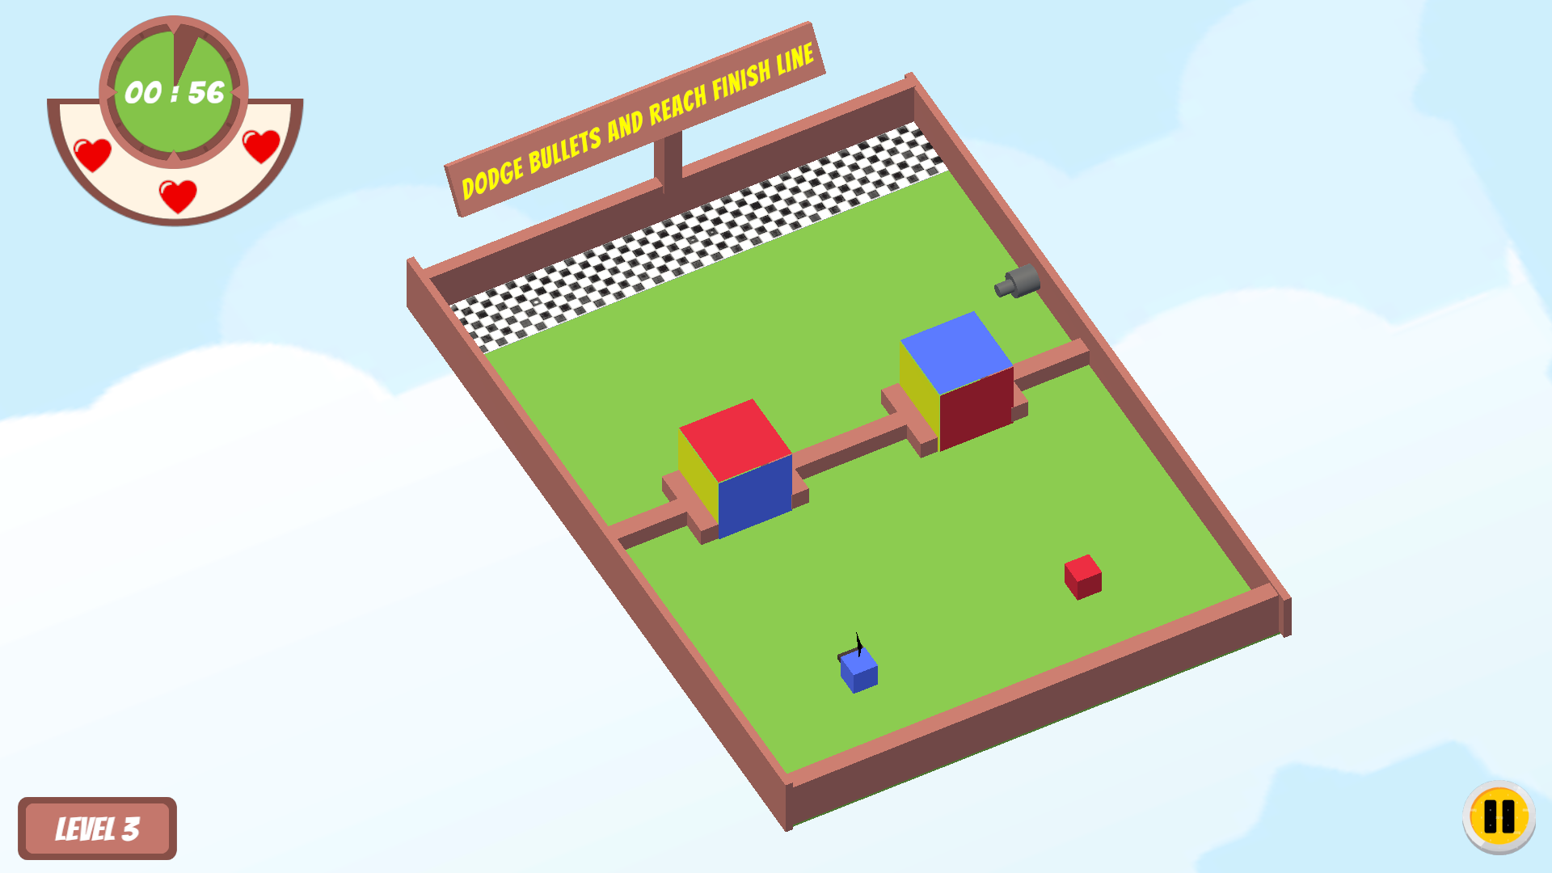

This level contains two characters of different colors. By playing this level, the player can understand that a character can pass through the gate iff the color-based gate face color that matches the character's color. Enemies are also introduced at this level. The player needs to dodge the bullet in order to succeed in the game. The player can see lives in the top left corner of the UI. A player will lose lives if the bullet hits any of the characters.

***Level 4***

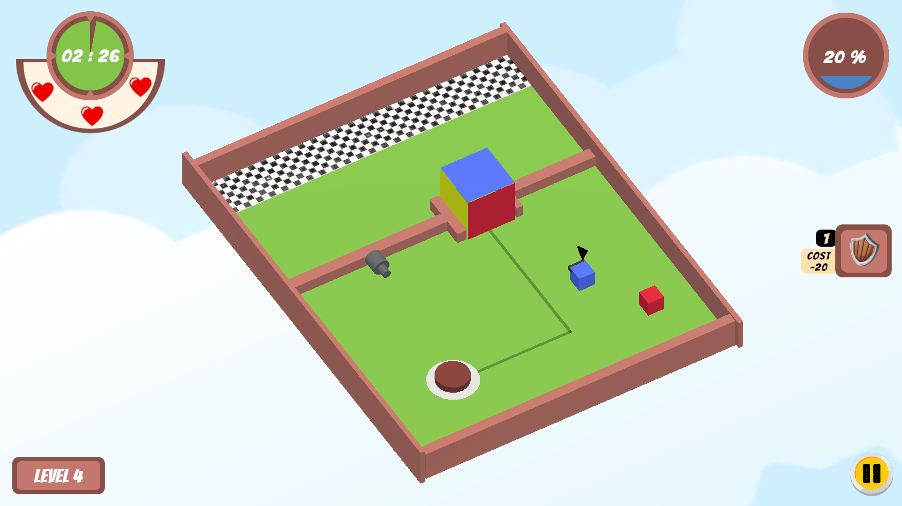

In this level, brown buttons to rotate the color gates, enemies firing bullets, and a shield mechanism to protect the player from bullets are introduced. Also, the player will be introduced to the ‘MANA’. The instructions for using MANA and shield mechanisms have been given in the form of popup messages,

***Level 5***

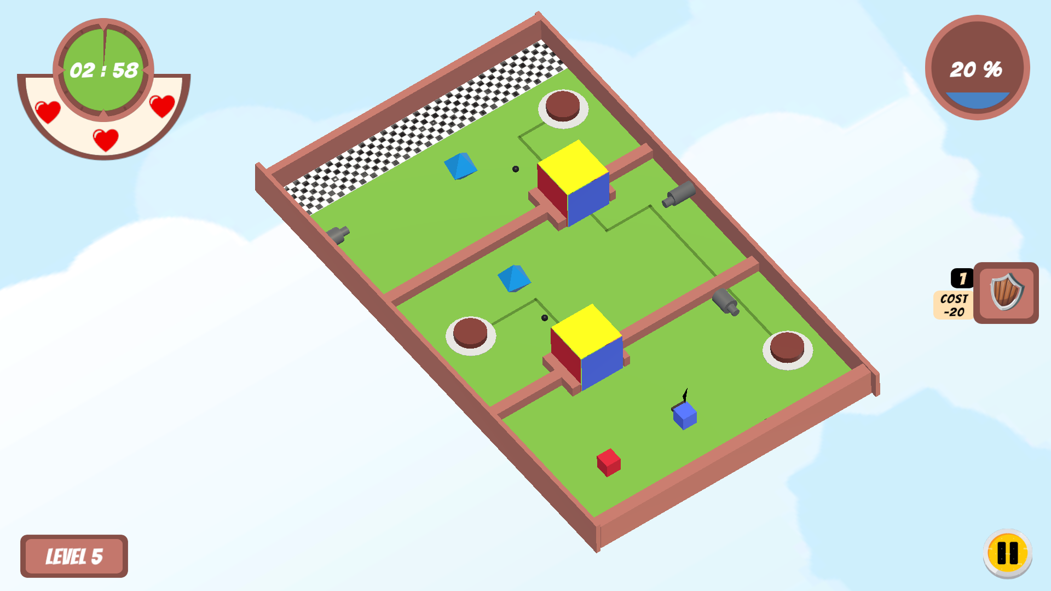

The difficulty level has been increased at this level. Additional color-based gates have been introduced. The player must think of the right strategy to complete this level by dodging the bullets within the time limit. Gems that increase the MANA have been introduced at this level.

***Level 6***

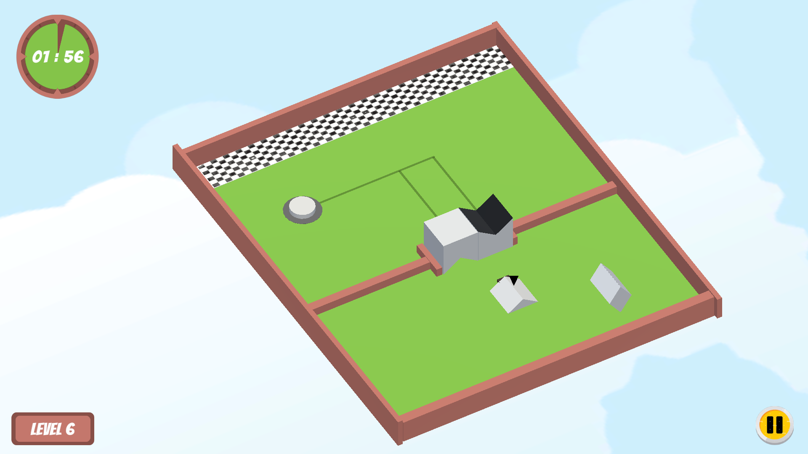

The shaped-based characters, shape-based gates, and white buttons that operate the shape gates are introduced in this level.

***Level 7***

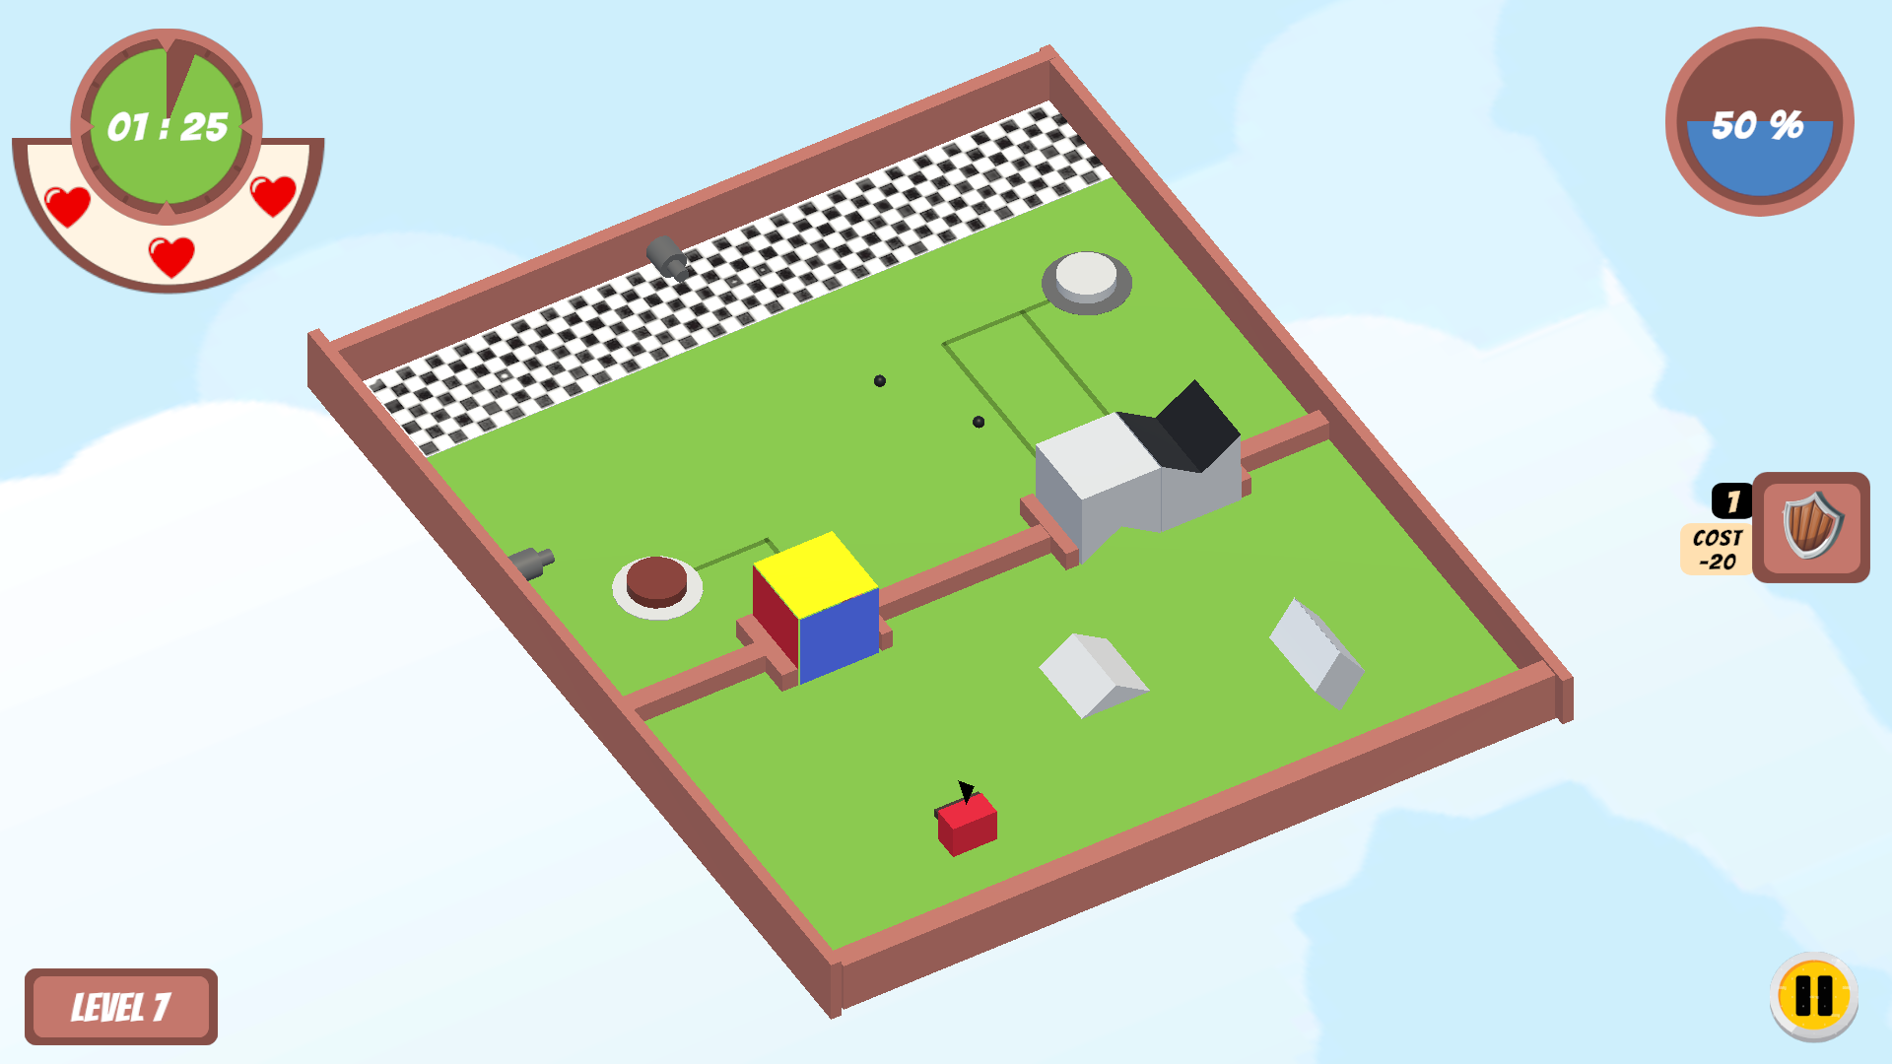

This level is a combination of both color-based and shape-based gates. Characters of different shapes or colors is been present. This will act as a basic level for the player to get familiar with using

***Level 8***

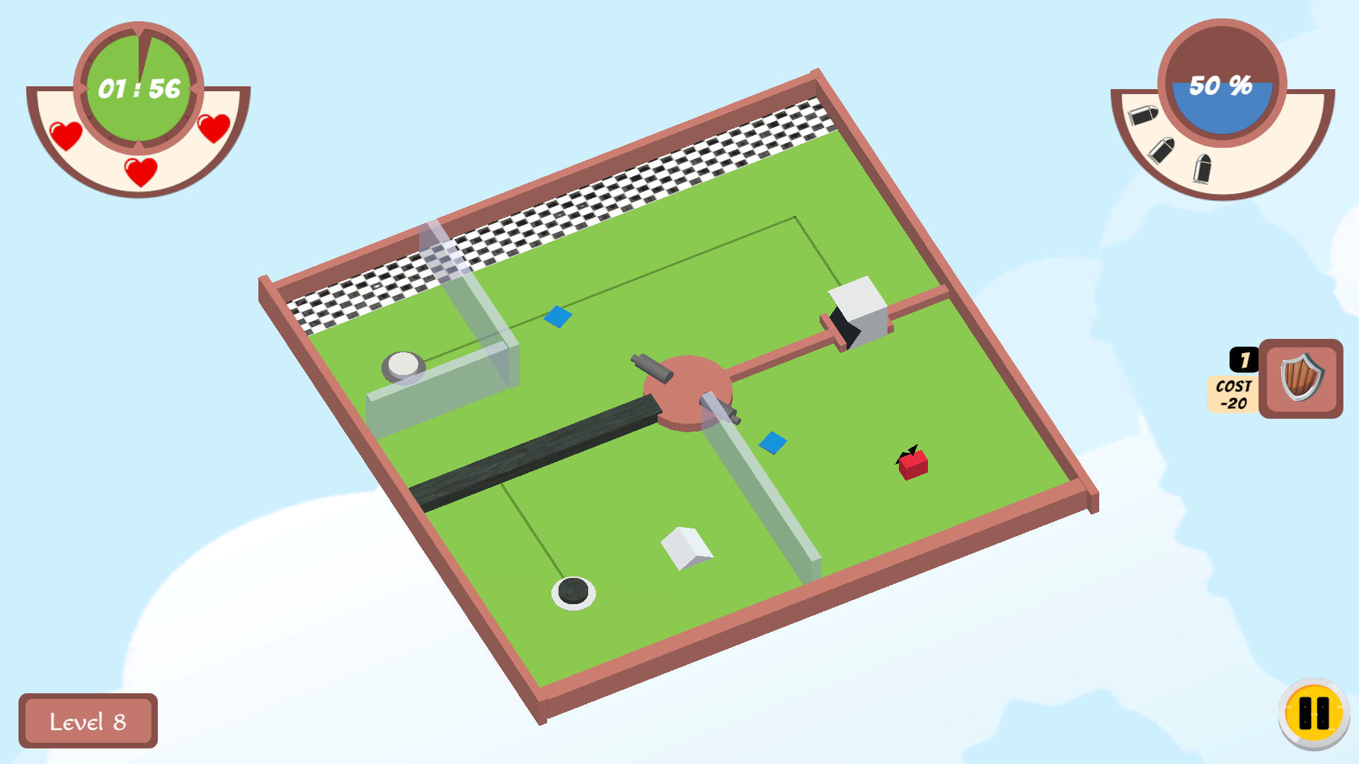

In this level, black gates and glass walls are introduced to the player. The player needs to pull off the black gate by pressing the appropriate black button in order to make all characters reach the finish line. The shooting mechanism and the player’s ability to collect bullets using a shield mechanism have been introduced at this level.

***Level 9***

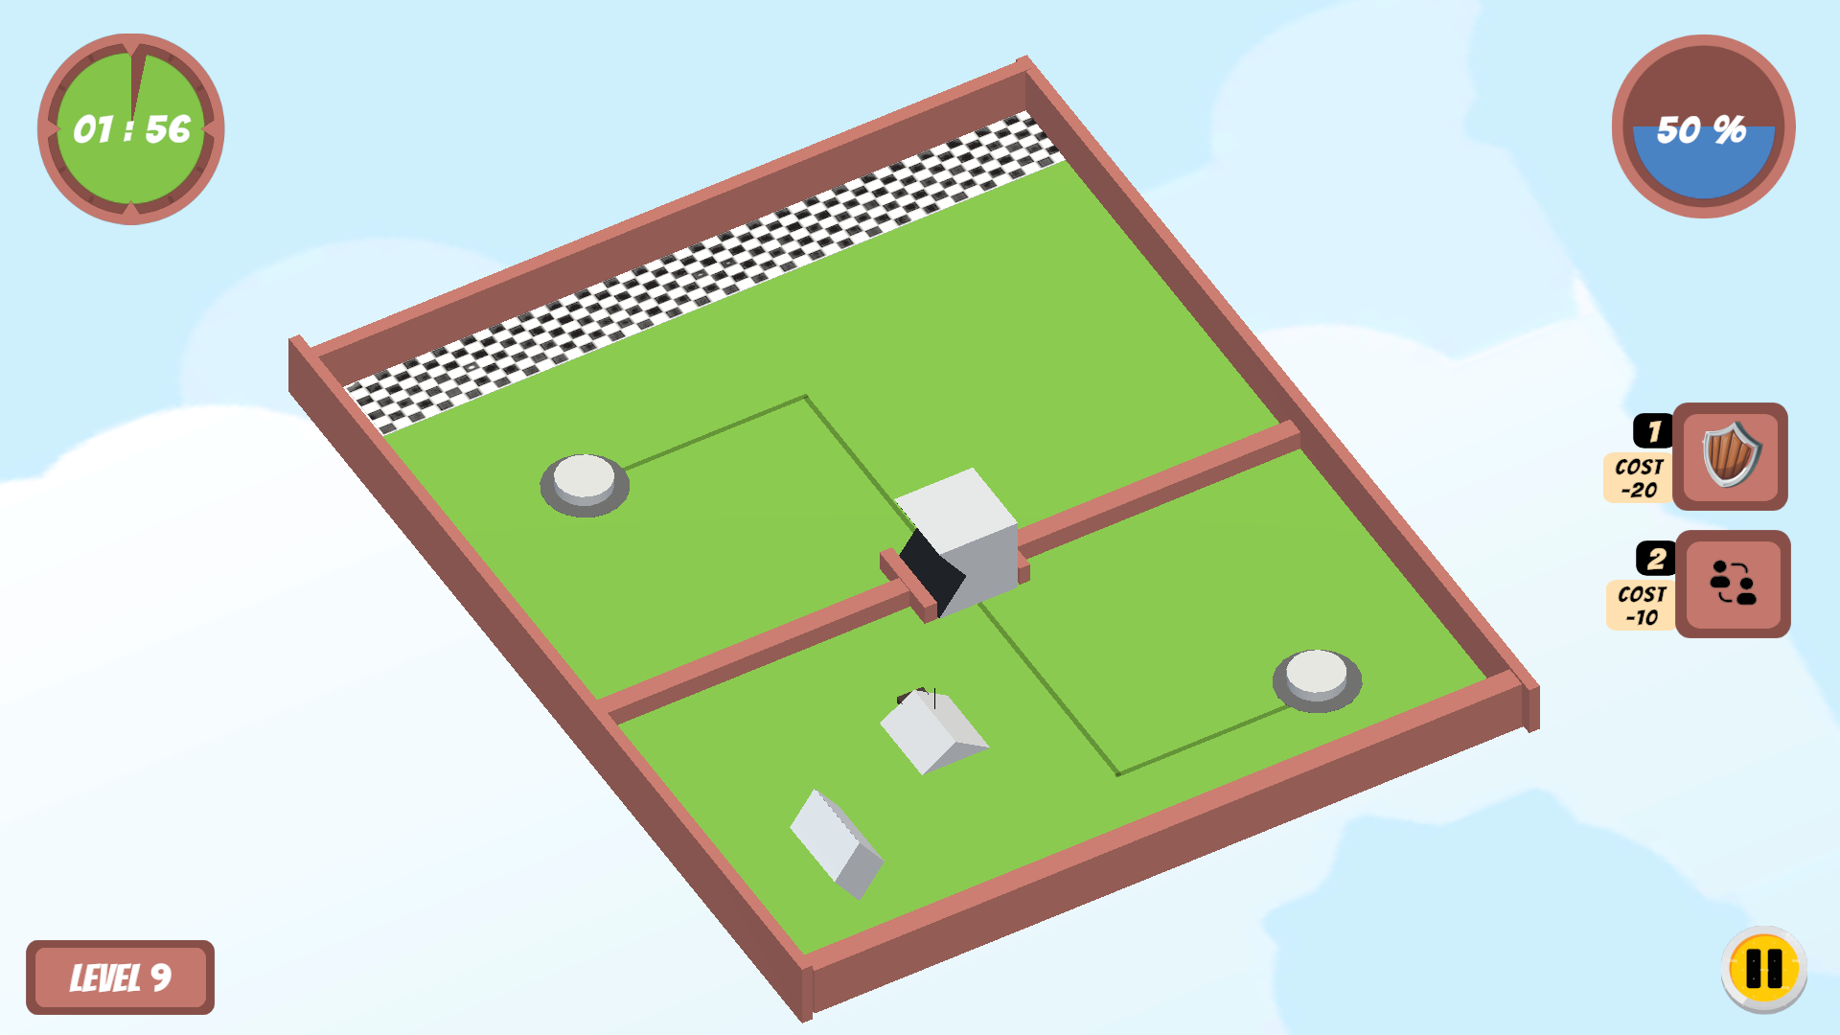

In this level, swapping between shape character’s positions mechanism have been introduced to the player. The cost of MANA to use the mechanism has also been instructed to the player at this level.

***Level 10***

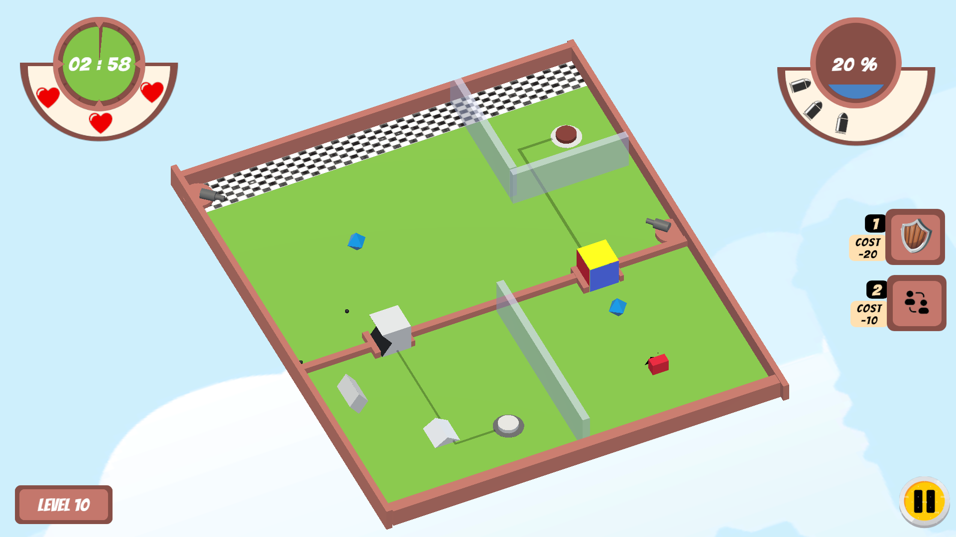

This level is designed with increased difficulty to let the player get familiar with the swapping of positions.

***Level 11***

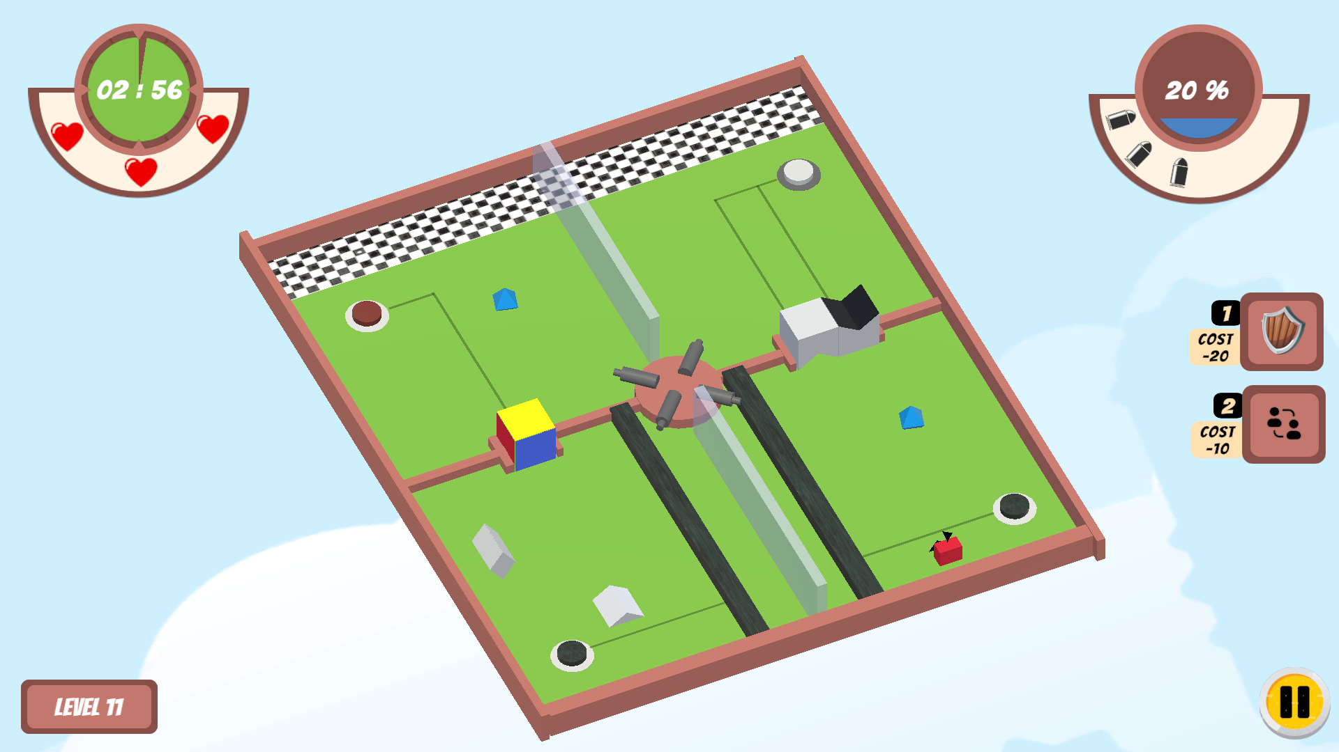

This is an advanced level where the player can use all the mechanics that they learned so far strategically to complete this level.

***Level 12***

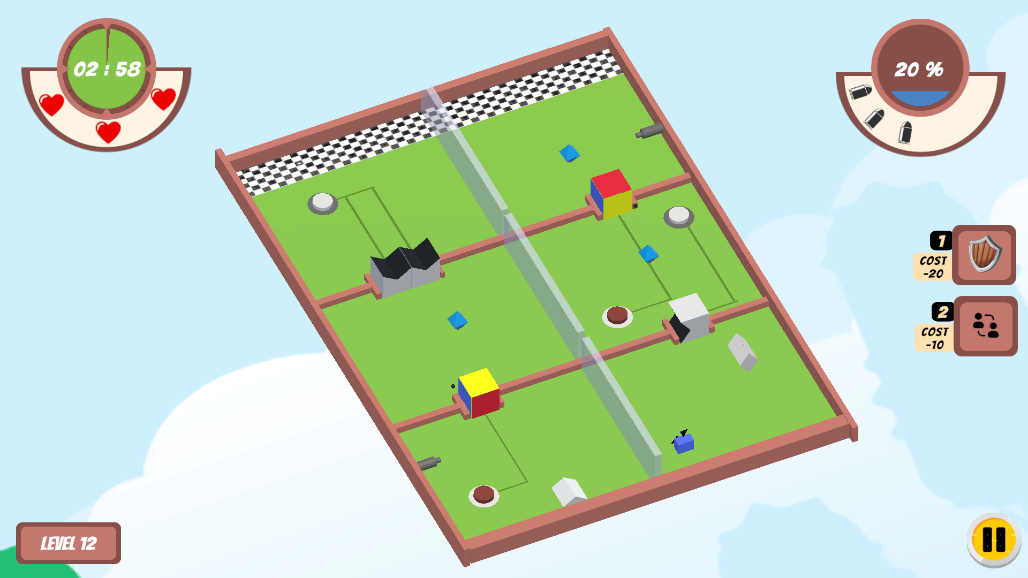

This level is intended to increase strategy complexity by increasing the number of gates.

***Level 13 (BONUS LEVEL)***

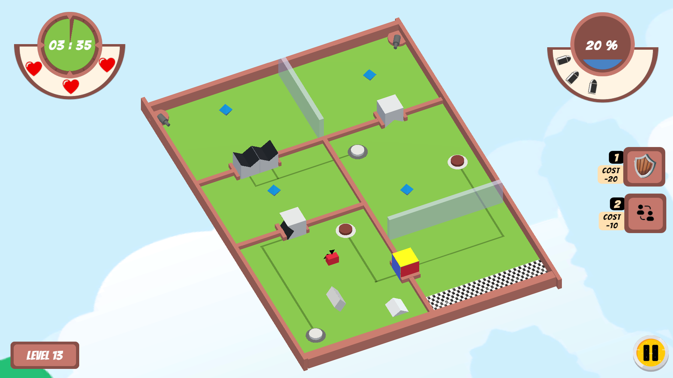

This is the bonus level with increased difficulty where the player needs to use all the mechanics that have been introduced throughout the game in order to reach the finish line.

## User Interface

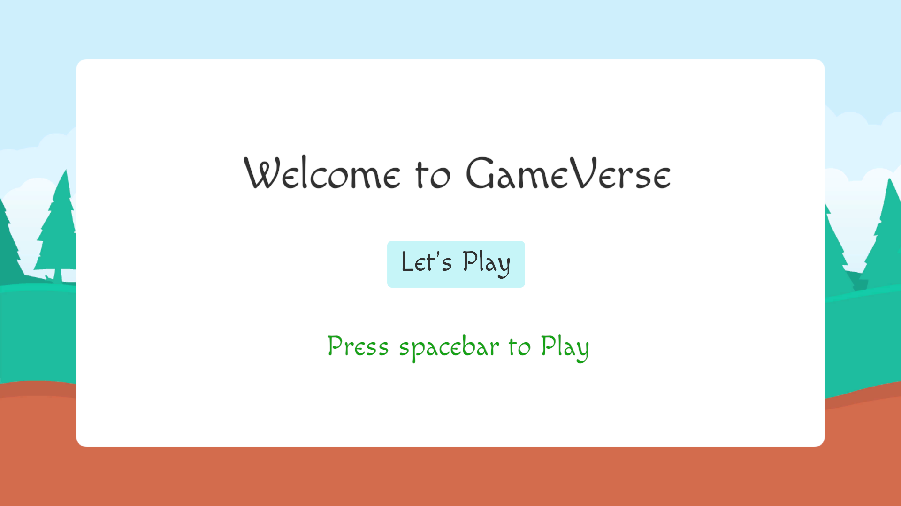

The above images shows the initial screen a player sees when they start the game. The player needs to press ‘spacebar’ button/click the ‘Let’s Play’ button in order to start the game.

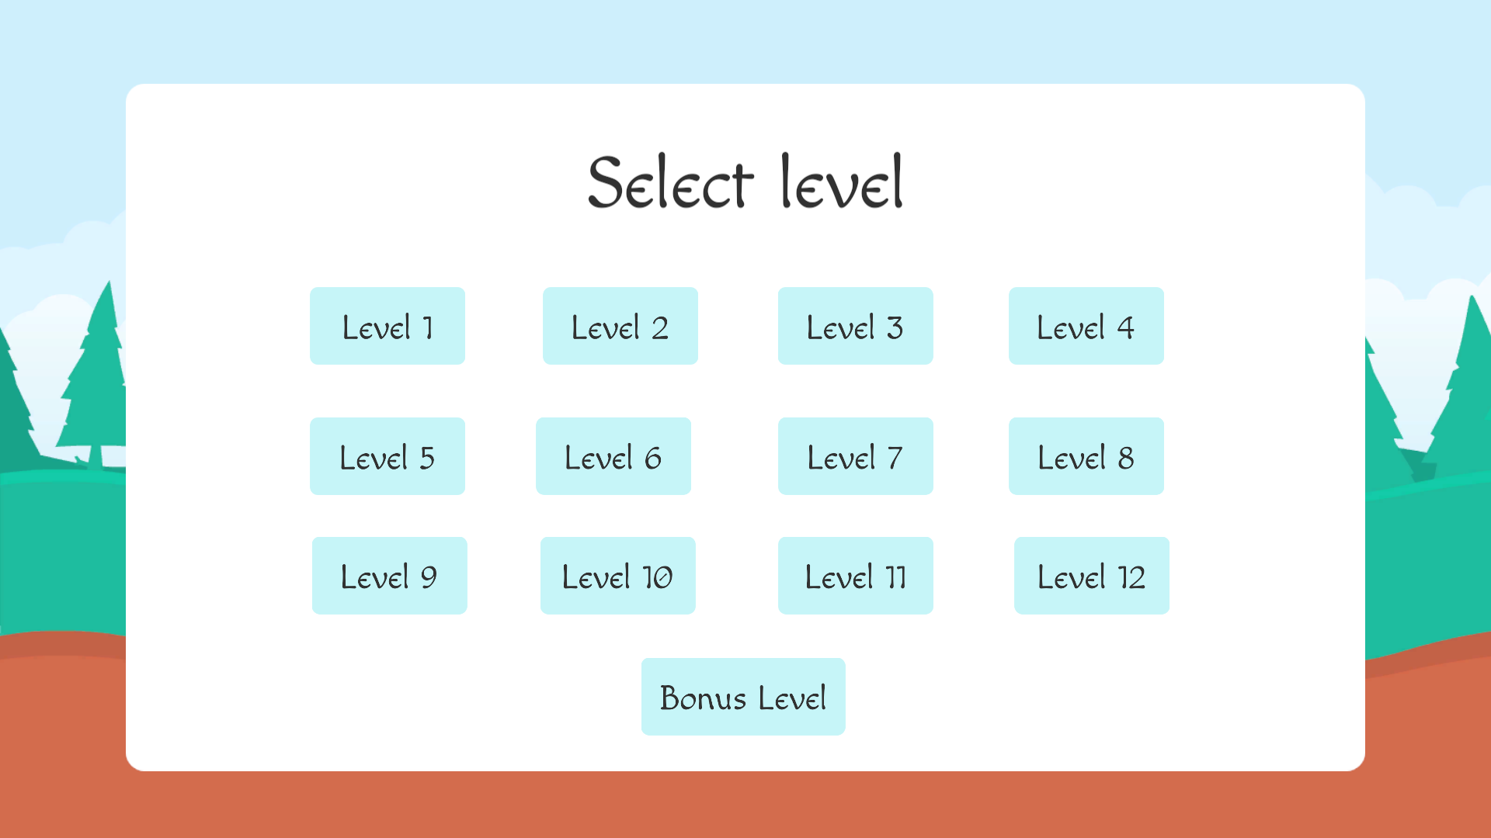

When the player presses the spacebar on the previous page, the above will be displayed to them. The player can select the levels they want to play by moving the arrow keys on this page. A player can play a level by just pressing the spacebar. Or, the player can simply select the levels using the mouse. The selected level will be highlighted in grey color. The player can also use the mouse to select the levels

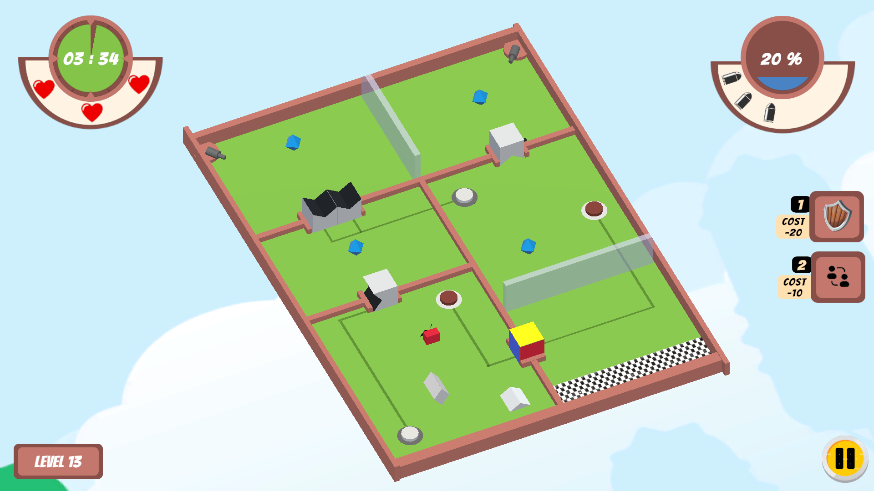

Once the player selects the level they need to play, the corresponding level will start. The player can notice the following depending on the level in the UI,

* Level label palette: In the bottom-left corner, players can find a wooden palette containing the Level label
* Timer: In the top-left corner of the UI, the player will find a timer showing the remaining time to complete the level. The timer will start blinking when the player has less time to complete the level.
* Health: In the top-left corner of the UI, under the timer, the player can notice the hearts depicting the number of lives provided and they left with to complete the level.
* Mana: In the top-right corner of the UI, the player can find the Mana they left with to complete this level.
* Bullets: In the top-right corner of the UI, under the mana, the player could find the number of bullets they left with to complete this level.
* Pause: In the bottom-right corner of the UI, the player can notice a pause button that they can use to pause the game. Clicking on the pause button will display an overlay containing the options to resume the game, restart the game, and go to the level selection page.
* Players can also notice shield and swap positions icons in the middle-right corner of the page, along with respective keys to use them and the mana cost. Once any one of the mechanics has been used by the player, they can see an animation showing the time left to expire or use them again.

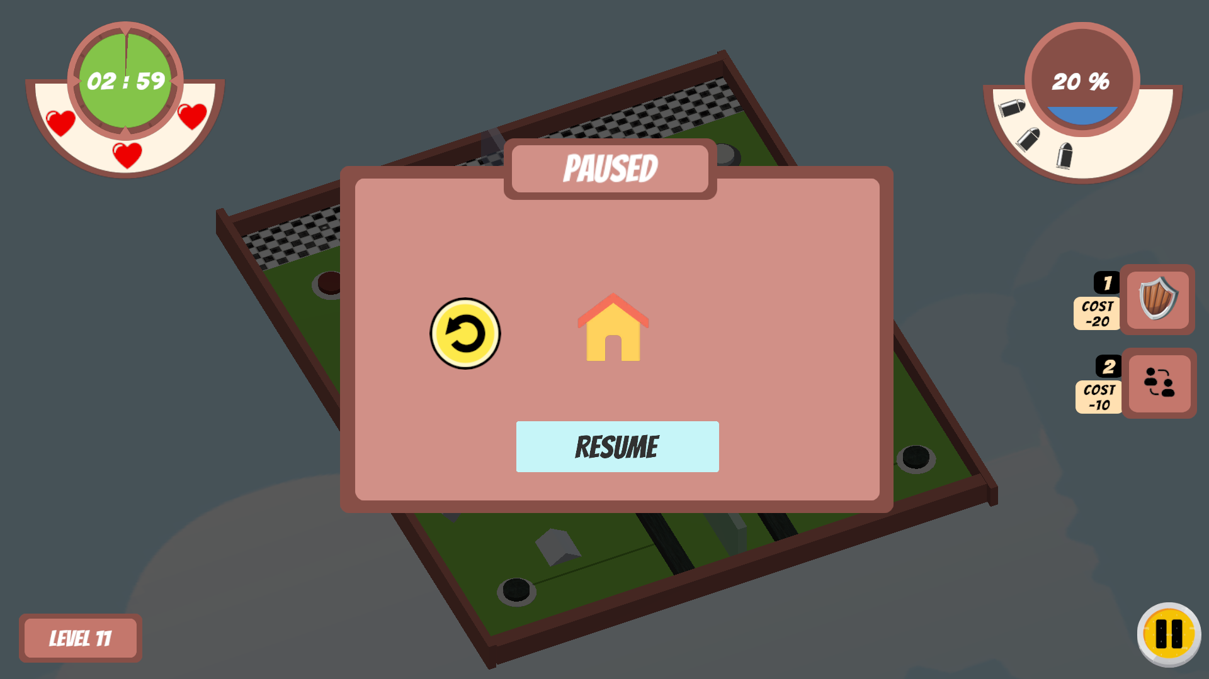

The above overlay will be displayed with the following when the player clicks on the pause button.

* Reset/Restart Button: The player can use this button to restart the game.
* Home Button: The player can use this button to move back to the level selection page
* Resume Button: The player can use this button to resume the paused game.

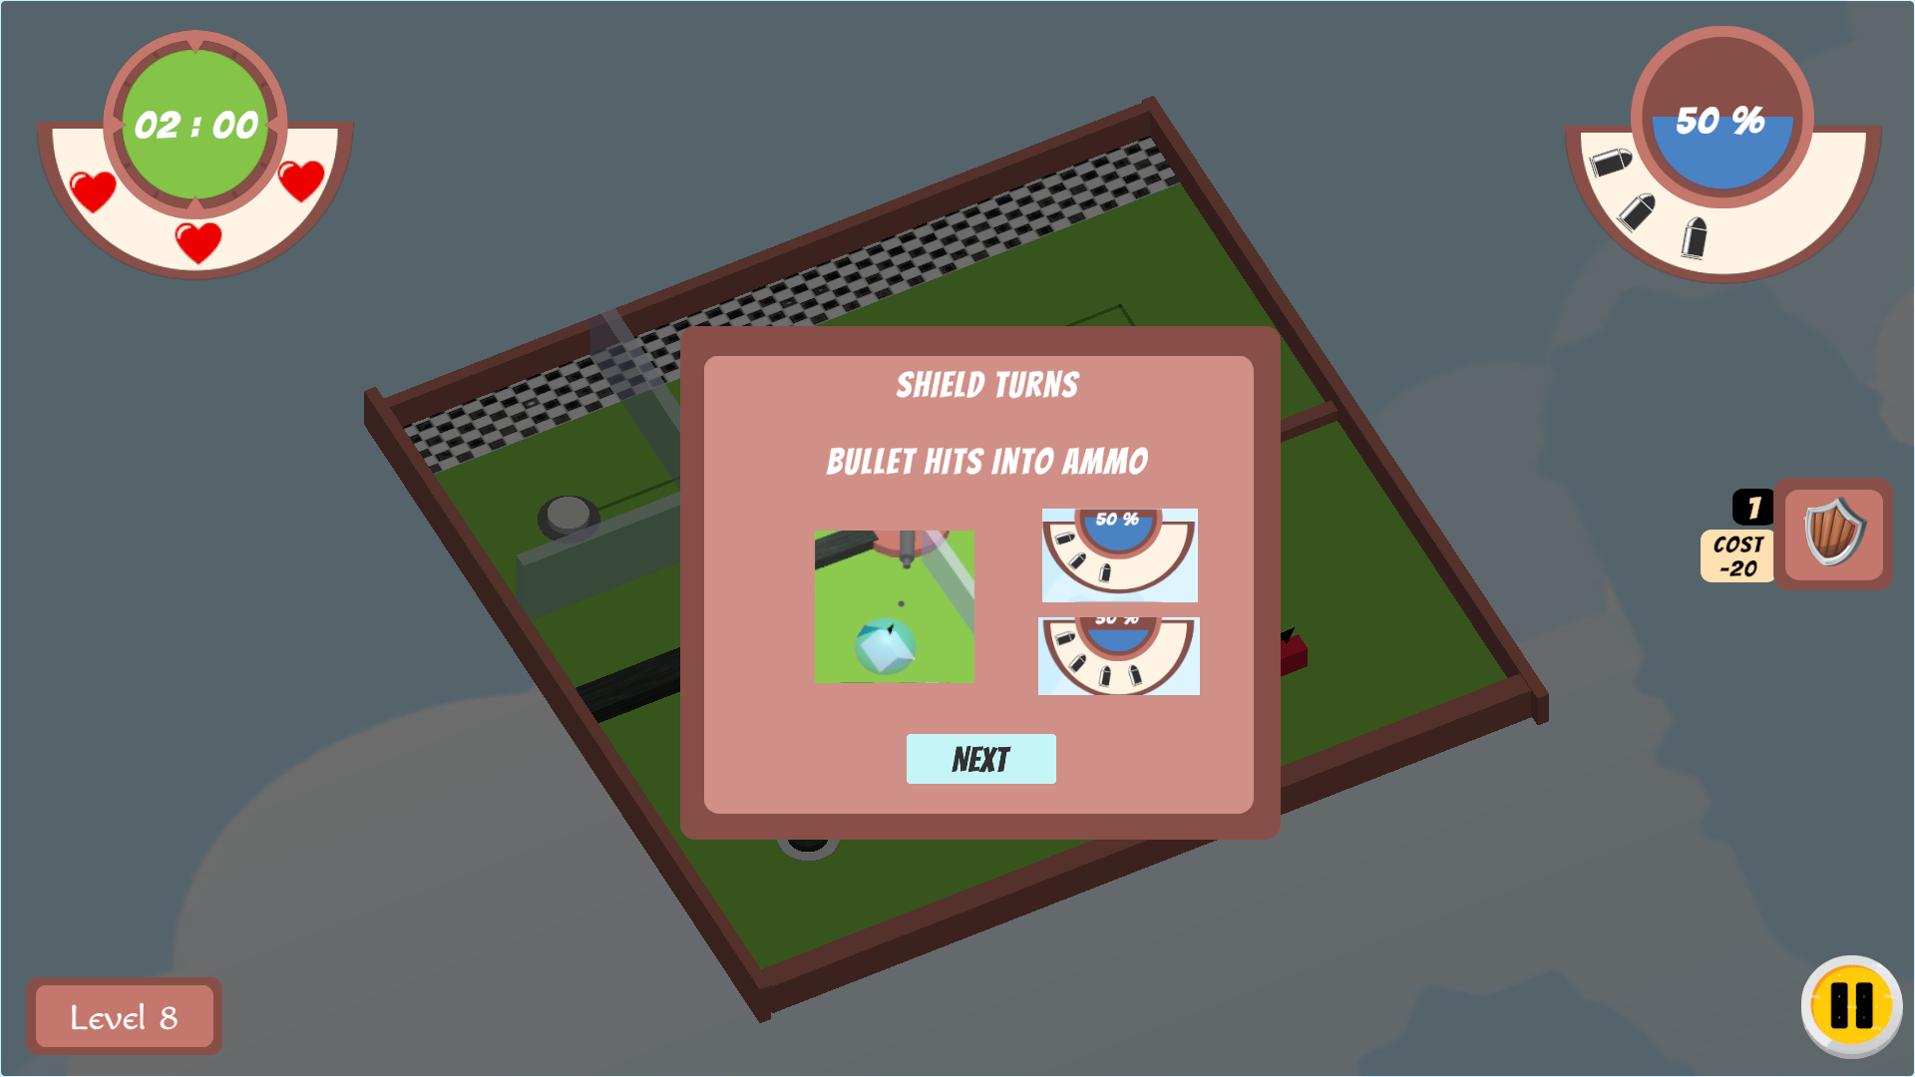

The Instructions for each level will be given one by one, like a pop-up before the level starts. The player can skip or move to the next instruction by clicking the ‘NEXT’ button or pressing the spacebar.

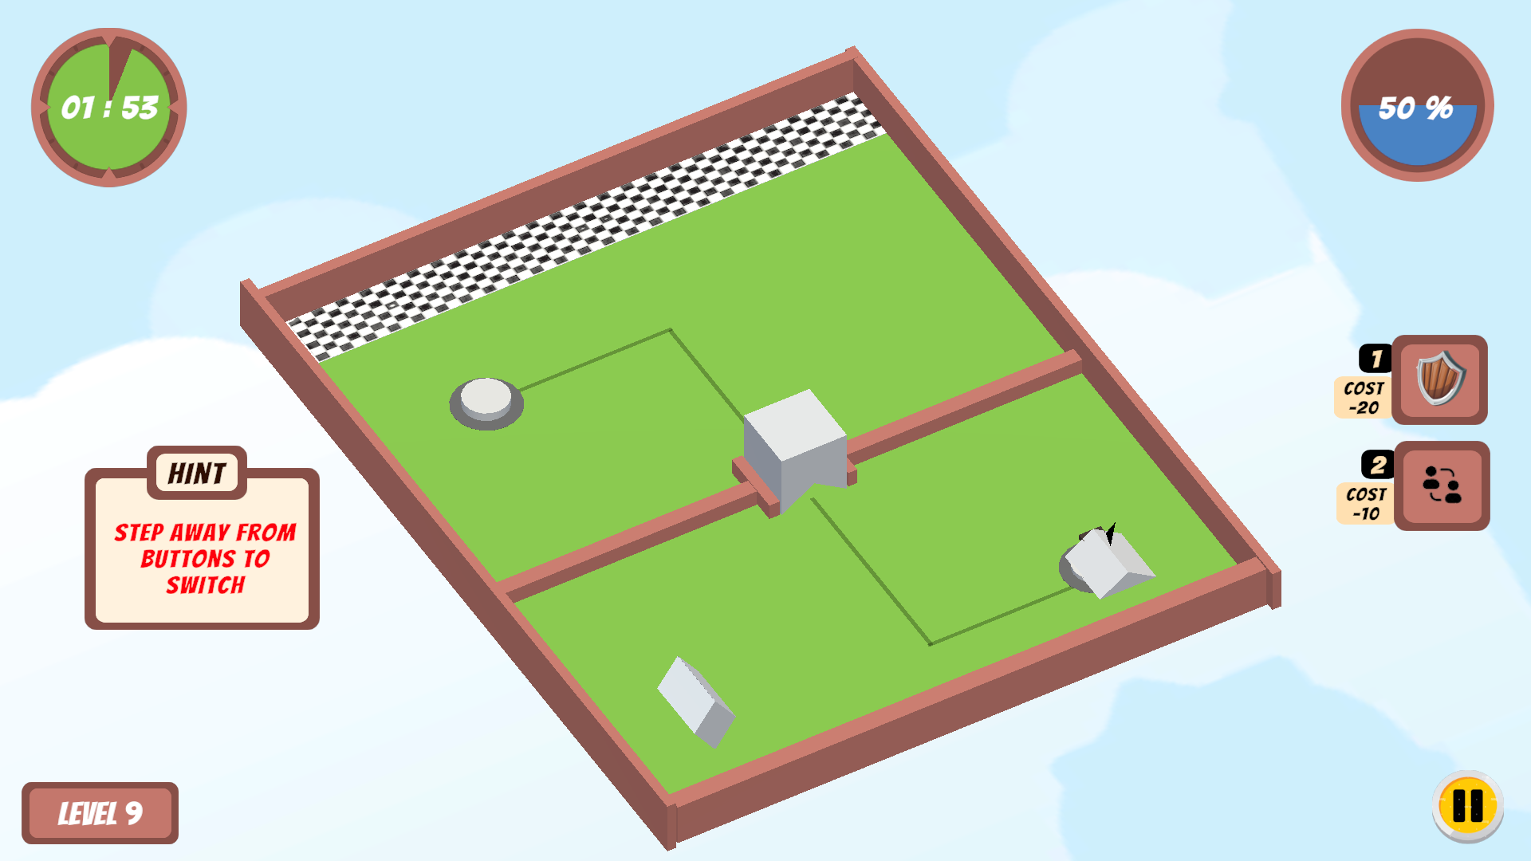

Whenever the player tries to use the swap mechanism while standing on the button, a hint will appear on the screen like above to instruct the player to step away from the buttons to swap.

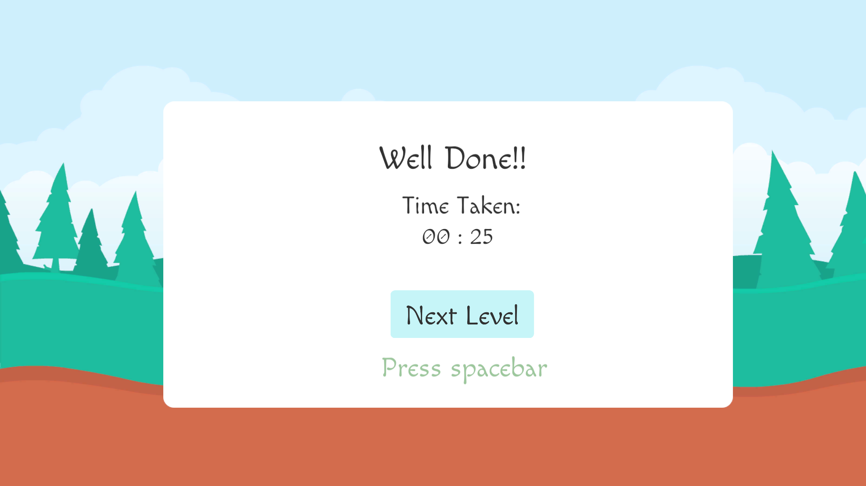

The player can see the above page if they successfully completed the level. This page displays the time taken by the player to complete the level. The player can move to the next level by clicking the “Next Level” button/ by pressing the spacebar.

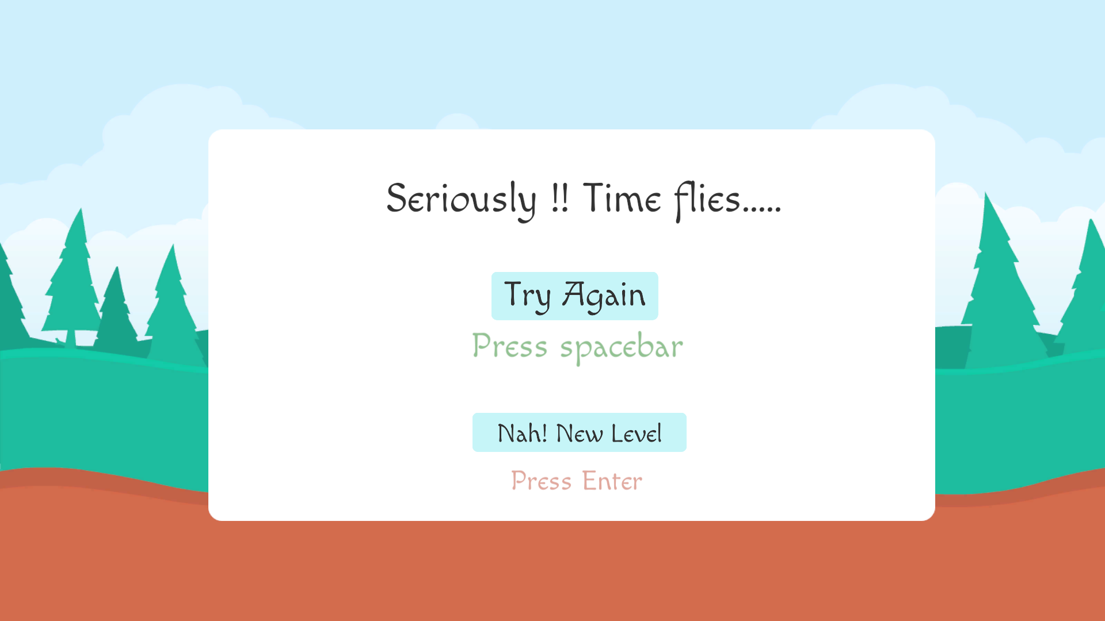

If the player fails in the current level due to time constraints, the above page will be displayed to the player. The player can either replay the current level by clicking on the “Try Again” button/ pressing the spacebar or move to the level selection page by clicking on the “Nah! New Level” button/ pressing enter.

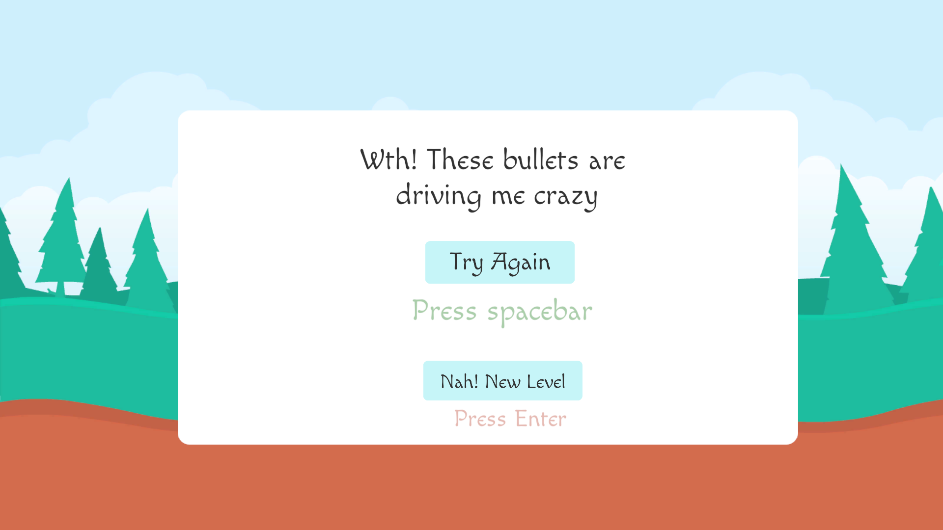Similarly, if the player fail the current level by losing all lives the above page will be displayed.

## Gameplay Loop

Gameplay Loop

Move through the gates, switch between characters, dodge bullets, protect from bullets/collect bulltes, swap positions between shape characters, fire bullets to break the glass walls, and use buttons to rotate/pull the gates

Outer Game Loop

Complete the level satisfying the time and lives constraint

Game Progression

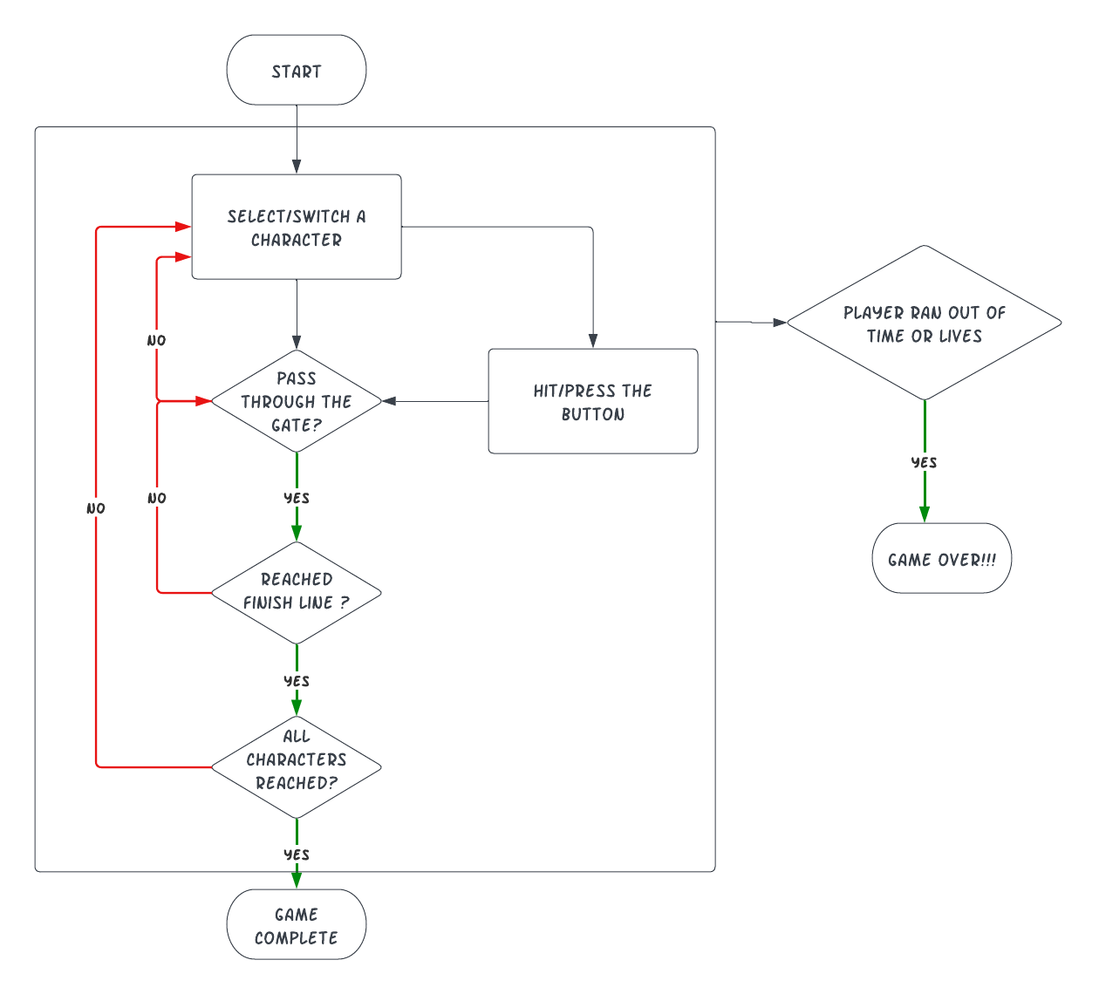

# Project Progress

## Prototypes

### Prototype 1 :

Logline:

3D Platform puzzle game, where the player safely guides and drops sub-players to the finish area, while saving their selves from enemies.

Description:

* One imposter among identical friends with labels switching periodically.
* 3 chances to kill the imposter before time runs out.
* Shaded regions are only visible when player color = shaded region color.
* Collectibles and powerups at random locations.

Drawing:

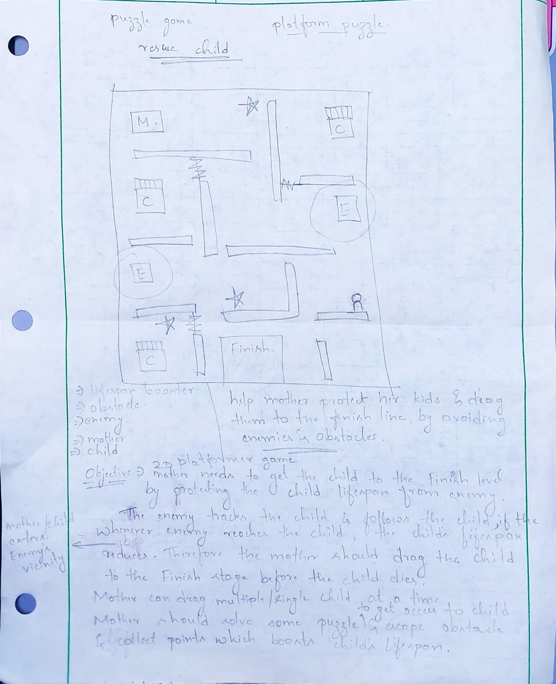

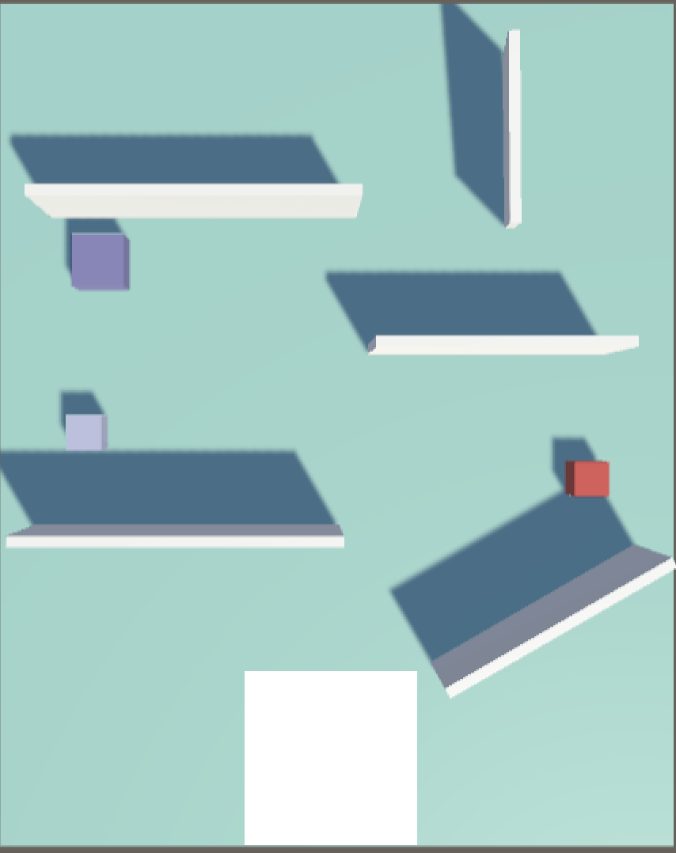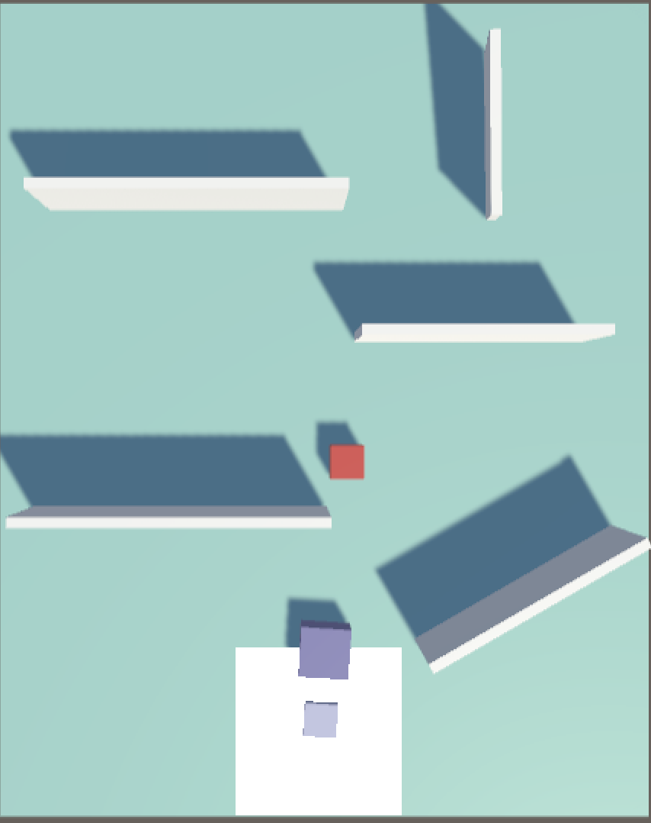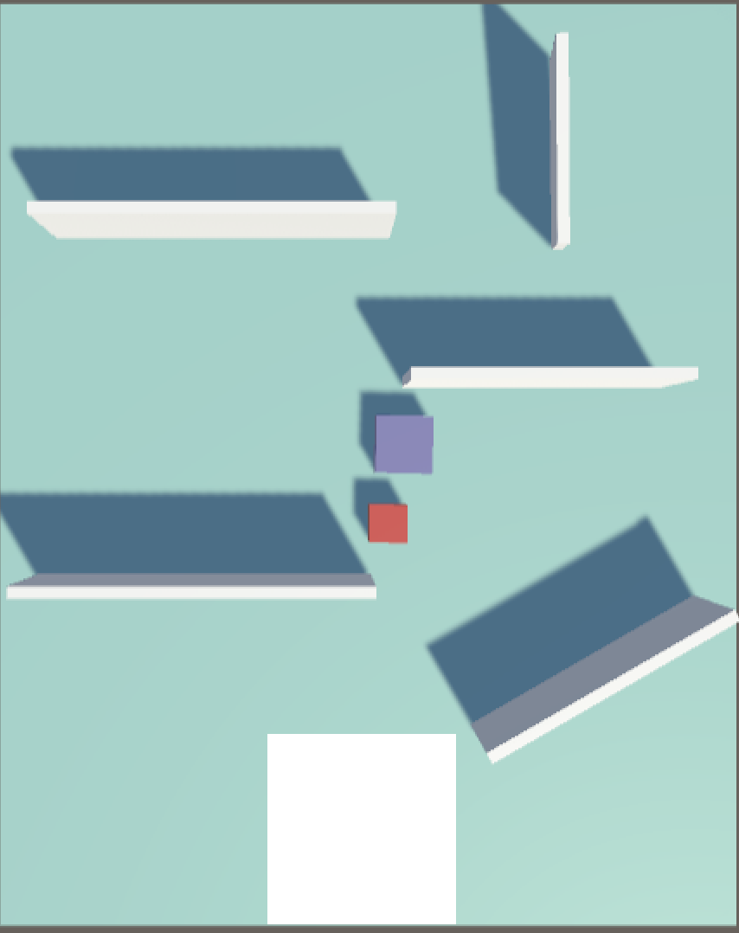

Link: <https://play.unity.com/p/prototype_1_webgl-2/>

### Prototype 2:

Logline:

A 2d platformer + puzzle game in which the player finds the imposter among identical-looking friends and kills it before the time runs out.

Description:

* One imposter among identical friends with labels switching periodically.
* 3 chances to kill the imposter before time runs out.
* Shaded regions are only visible when player color = shaded region color.
* Collectibles and powerups at random locations.

Drawing:

## 

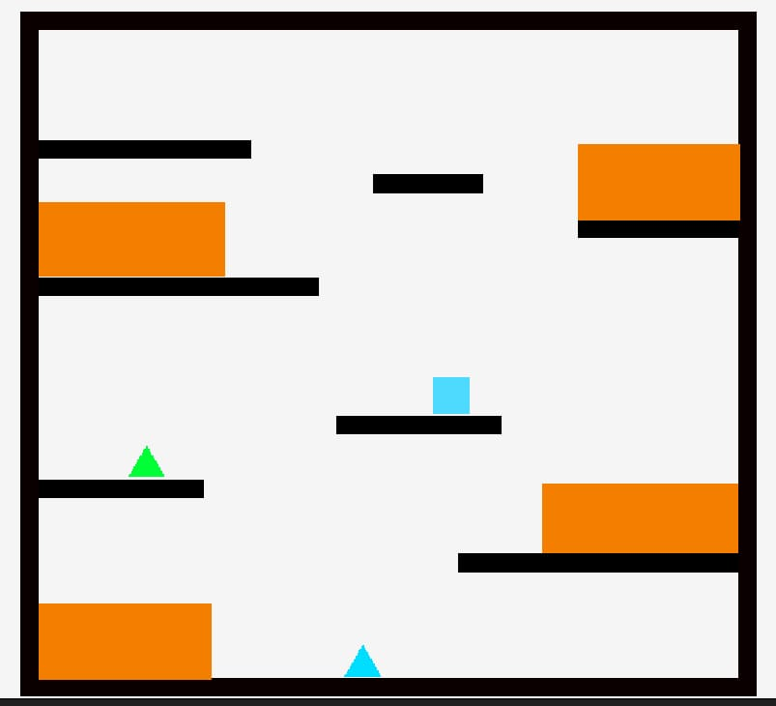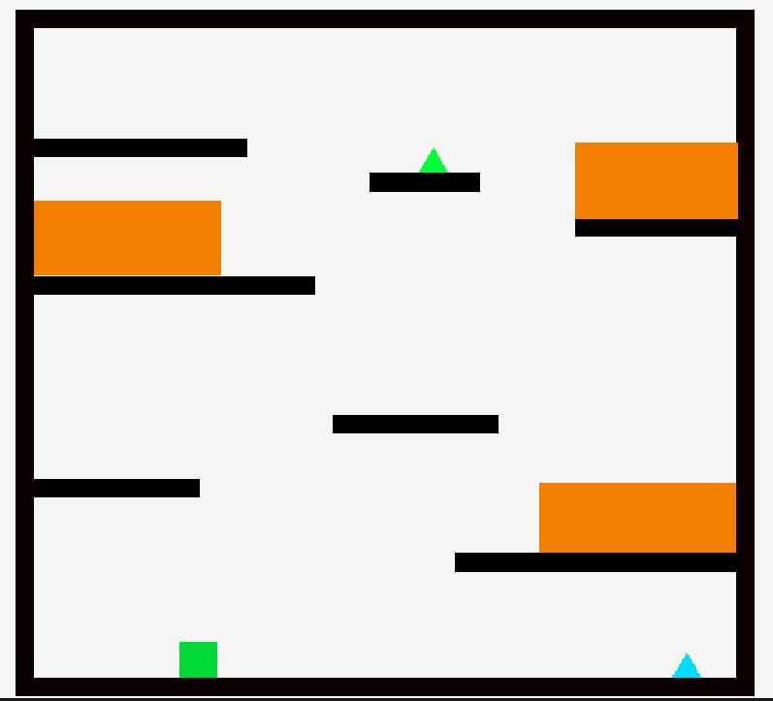

Link: <https://play.unity.com/p/webgl-builds-315067/>

### Prototype 3:

Logline:

A 3D Platformer + Puzzle + Rush game where the player has to reach the finish point before the time runs out without losing all the lives.

Description:

* Player encounters various types of obstacles
* Player can move, jump and shoot enemies on the way to avoid getting killed
* Powerups and collectibles to assist crossing levels
* Player meet other supporting characters, merge with them to absorb abilities, shrinks, grows, fly, glide

Drawing:

# 

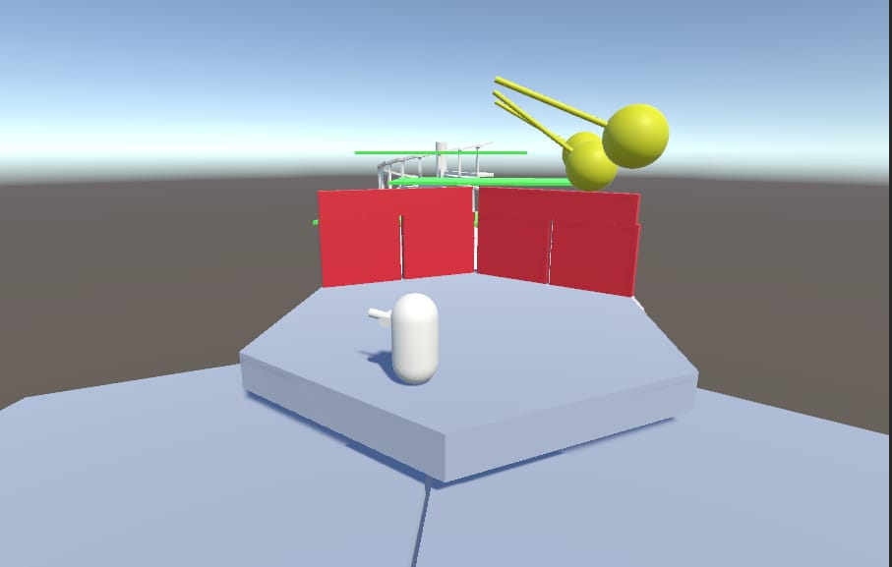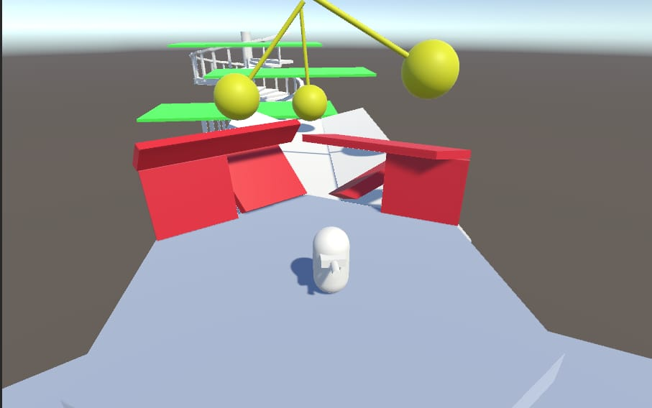

Link: <https://play.unity.com/mg/other/build-a8q>

## Graybox Prototype

Logline:

A 3-D platformer game with the elemental theme where the player needs to reach the finish line by crossing the obstacles

Description:

It’s a 3-D platformer game where the player needs to cross all the obstacles in order to reach the finish point. The player can jump and move in all four directions. The player will be provided with powerups like fire, water, and earth in order to cross the obstacles. The player needs to complete the level within the stipulated time and use 3 lives. The player will lose a life each time he falls from the platform. If the player lost 3 lives then the player will be lost and the game will end.

Drawing:

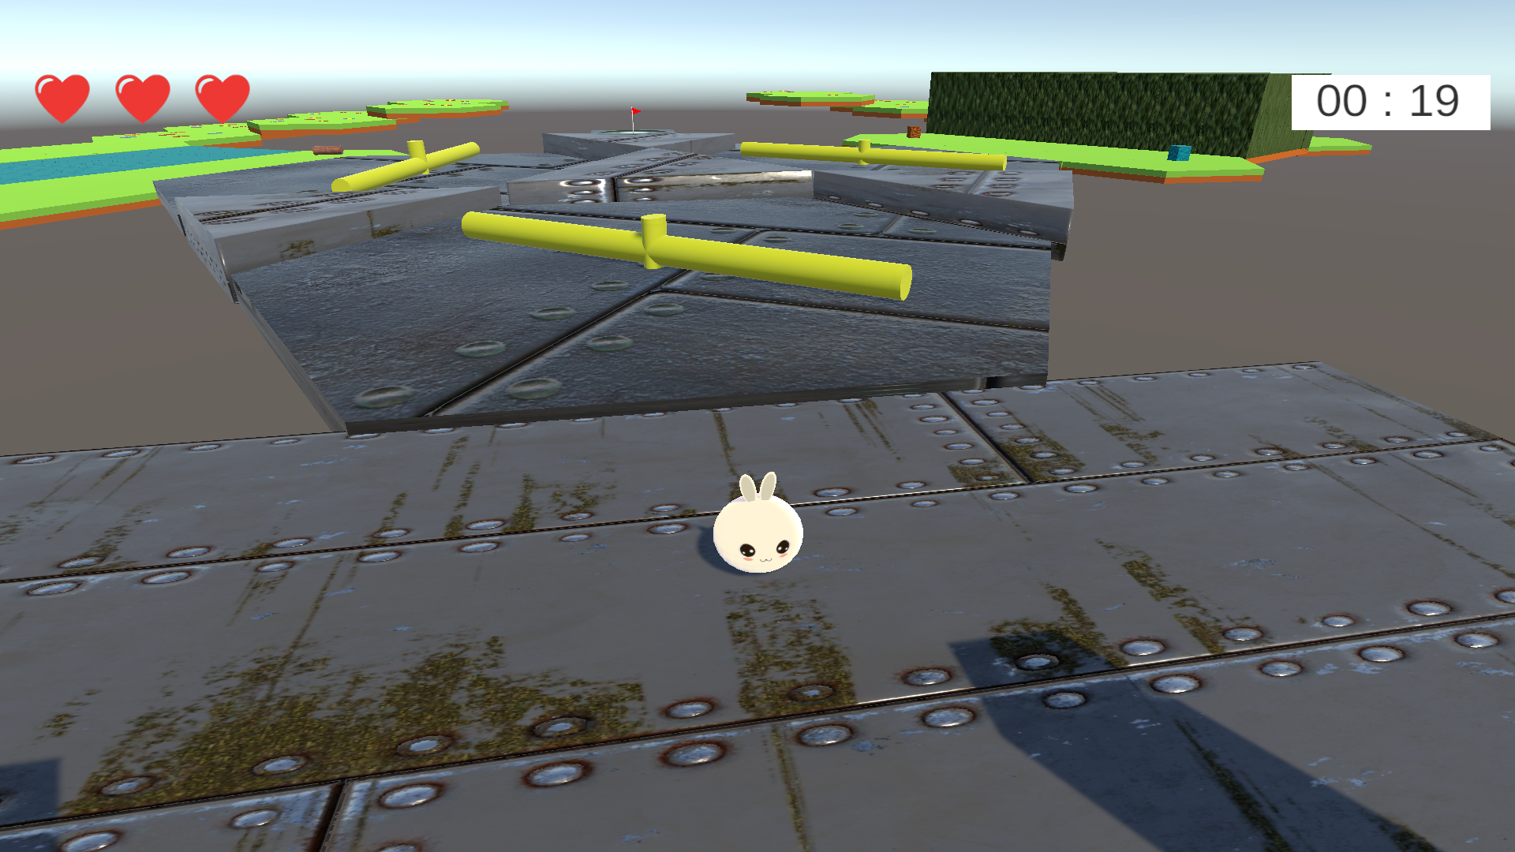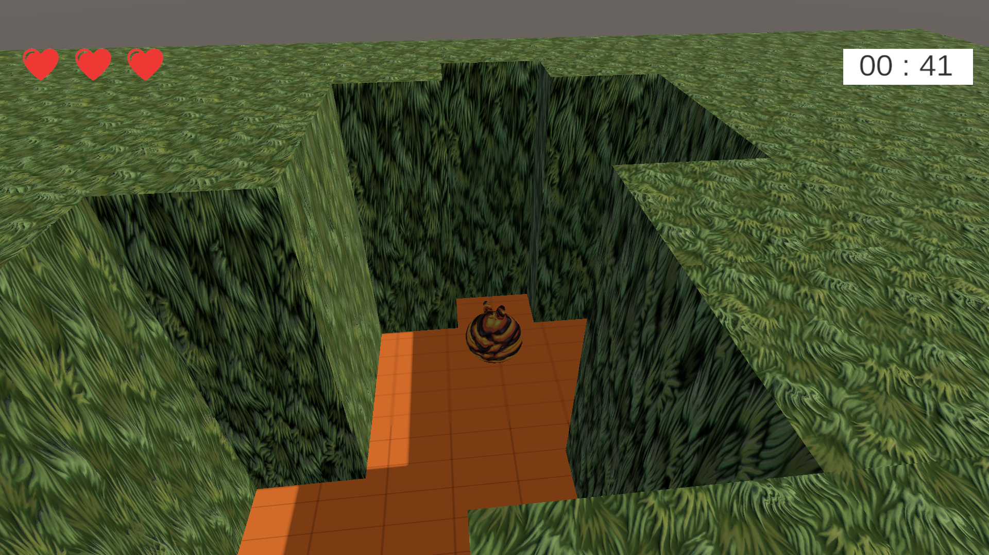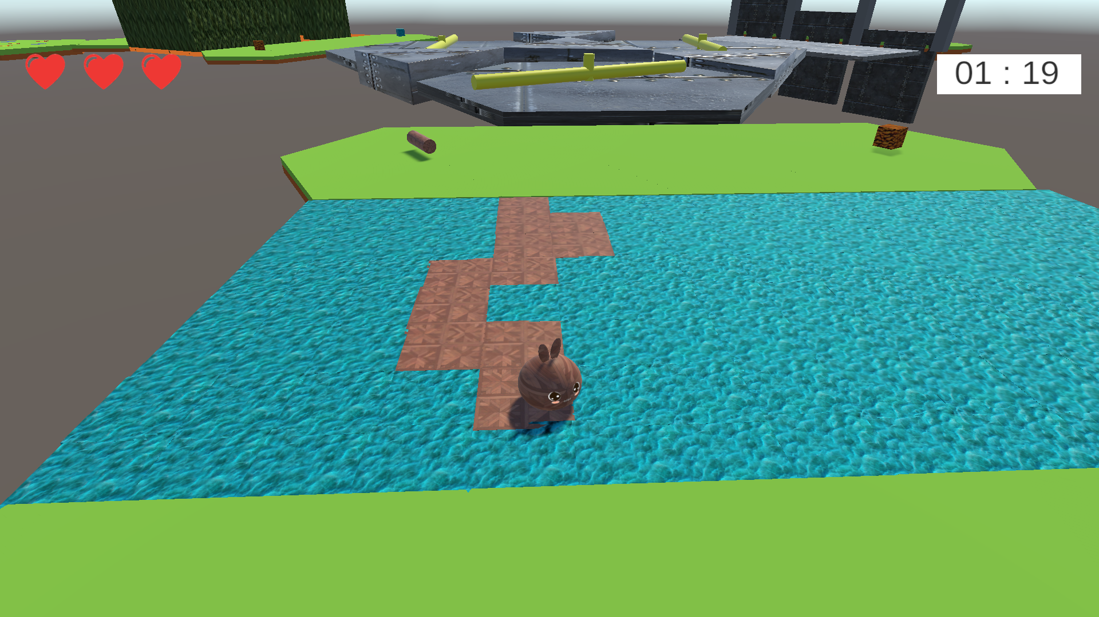

Link: <https://play.unity.com/mg/other/unity-builds-1317>

Playtest Video Link: <https://drive.google.com/file/d/18zWcJIAKzsi6CQnMSpH4ltMIeU99Jz7r/view?usp=share_link>

## 

## Weekly Milestones

| **Week** | **Description of new features, changes, and other noteworthy events** |
| --- | --- |
| *Week 1* | Introduction Week |
| *Week 2* | Tutorials and Team Formation |
| *Week 3* | Game Idea Discussion |
| *Week 4* | Prototype Design and Implementation for three different Ideas  [Prototype 1](https://play.unity.com/p/prototype_1_webgl-2/) [Prototype 2](https://play.unity.com/p/webgl-builds-315067/) [Prototype 3](https://play.unity.com/mg/other/build-a8q) |
| *Week 5* | Finalize the Prototype, Analytics Research And Improvements in the Prototype  [WebGL](https://play.unity.com/mg/other/build-a8q) |
| *Week 6* | * Development of Analytics Pipeline and Visualization of 2 Analytics metrics with real data. * Implemented Greybox Prototype and resolve the issues given in the feedback * Complete Junior Program Pathways Module 1   [Playtest Video](https://drive.google.com/file/d/18zWcJIAKzsi6CQnMSpH4ltMIeU99Jz7r/view?usp=share_link) [WebGL](https://play.unity.com/mg/other/gameverse-week06-graybox-prototyping) |
| *Week 7* | * Add two more working analytics * Make the game more cohesive * Fix player movement and camera * Clean up GDD   [Playtest Video](https://drive.google.com/file/d/15cXJnKl8qwkIniT5uTAEuKCpZV7_ycgc/view) [WebGL](https://play.unity.com/mg/other/gameverse-week7) |
| *Week 8* | * Design and develop a new game with different levels * Add 6 new working analytics for the new game   [Playtest Video](https://drive.google.com/file/d/1p01Y-PjncAUU_t_Tr9Plv_g9sNUY699Q/view?usp=sharing) [WebGL](https://play.unity.com/mg/other/gameverse-week08) [Github Build](https://akj2018.github.io/GameVerse_Week8/) |
| *Week 9* | * Develop new levels for the game * Resolve the glitches in the game * Finalize the 6 new analytics for the game * Revise the GDD for the new game   [Playtest Video](https://youtu.be/Ocp_W1abQVI) [WebGL](https://play.unity.com/mg/other/gameverse-midterm) [Github Build](https://akj2018.github.io/GameVerse_Midterm/) |
| *Week 10* | * Play and record other team games and complete filling the questionnaire |
| *Week 11* | * Analyze the player feedback * Plot the Post-Midterm graphs * Come up with 10 Hypothesis * Fix the bugs in the game found through feedback   [WebGL](https://akj2018.github.io/GameVerse_Week10/) [Github Build](https://akj2018.github.io/GameVerse_Week10/) |
| *Week 12* | * Improve representation of graphs * Work on possible solutions for the hypothesis and finalize one * Implement Hypothesis 3 and 9   [Playtest Video](https://drive.google.com/file/d/1RjBd3O2tGDcrxMMZ5pNZQDk2cBTiePSj/view?usp=sharing) [WebGL](https://play.unity.com/mg/other/gamverse-week-11) [Github Build](https://akj2018.github.io/GameVerse_Week_12/) |
| *Week 13* | * Make the turrents dynamic in their firing direction and reduced the firing rate * Introduce a new mechanic - Shield powerup to protect from bullets * Improve the level UI with new radial timer and compact representation of health system. * Introduce new switching mechanic and design new levels * Improve active power Overlay with bounce animation   [Playtest Video](https://drive.google.com/file/d/16yN6W1ydv3RH-DSMDfoAQ6b3Ava0o8Os/view?usp=sharing) [WebGL](https://play.unity.com/mg/other/gameverse-week13) [Github Build](https://akj2018.github.io/GameVerse_Week13/) |
| *Week 14* | * Implement the firing Mechanism and glass walls * Bug Fixes from Playtesting * Design and develop new levels * Develop Tutorial levels for new Mechanics   [Playtest Video](https://drive.google.com/file/d/16Jbw64Sn-GxPMfs7WDuQhSc8U26uipde/view?usp=sharing) [WebGL](https://play.unity.com/mg/other/gameverse_week14) [Github Build](https://akj2018.github.io/GameVerse_Week_14/) |
| *Week 15* | * Implement new levels * Fix the bugs from Playtesting * Prepare for Presentations * Complete the GDD   [Final Presentation](https://www.youtube.com/watch?v=SqwgM9vU0pY) [WebGL](https://play.unity.com/mg/other/gameverse_final) [Github Build](https://akj2018.github.io/GameVerse_Final_Build/) |

# 

# 

# 

# 

# Analytics

## Methodology

A pipeline is built from WebGL using Google Forms, and the data is stored in the form of a table using Google Sheets.

Detailed Description:

* Set up a Google Form with the metrics/variables that we are trying to measure.
* In our project, we are keeping track of the time consumed to win/lose a game and the number of attempts used to win a game.
* In the C# scripts Health.cs and finish.cs we are sending the above two metrics to track the game’s analytics. We record the number of attempts the user uses and the total time users spend at each level.
* Whenever somebody plays the game the data is saved to the google sheet from the two scripts using the UnityWebRequest package. The data saved in the google sheet is extracted into an excel sheet. Later, this information is processed and graphed for visualization in order to enhance the functionality of the game.

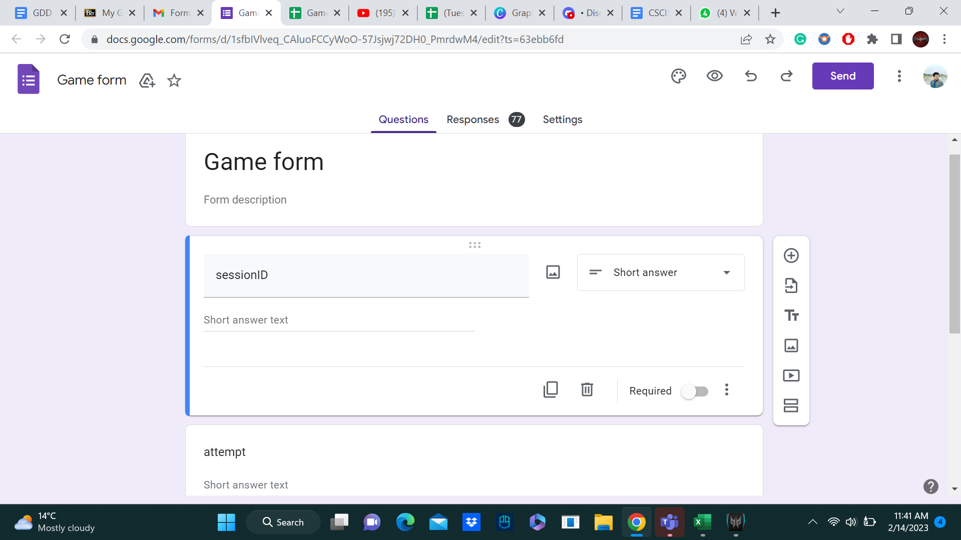

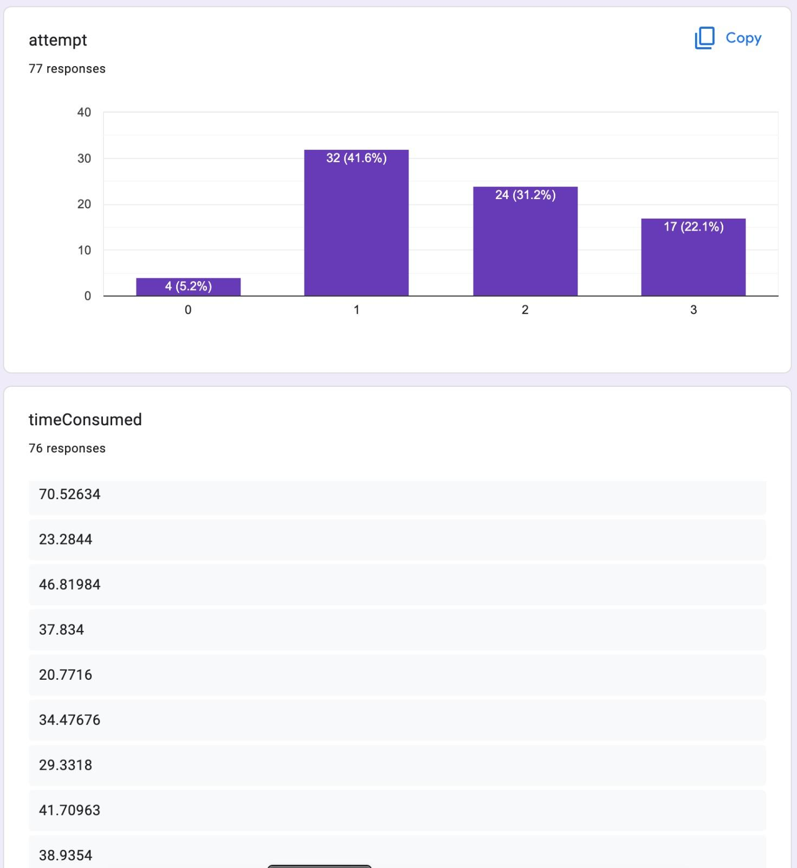

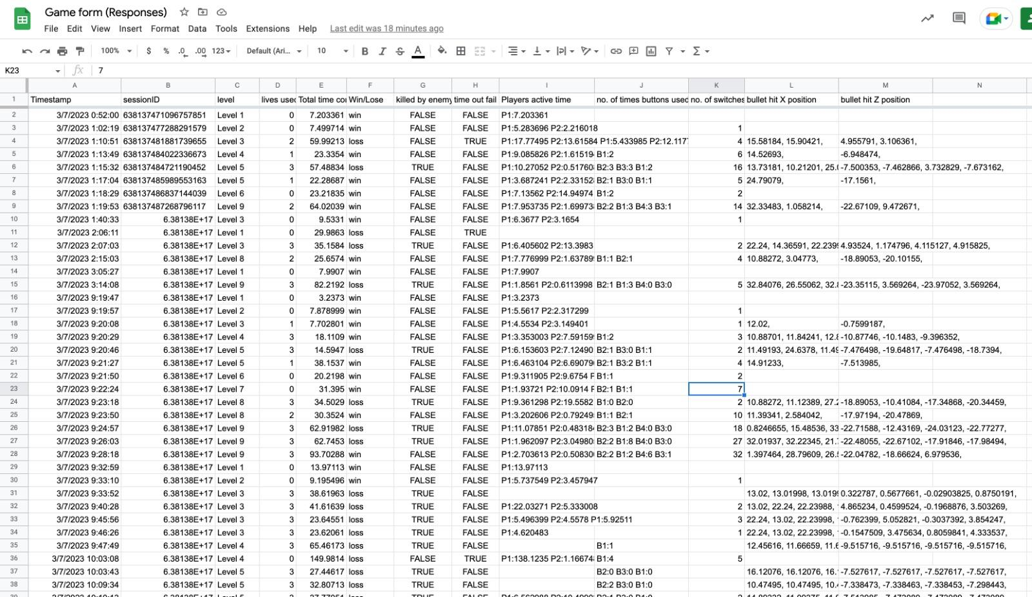

## 

## Metrics and Graphs

**Metric #1: Total Number of players starting the level, failing, and successfully completing**

*Description:*

This metric records the overall traffic playing the game. Some players will win the game, some will lose, and some may quit the game.

*How the metric will help improve the game:*

This metric is used to understand %win, %lose, and %quit. Also, these analytics are combined with other metrics to draw more specific conclusions.

Number of quits is calculated as: Total number of players - (number of players won + number of lost)

*Hypothesis:*

* If % win is greater: which means most of the players have figured out how to play the game and came up with the winning strategy. In this cases we check analytics #2 and #3 to figure out if the lives and time given are more than sufficient.
* If % loss is greater: This means the player is not able to figure out the strategy and how to play a game in the given attempts and time. To find out the cause of death we have to look into analytics #3 and make changes into the game accordingly. Also, percentage loss can be decreased by increasing the number of lives or time given to players. This is explained in detail in analytics #2 and #3 respectively.
* %quits: if % quits are greater can lead to question whether the player is sufficiently directed throughout the experience, and whether the player leaves the game because they are having trouble following along. With this information, we can expand the lesson or provide the player with more guidance on how to play.

Initial Sketches: (Image)

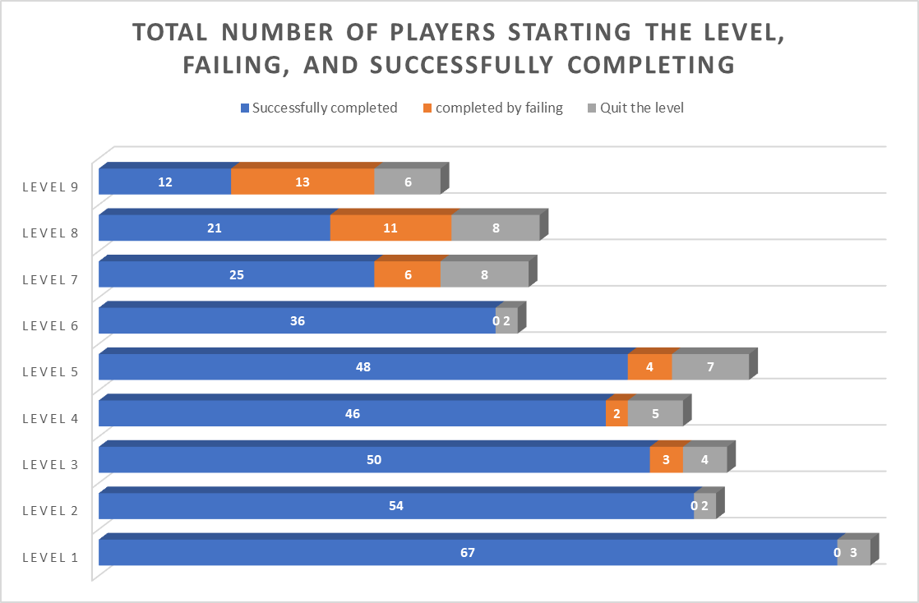

**Metric #2: Number of lives used**

*Description:*

It is difficult to win the harder levels on the first attempt. This will result in a massive failure in metric #1. So, we have added three lives to each level to give players more chances to try the levels. This metric records the valid number of attempts used to play the level. Invalid attempts are found using the active time of player #4. If no player was active in the gameplay, the player failed without giving the level a try.

*How the metric will help improve the game:*

This metric will help us find out the minimum number of lives to give to the players so that they have high chances of winning. This metric will also make sure that we are not giving excessive lives to players so that they lose interest in the game. On the other hand, the attempts are not so low that players are not able to win the game. This metric will help us maintain the balance between %win and %lose in #1.

*Hypothesis:*

* % win is greater in #1 and the average number of lives used is less than three: In this case we have given more lives than required to the player. In such cases we will decrease the number of lives for that particular level.
* % win is greater in #1 and the average number of lives used is three: Sufficient lives are provided, no changes needed.
* % lose is greater in #1: In this case we would look into the cause of death #3 and try to make changes accordingly. However, even after those changes a player is not able to win a particular level means that level is harder. Finally, in this situation the number of lives given are not sufficient and we need to give more chances to the player to try that level.

Initial Sketches: (Image)

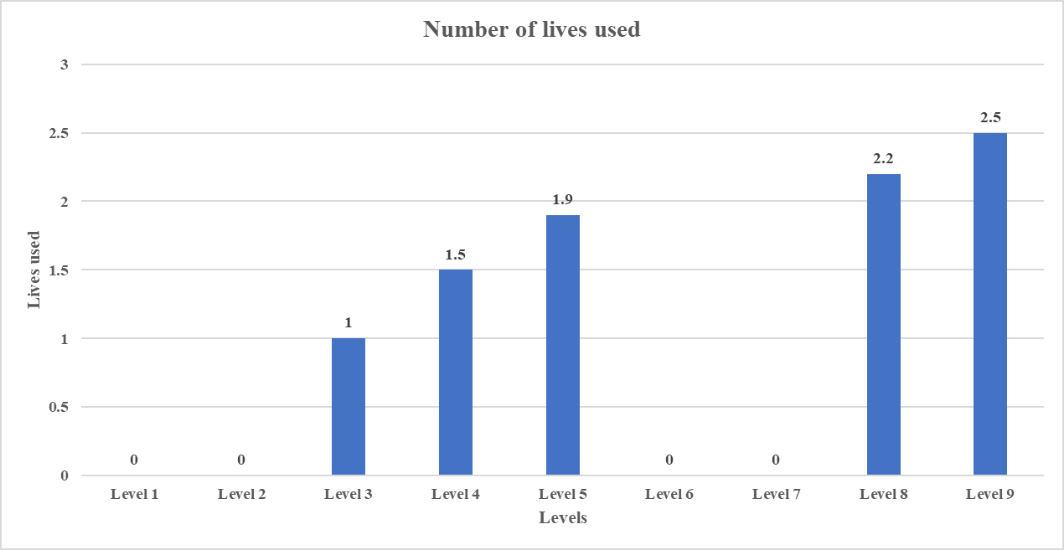

**Metric #3: % Death caused by bullets/timeouts**

*Description:*

The player's death is caused by either being hit by the bullet or running out of time. Every death will cause the player to lose one life. If the player uses all their lives, it fails. This metric shows the number of deaths caused by bullets and the number of deaths caused by running out of time from overall failures in #1.

*How the metric will help improve the game:*

If the percentage loss is greater for a particular level, this metric helps us find the cause and make the right decisions to increase the probability of winning.

*Hypothesis:*

* %win is greater in #1: In this case we will ignore this metric as the players are able to find out the winning strategy in the given finite time and also manage to avoid getting hit by the bullets. In In this scenario both bullets and finite time add perfect risk factors to keep the game interesting and challenging.
* %Death by bullets is massive: This means players are not able to avoid the bullets and lose their lives. In this case we look into #5 to get more inputs on the position of death and will make the changes in the bullet mechanics accordingly.
* %Death by timeouts is massive: This means the time given is not sufficient and we have to study metric #4 to make the changes in the given time.

Initial Sketches: (Image)

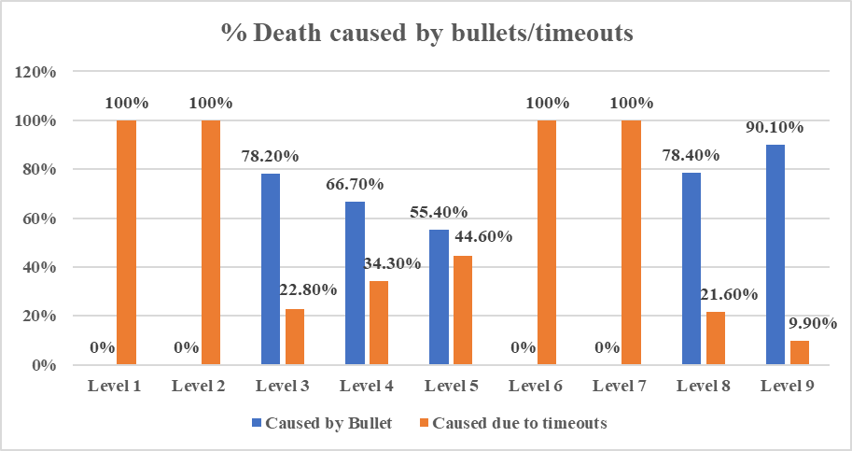

**Metric #4: Time required to win the level with active time of each player**

*Description:*

A finite amount of time is given to the player to play every level. This metric gives us information about the average time used to win the level. The average time used also keeps track of the active time of each player in multiplayer levels. Here, inactive time is calculated as (total time - active time of players). Inactive time shows the time taken to think of the strategy.

*How the metric will help improve the game:*

This is a strategic game. Coming up with the right strategy to win the game in the minimum amount of time makes this game more challenging and enjoyable. If the player doesn’t come up with the strategy and reach the final line in the given time, he/she loses one life. This encourages players to use their brains at their optimal level to win the level in a finite amount of time. This metric will avoid the possibility of the player playing the levels for an infinite amount of time and losing interest.

*Hypothesis:*

* %win is greater in #1 and average time used is less than time given: This case shows we are given more the required time and given time should be decreased to average time used.
* %win is greater in #1 and average time used is almost equal to time given: This case shows that the given time is sufficient. No need for changes.
* %Death by timeouts is massive in #3: This case tells us that the given time is not sufficient to win the level. We need to increase the time given to decrease the %lose in #1. Here we also check the inactive time players. If it is very large it means the player is taking so much time in thinking.
* If Inactive time of players is almost equal to average time taken: This means the player didn’t try playing the game. These cases will add garbage values and can corrupt the data. Such cases are declared as invalid attempts and ignored.

Initial Sketches: (Image)

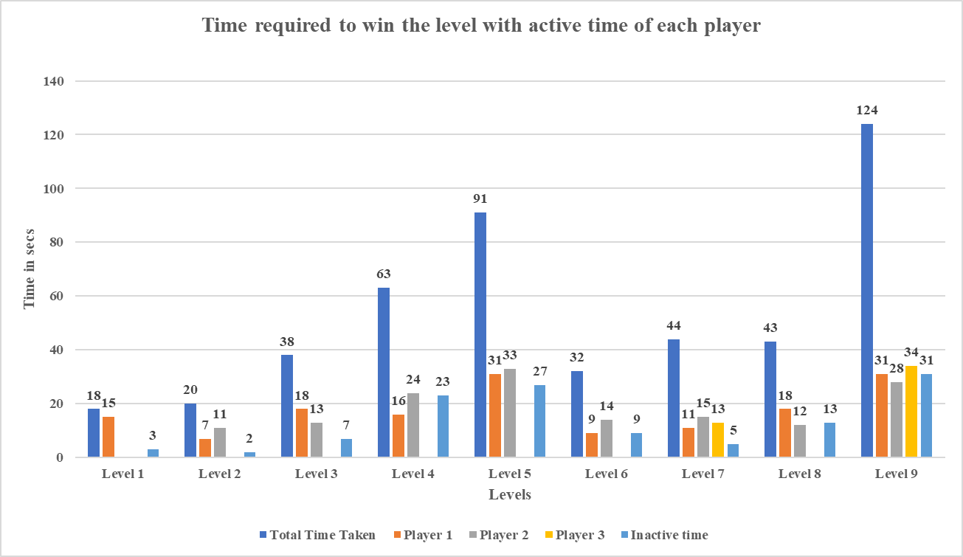

**Metric #5: Player death location superimposed over game board**

*Description:*

This metric gives us the coordinates of the point where the player is dying by getting hit by the bullets. These coordinates are tracked on the game board to find out the exact location. This metric is only tracked in failure scenarios where death happens by colliding with the bullet.

*How the metric will help improve the game:*

If the player is dying mostly at the same place, it indicates that it is difficult for the player to avoid the enemy at that point, and we can make adjustments in placing the enemies in the level or change the frequency at which bullets are fired.

*Hypothesis:*

* If the % death by the bullets is massive in #3, then only we look into this metric.
* If there is a specific position where players are dying then we can change the position or direction of the bullet fired to avoid deaths.
* If there is not a specific position and deaths are scattered, we can make the bullet mechanism move slowly and decrease the frequency of bullets fired to avoid massive deaths.
* We are taking the coordinates( X and Z axis) of the game board from each level where bullet mechanism is added, as follows,

Level 4

Mix x, Min z = (7.03, -15.48)

Max x, Max z = (27.03, 9.23)

Level 5

Min x, Min z = (7.03, -23.53)

Max x, Max z = (27.03, 8.93)

Level 8

Min x, Min z = (-4.20, -28.56)

Max x, Max z = (36.65, 10.84)

Level 9

Min x, Min z = (-4.20, -28.36)

Max x, Max z = (36.65, 18.60)

* We receive the X and Z positions of the bullet hit spot as part of the analytics. If a player is shot at the top of the board, the Z axis will be positive, and if they are hit at the bottom, the Z axis will be negative. The X axis will typically be positive for the bullet impact position at all levels. As demonstrated in the sample scatter plots, we can easily correlate and plot the scatter plot for each level using the game board coordinates.

Initial Sketches: (Image)

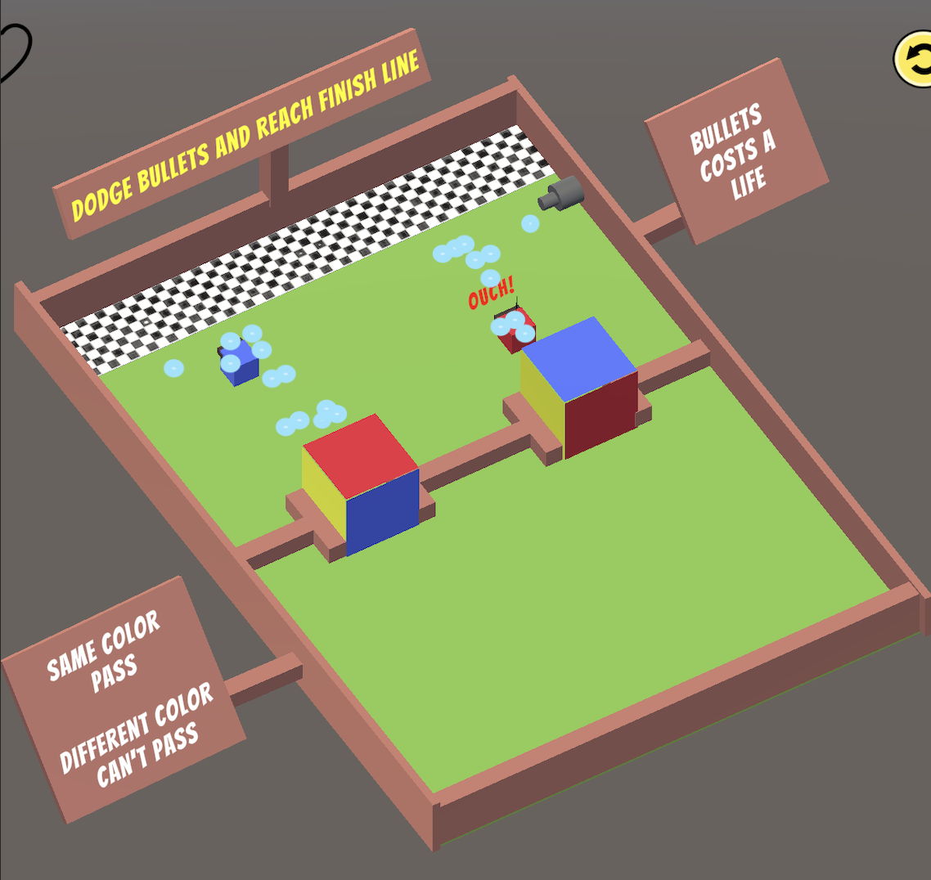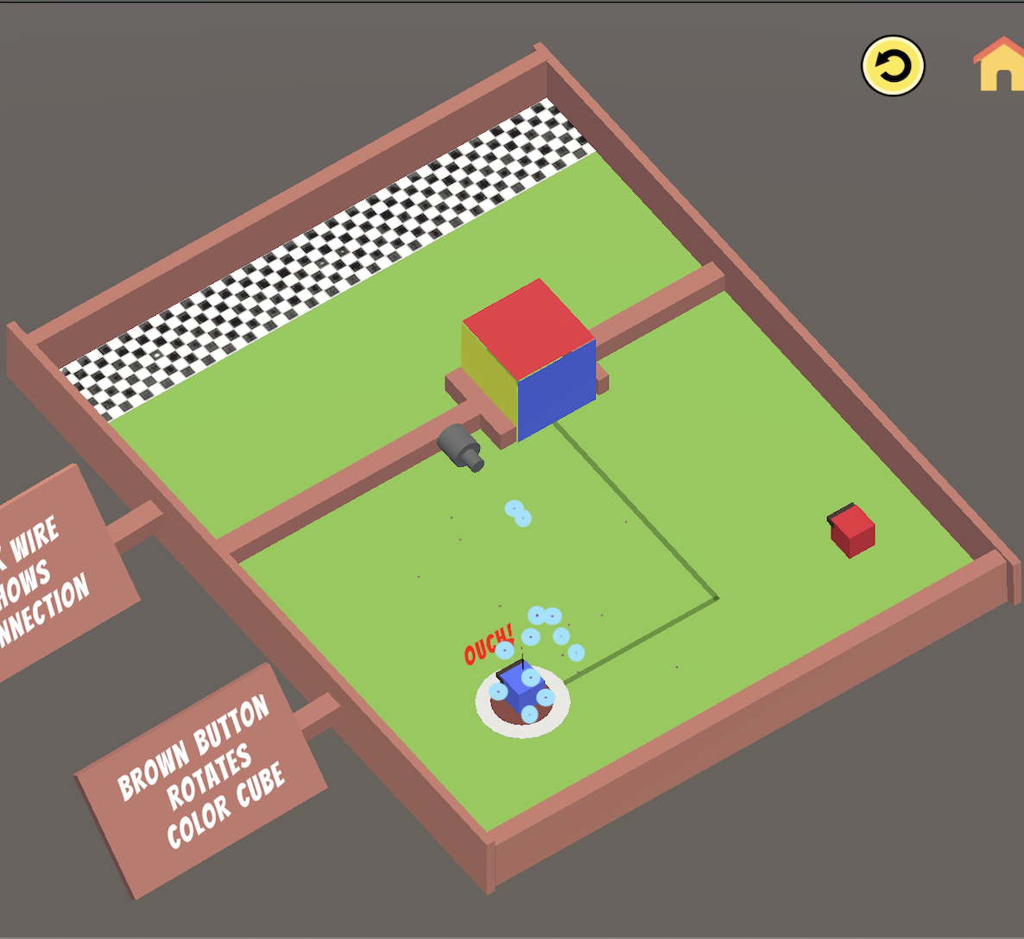

Level 3 Level 4

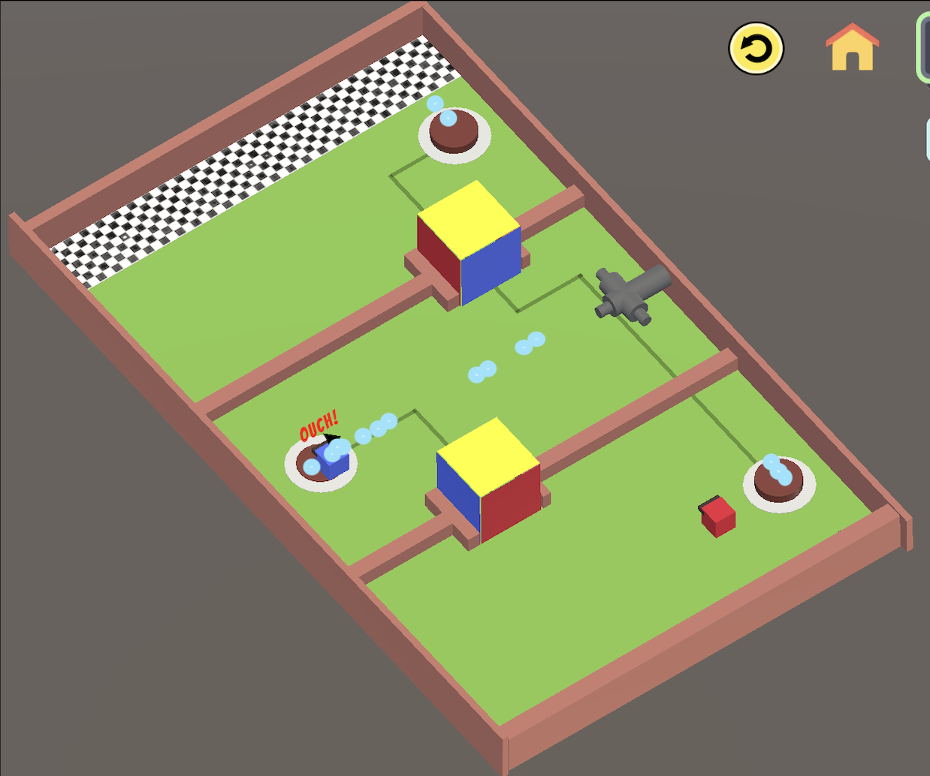 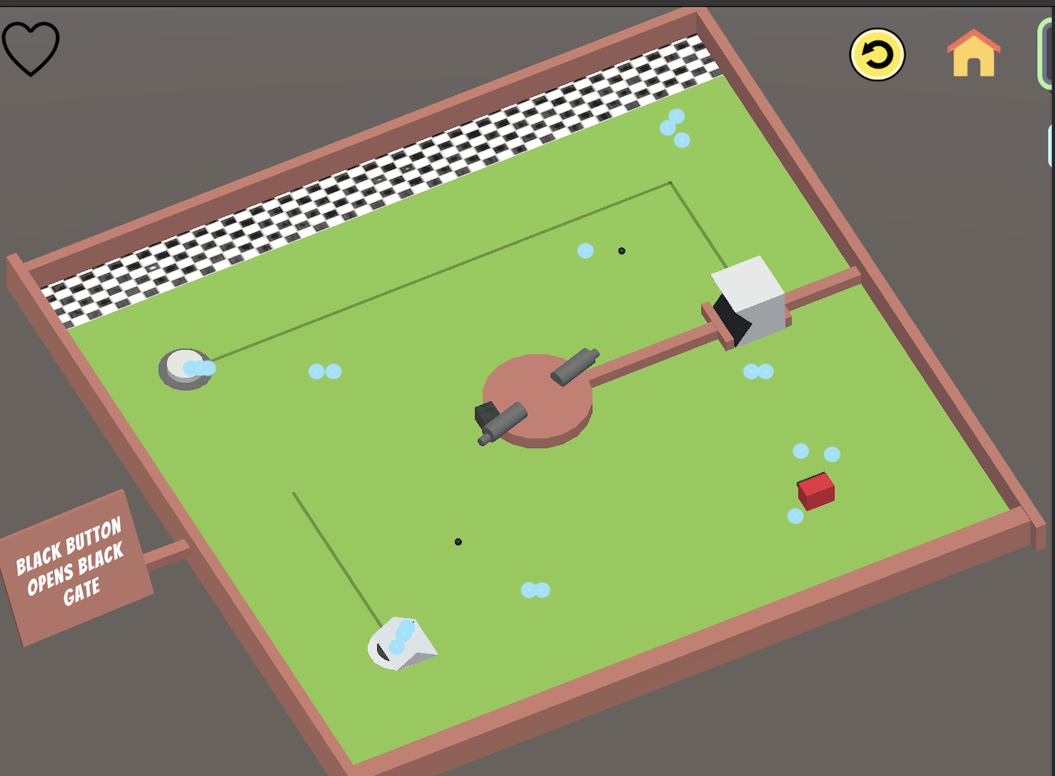

Level 5 Level 8

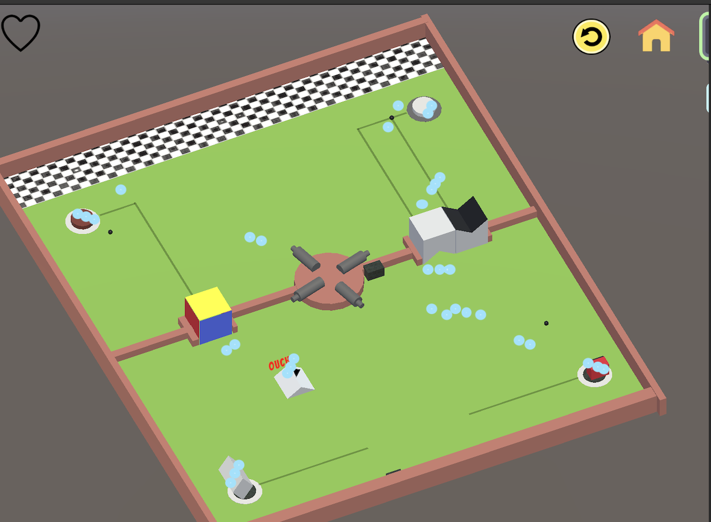

Level 9

**Metric #6: Number of times switches used**

*Description:*

Players can come up with their own unique strategy to win each level. However, every level has an optimal strategy. The optimal strategy calls for using switches a minimum number of times to win the game. This metric tracks the number of times switches are used by players to win the game. This metric is ignored in cases of failure.

*How the metric will help improve the game:*

The difference between the optimal number of times switches are used and the number of times switches are used by players shows us how difficult it is for the player to figure out the winning strategy for a particular level. By using this metric we can maintain the difficulty level of the next level harder than the previous one

*Hypothesis:*

* If this difference keeps on increasing as we move to upper levels, the level design is on the right track.
* If the difference is fluctuating it means we are not maintaining the difficulty levels as the game proceeds and need to work on the strategy designing more carefully.

Initial Sketches: (Image)

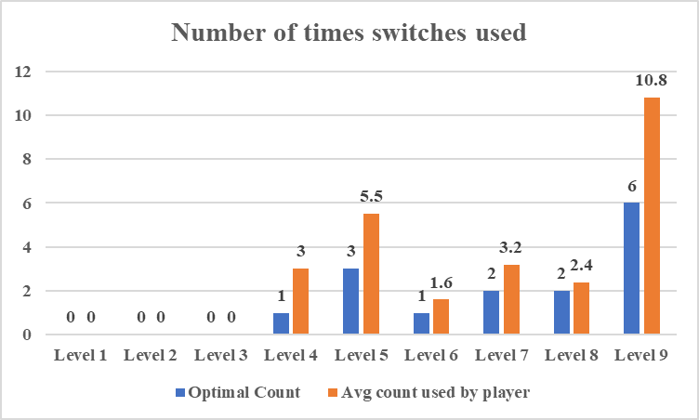

# 

# 

# 

# 

# 

## 

## Analytics - Midterm

**Metric #1: Total Number of players starting the level, failing, and successfully completing**

Description: This metric records overall traffic playing the game. Some players will win the game, some will lose, and some may quit the game. This metric records the overall traffic playing the game. Some players will win the game, some will lose, and some may quit the game.

Midterm Graphs:

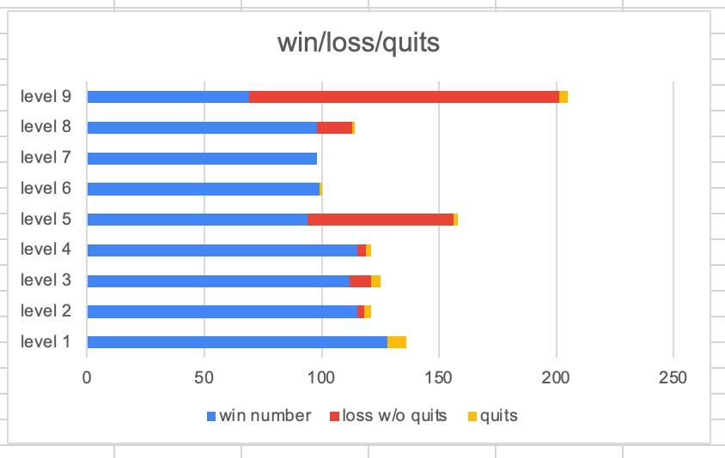

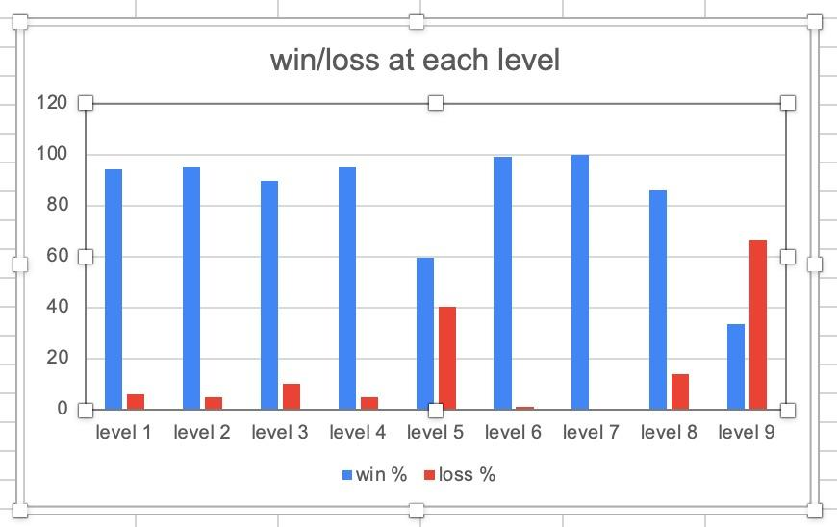

Analysis: Levels 5 and 9 have a higher losing probability than winning. People were able to figure out strategies for remaining levels within given constraints. The quit probability is significantly lower.

**Metric #2: Number of lives used**

Description: It is difficult to win the harder levels on the first attempt. This will result in a massive failure in metric #1. So, we have added three lives to each level to give players more chances to try the levels. This metric records the valid number of attempts used to play the level. Invalid attempts are found using the active time of player #4. If no player was active in the gameplay, the player failed without giving the level a try.

Midterm Graphs:

# 

Analysis: From the above graph, we can see that levels 1, 2, 6, and 7 can be completed without multiple attempts. The attempts at levels 5 and 8 are just sufficient. Players need more attempts to win level 9.

**Metric #3: % Death caused by bullets/timeouts**

Description: The death of the player is caused by either being hit by the bullet or running out of time. Every death will cause the player to lose one life. If the player uses all their lives, it fails. This metric shows the number of deaths caused by bullets and the number of deaths caused by running out of time from overall failures in #1.

Midterm Graphs:

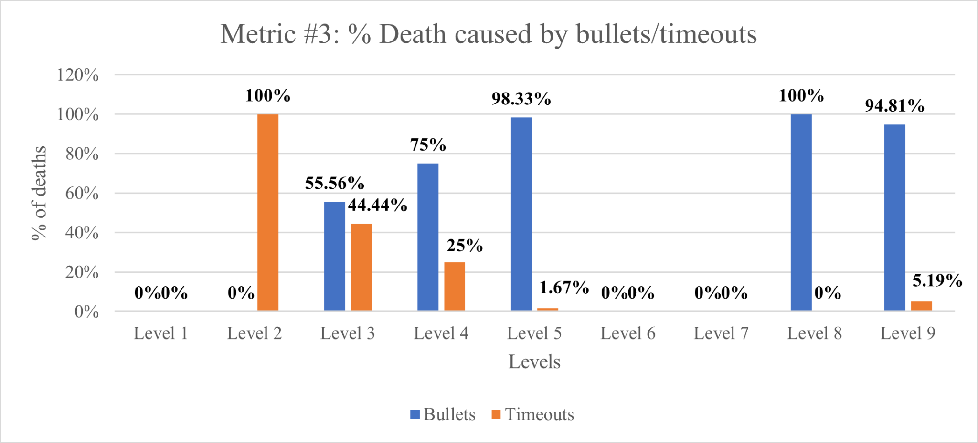

# 

Analysis: If we look at levels 5,8 and 9 for which losing probability is greater in metric #1, the sole reason for the deaths is being hit by bullets.

**Metric #4: Time required to win the level with active time of each player**

Description: A finite amount of time is given to the player to play every level. This metric gives us information about the average time used to win the level. The average time used also keeps track of the active time of each player in multiplayer levels. Here, inactive time is calculated as (total time - active time of players). Inactive time shows the time taken to think of the strategy

Midterm Graphs:

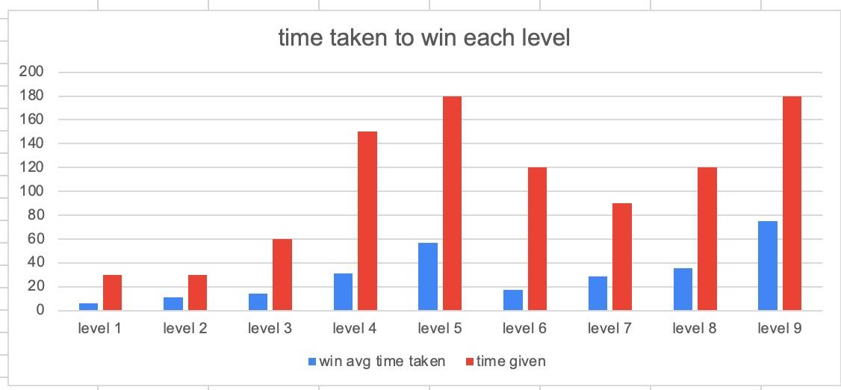

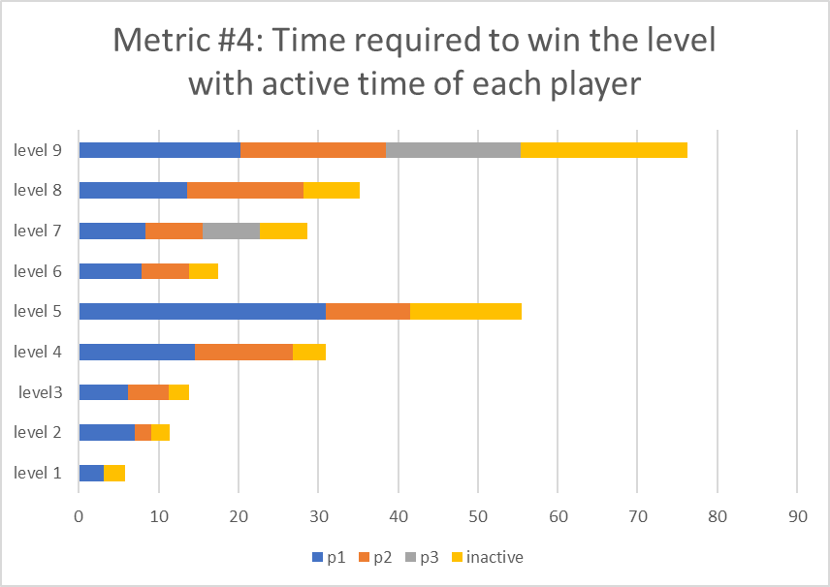

Analysis: The average time used by players is significantly less than the time given, hence, time is not acting as a risk factor. Also, inactive time for levels 9 and 5 is greater, indicating players are getting stuck trying to figure out the strategy.

**Metric #5: Player death location superimposed over game board**

Description: This metric gives us the coordinates of the point where the player is dying by getting hit by the bullets. These coordinates are tracked on the game board to find out the exact location. This metric is only tracked in failure scenarios where death happens by colliding with the bullet.

Midterm Graphs:

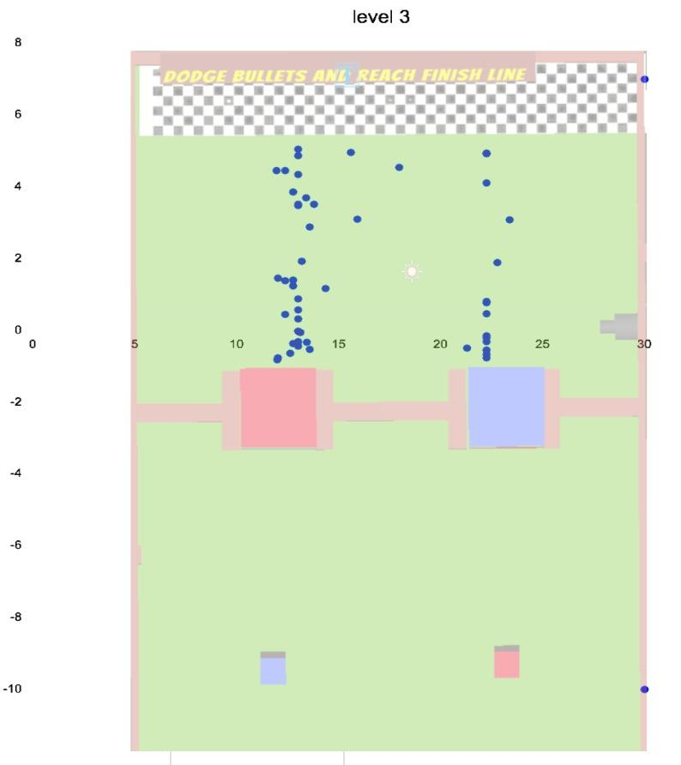

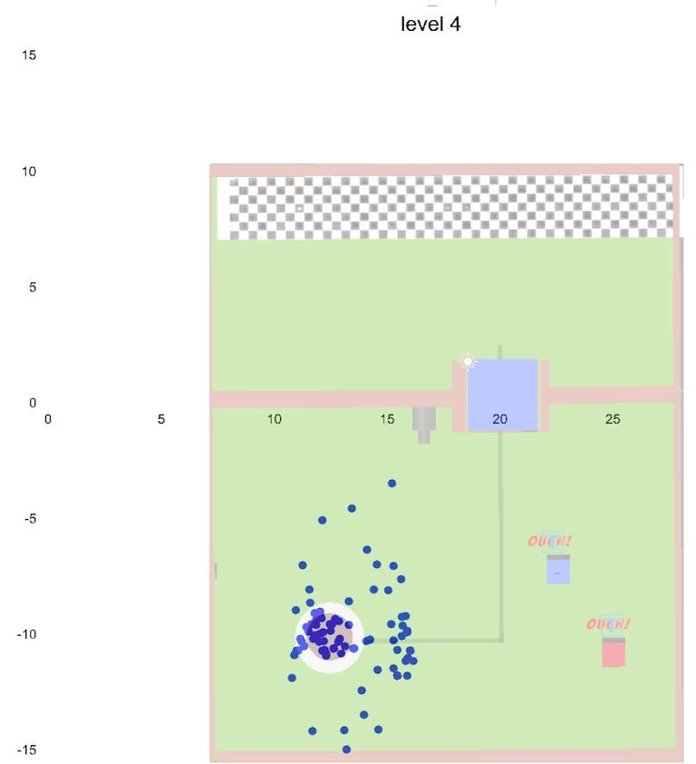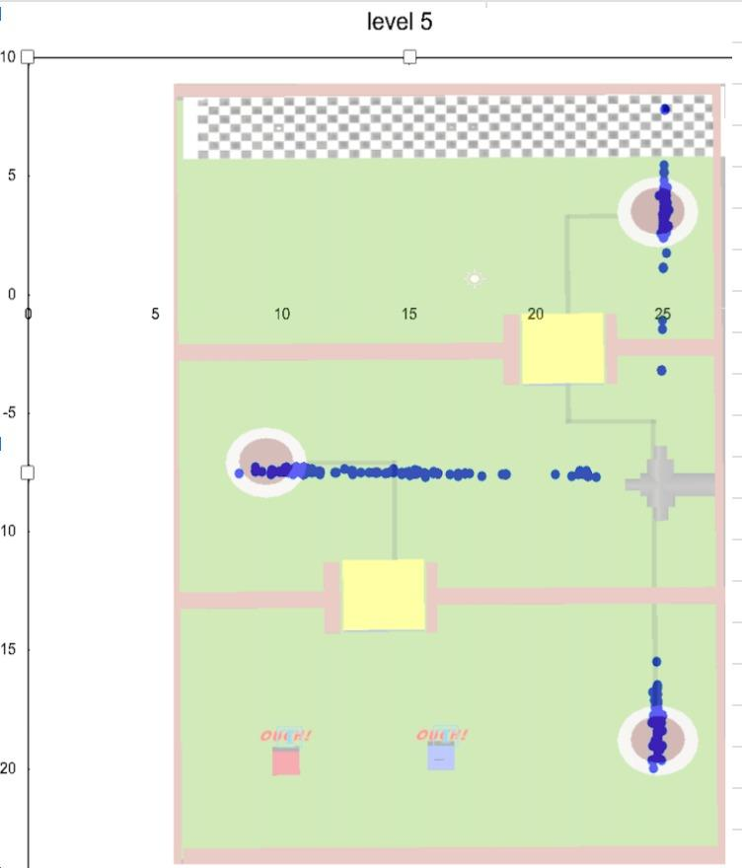

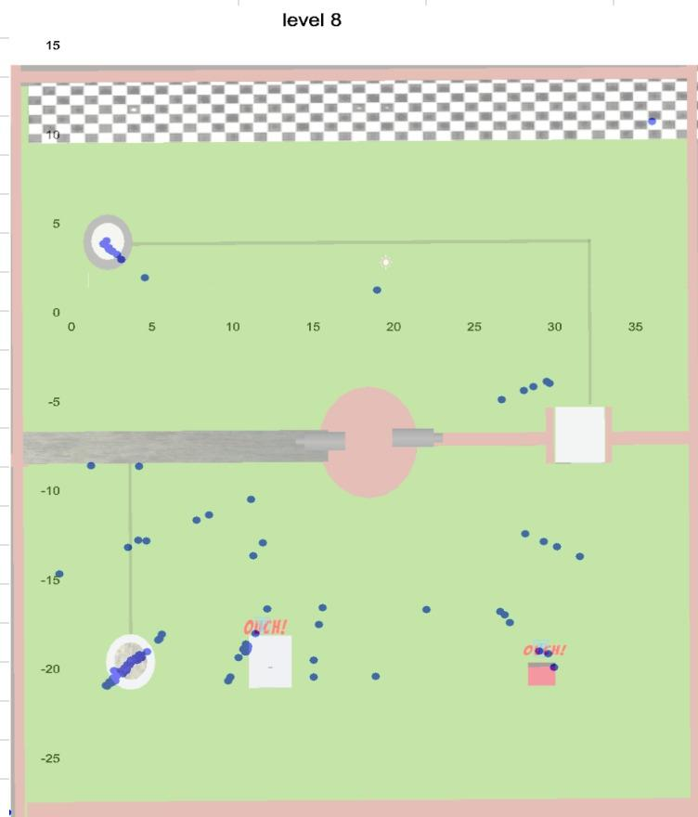 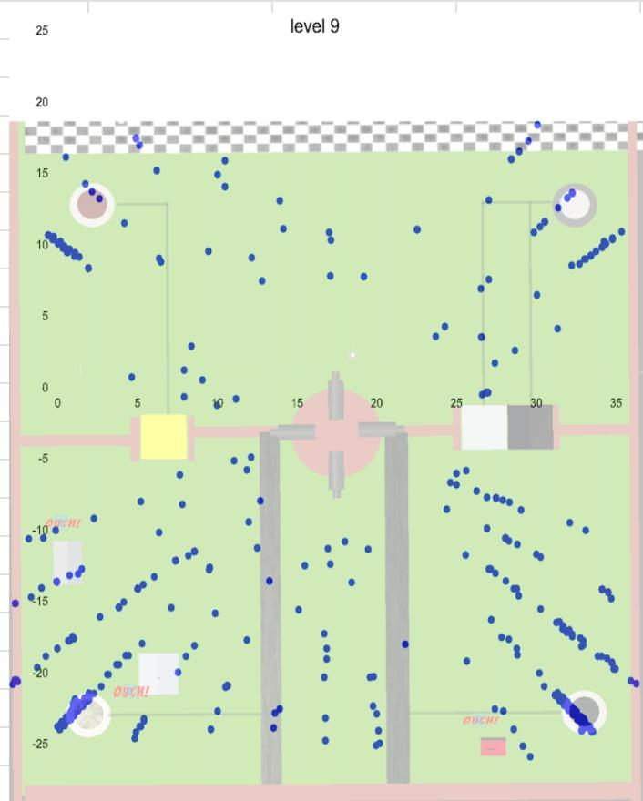

Analysis:The majority of deaths caused by bullets are happening near the switch area.

**Metric #6: Number of times buttons has been presses**

Description: Players can come up with their own unique strategy to win each level. However, every level has an optimal strategy. The optimal strategy calls for using switches a minimum number of times to win the game. This metric tracks the number of times switches are used by players to win the game. This metric is ignored in cases of failure.

Midterm Graphs:

* 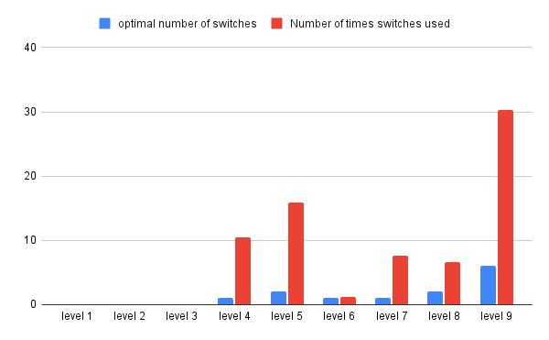

Analysis: Level 4 and 5 has maintained the difficulty level. However, level 6,7 and 8 are comparatively easier because new mechanics are introduced and the difficulty level is decreased deliberately. While level 9’s difficulty is multifold.

### Feedback Analytics

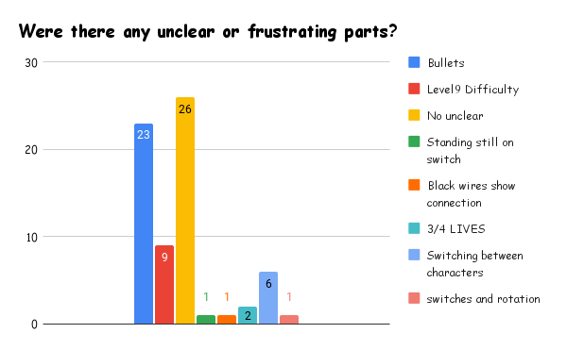

# Post Midterm Improvements

**Hypothesis 1:** **An increased frequency and speed of bullets in complex levels leads to higher user failure rates.**

***Evidence***

*User Feedback*

* The risk of bullets was mentioned in **60%** of the comments that we received in the feedback.
* Even though people liked the risk factor (as we can see in the feedback graphs above), they found the bullets' frequency annoying.
* Additionally, they found an issue with the randomly generated bullets, i.e., bullets not being generated in any particular pattern, and users could not figure out a way to avoid random bullets.

A few example comments -

1. “I wish the shot patterns from the guns were more regular, so you would always know where you could stand or not. Sometimes a seemingly safe spot would get hit.”
2. “The bullets are going too fast. The bullets are really hard to avoid when you're juggling 3 different pieces that are difficult to toggle control through. It gets really annoying to do so, to be honest”
3. “Bullets are very distracting, in level 9 it distracts and does not make us focus on the puzzle. The level 8 bullets are good because it's random and not concentrated near the switch so player can actually focus on winning the level”

*Analytics Graph*

* Let’s take the example of level 9. Following mapping the locations of the bullet hits in each stage. It is fairly obvious that the bullets are fired more often in levels 9. We can make this conclusion by using-

A. win/loss percentage graph: we can see that the percentage of losses is higher at levels 5, 8, and 9 compared to levels 1–4 and 6–7 because of the frequency.

B. According to this graph, the losses that occurred below were brought on by bullets. It also shows the proportion of deaths caused by bullets versus timeouts. This clearly proves that the frequency of the bullets is higher, which makes it difficult to clear the level.



***Solution*:**

* Reduce the number of turrets, and **bullets should be fired less often. Change how the turrets are firing** the bullets. Instead of firing bullets in one direction, we can make them fire by using dynamic turrets.
* We should **have a pattern for how the bullets are generated** because they are now generated at regular intervals. This makes things simpler and makes it easier for the player to develop a bullet-avoiding strategy.

***Status:*** COMPLETED

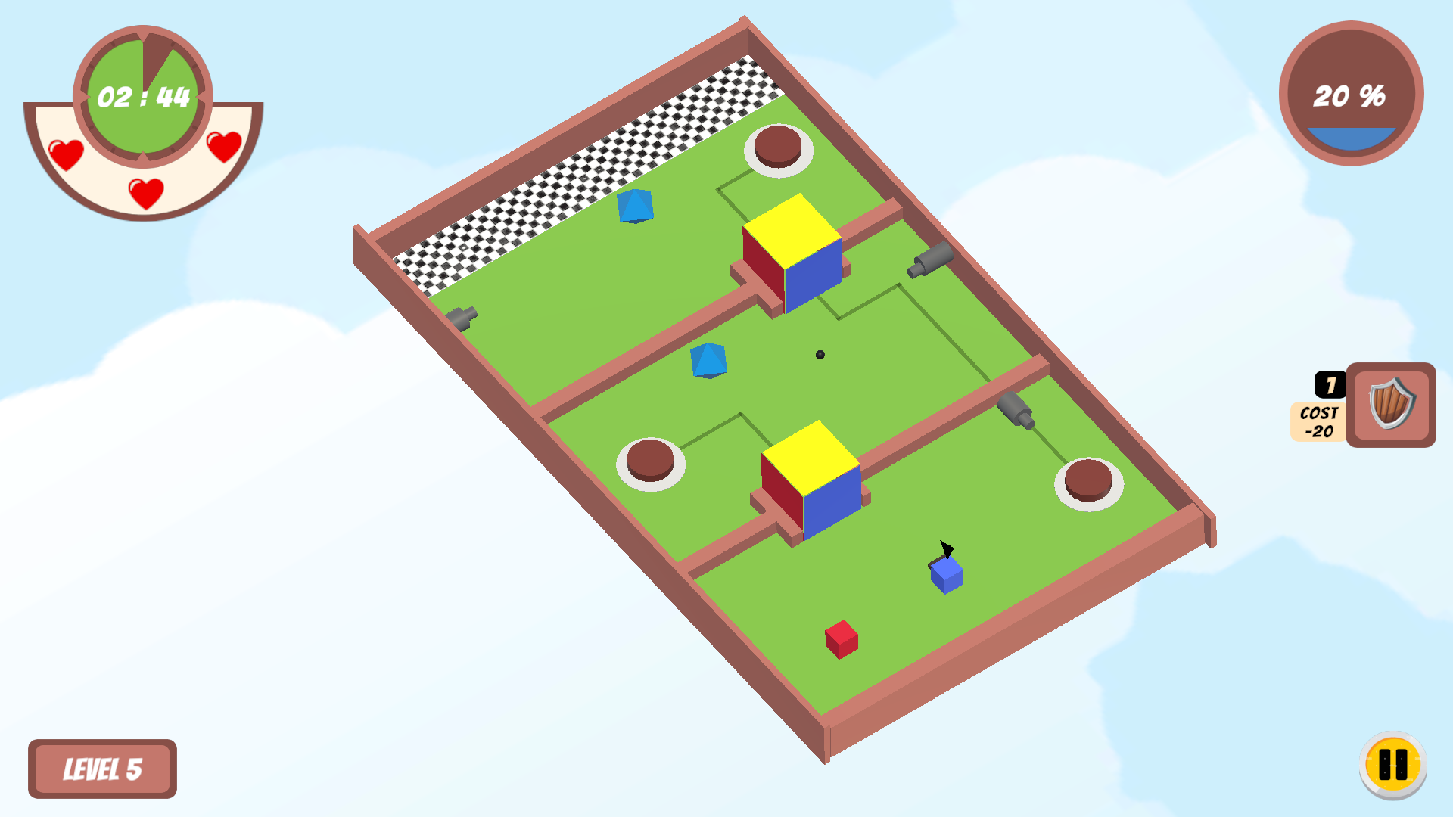

Reduced the Turrets/Enemies firing rates.

**Hypothesis 2: Users die more frequently because it is harder for them to effectively use switches due to the game's concentration of bullets aimed at them.**

***Evidence***

*User Feedback:*

* According to midterm feedback, **33%** of players found the game's **inability to kill or dodge gunshots** to be the most frustrating aspect.

A few example comments:

1. “The damaging system is hard to avoid losing if one block is on a button.”
2. “When I had to touch the switch in order to pass the level, I would always be shot by the bullets.”
3. “More ways to get around enemy bullets (block enemy bullets, kill enemies, etc.) or remove enemies and make the puzzle aspect harder.”

*Analytic Graph:*

The win-loss graph below gives us the idea that the losses at more difficult levels like 5 and 9 are greater than those at easier levels. Even after conducting an examination of the midterm data, it is clear that not being able to defeat the enemy is the main reason why players struggle at challenging levels. The mapping of bullet hits clearly shows that more deaths are concentrated at the button areas, and midterm feedback suggests that it will be good to implement a way to defeat the enemy. With this proof, we can develop a gaming mechanic that allows players to either kill or go immune to enemies for a short period of time.





***Solution:***

* The player should be given a powerup that will make them immune to bullets or shield them from bullets for a brief period of time if they choose to use it, but doing so will require them to spend extra time navigating to the powerup location and returning to the obstacle. This gives the player more options to consider and aids in the development of a more effective strategy.
* mechanism to kill the enemy, by giving resources to the character
* Introduce a new mechanism like a **shield, which protects the player from bullets.** Also players can collect the bullet using shield and use it to break walls or gates to win the level.

Status: COMPLETED

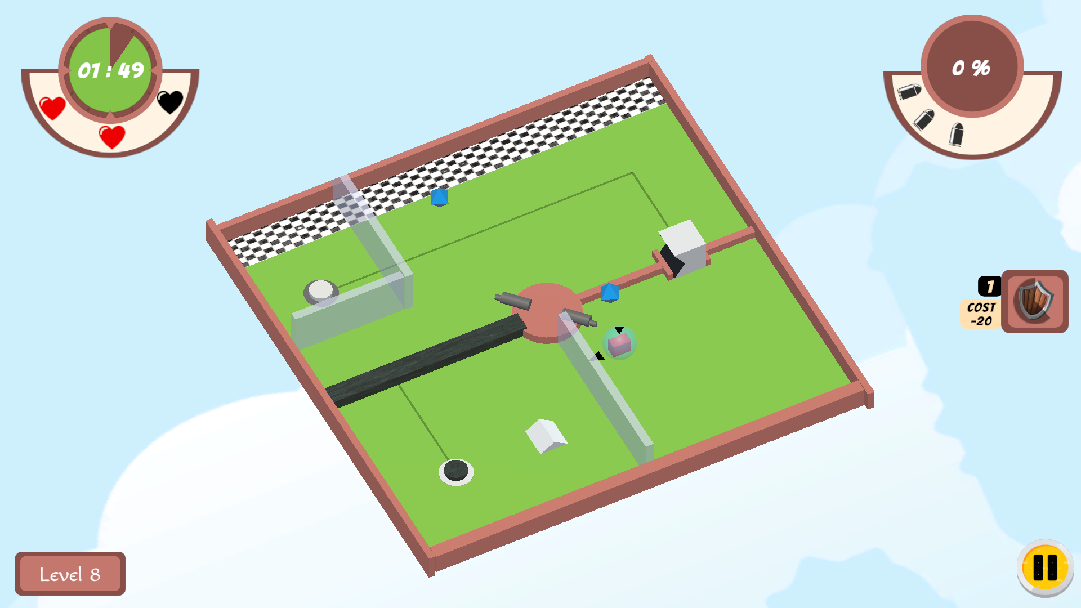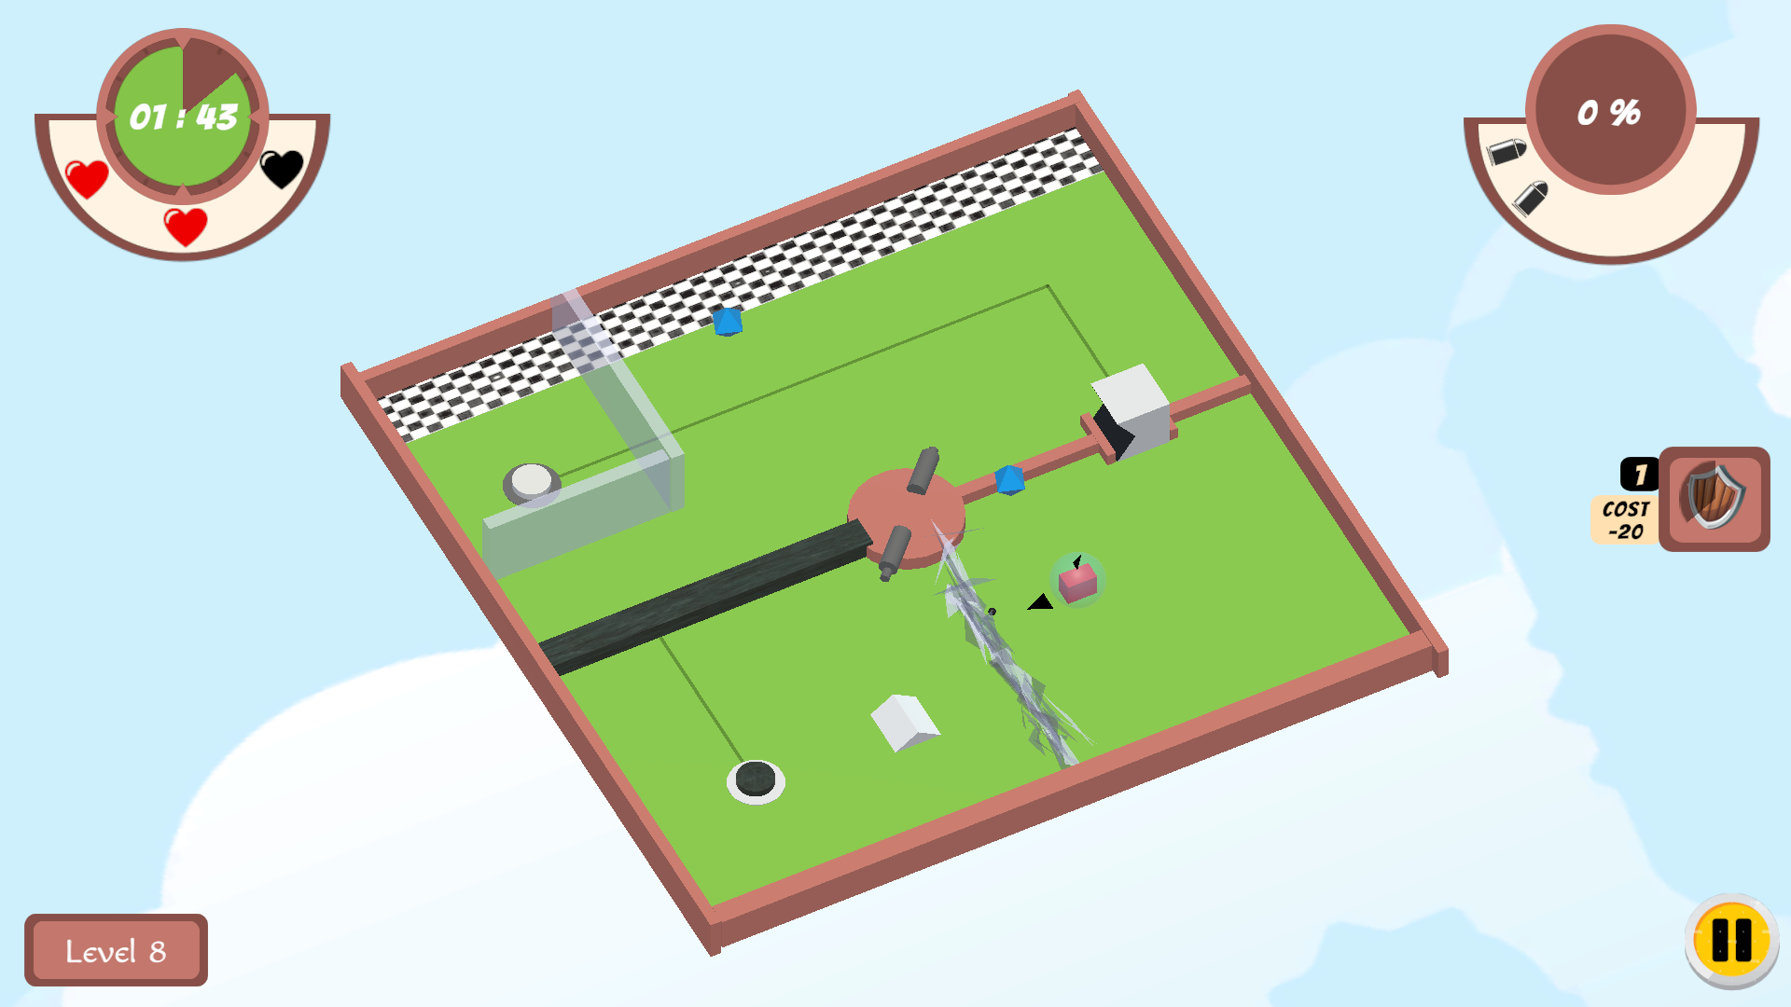

**Hypothesis 3: The representation and notification of the lives lost in the game need to be improved.**

***Evidence:***

*User Feedback:*

* In the feedback under "Unclear/ Confusing aspects"  **3%** claimed that they couldn't figure out that they were losing lives until they lost the game. **It is not obvious that they are losing lives.**
* Even 3-4 people expressed displeasure with the **concept of losing one whole heart for a bullet** to the body.

Few example comments:

1. “Level 9 was too difficult couldn't figure out much, I was able to play a few times even after losing all 3 lives”
2. “I did not figure out that I was losing lives until I reached level 9, you guys can make it more visible that lives were getting deducted”
3. “It is too punishing to lose a whole life for one bullet, while there is only 3 lives to spare”

*Analytics Graph:*

* Since Levels 1,2,3 and 6 are tutorial levels, there is no possibility for the player to lose a life and hence, the average lives lost resulted in 0.
* However, In Level 9, the player almost loses all 3 lives in a level on average. Which indicates that more lives should be given to more difficult levels and hardly one or 2 lives for easy levels.

# 

***Solution:***

* Depending on the level of difficulty and the typical number of lives lost at each level, we will use a varied number of lives or hearts. The game would become more fascinating and difficult as a result.
* Remove lives/hearts in the tutorial level, so that the player gets enough health and time to understand the game and read through all instructions.
* Display ‘-1’ whenever the player dies and add an UI effect, so that it is obvious for the player that they lost life.
* Introduce ‘mana’ magic power, which can be used to get shields and swap power.
* Replace hearts with a health bar and reduce a certain amount of health when a player loses a life.

Status: COMPLETED

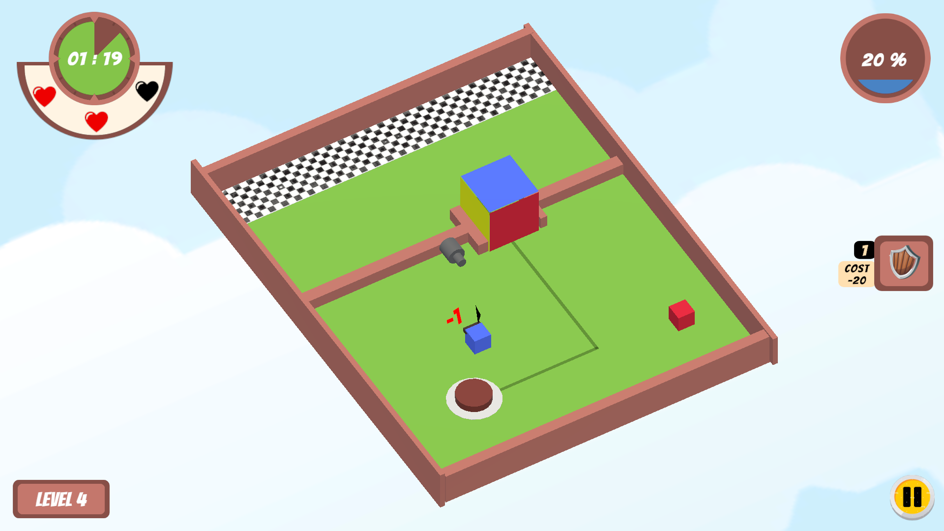

**Hypothesis 4: The time limit provided for each level is not effectively challenging the players and can be extended to add more risk and excitement to the game.**

***Evidence:***

*User Feedback:*

* In the feedback under "Unclear/ Confusing aspects" **6% e**xpressed that they were **confused about the time given for each level**. **It gave them a false sense of difficulty**. Even for the easy game the time given confuses the player, and they hurry for nothing,g and at the same time makes them wonder if there is more to the level.

Few example comments:

1. “The time given is more than the required time in few levels, this gives false sense of difficulty in the level”

*Analytics Graph:*

* From the below graphs, it is observed that the average time used to complete the levels is much lesser than the time given. Also, the lost percentage due to timeouts is extremely low when compared to the lost percentage due to bullets 

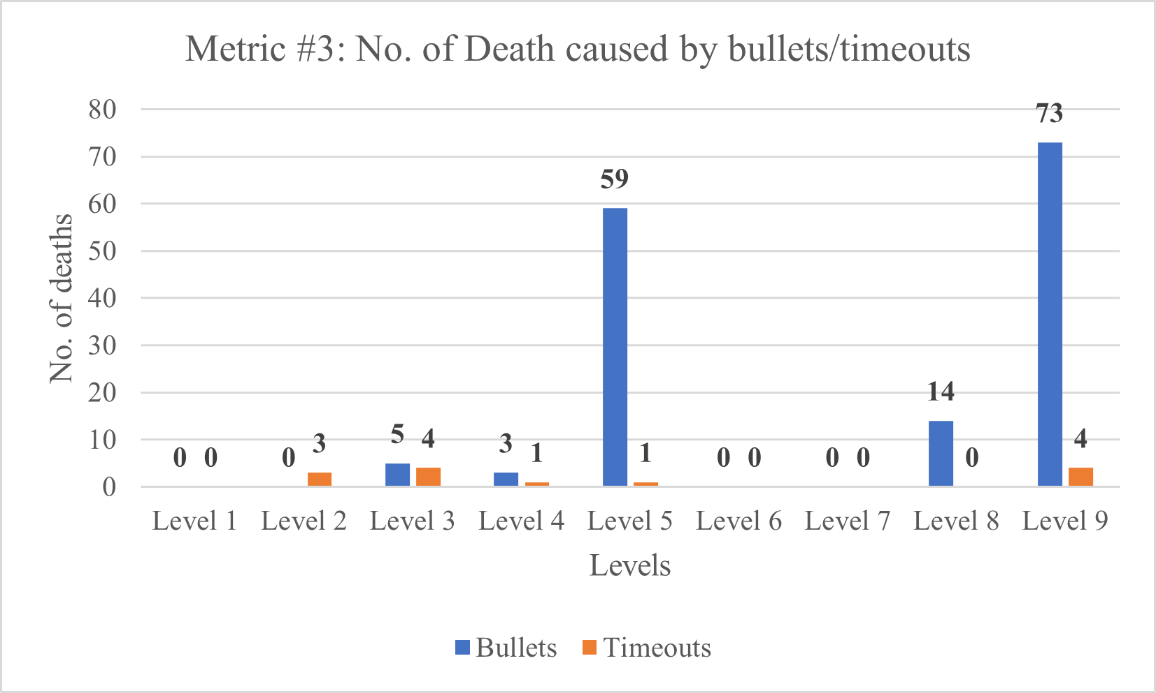

Solution:

* Decrease the time given for the levels where winning rates are greater, such as levels 3, 4, 7, and 8, and give more time to the difficult levels.
* By introducing powerups, we are making users spend more time at each level and explore the game more.
* We can lock the gates when the level starts. Only when the player collects a certain amount of power will the gates be unlocked, and the player will be able to pass through the gates.
* Collecting a certain number of powerups gives the player a chance to increase the mana power, which makes the **player spend some time collecting the powerups** and exploring the game board a little more.
* Build different game boards.

Status: COMPLETED

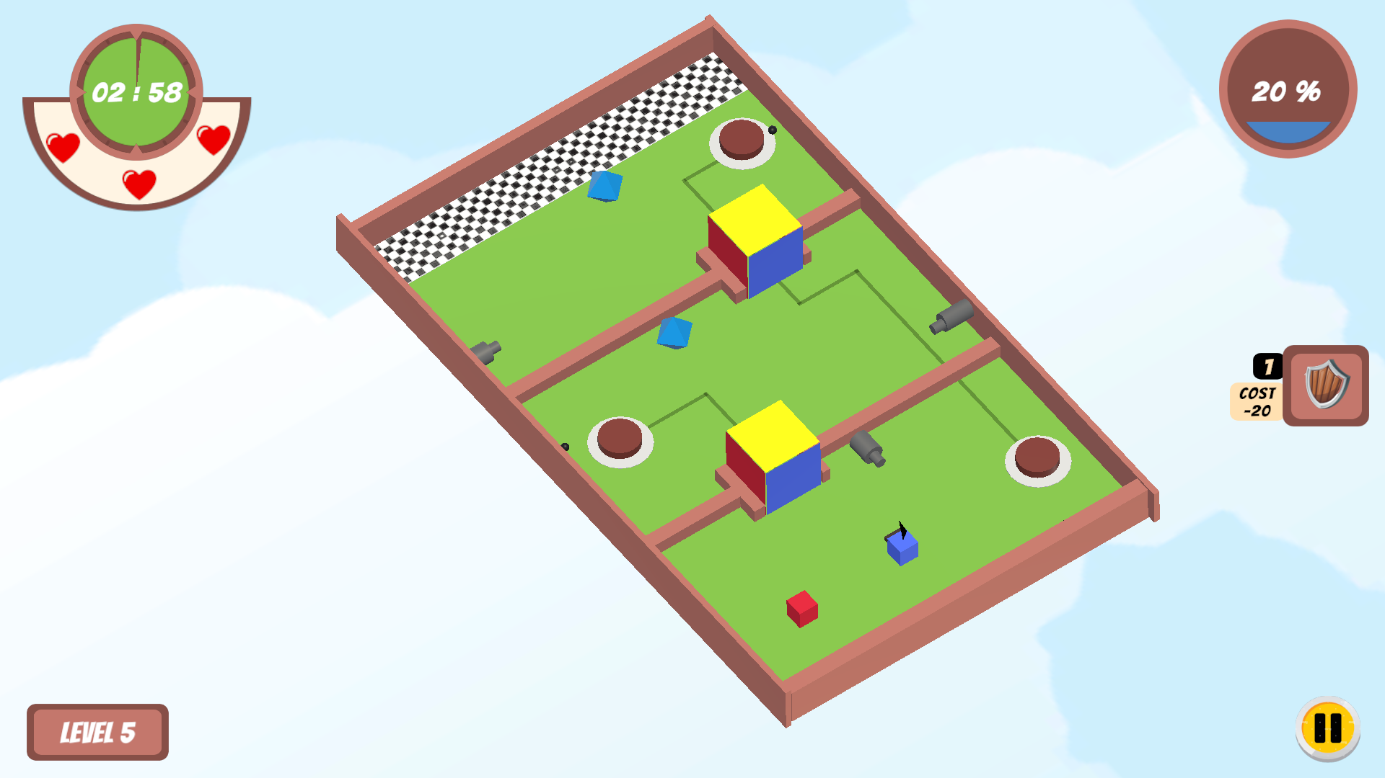

**Hypothesis 5: Incorporating more gradual difficulty levels before level 9 will improve player performance and success rates.**

***Evidence***

*User Feedback:*

* Out of 150 midterm feedback, around **50%** mentioned in their feedback how **difficult and even impossible it was to complete level 9**.
* They also noted that **despite its difficulty, it is really satisfying to complete level 9**.

Few example comments:

1. “Level 9 was too difficult couldn't figure out much, I was able to play a few times even after losing all 3 lives”
2. “Please complete level 9 if you can”
3. “My favorite moment was the last level where the two ideas: colored blocks and shaped pegs were combined.”
4. “I also liked the design idea of level 9, which makes the player think hard with all the mechanics complementing it. Such challenging game levels in the future will make the game more exciting. ”

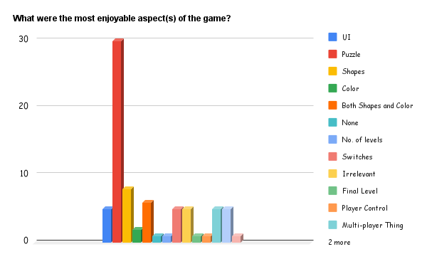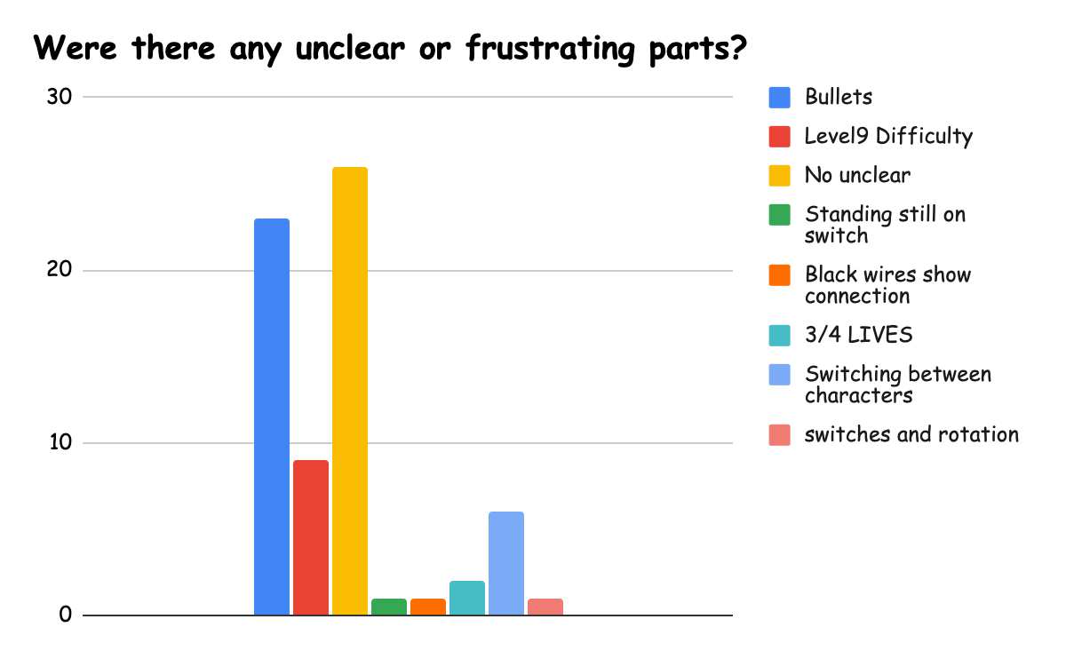

*Analytics Graph:*

* Even from the graphs, we can infer that level 9 of the game saw the most losses out of all the levels. The rate of losses is really high. At level 9, more than half of those who attempted the level failed.
* However, compared to all the levels, level 9 is played the most. This gives us an idea that even though it is difficult people liked to play it more. . 



***Solution:***

* Level 9 is highly challenging, but at the same time it is more entertaining and provides greater satisfaction, according to the feedback and analyses. Therefore, we have chosen to **preserve the level 9 game design but we are going to make it a higher level.** In other words, we'll increase the present level range from level 9 to level 13 or higher and add simpler levels in between.

Status: COMPLETED

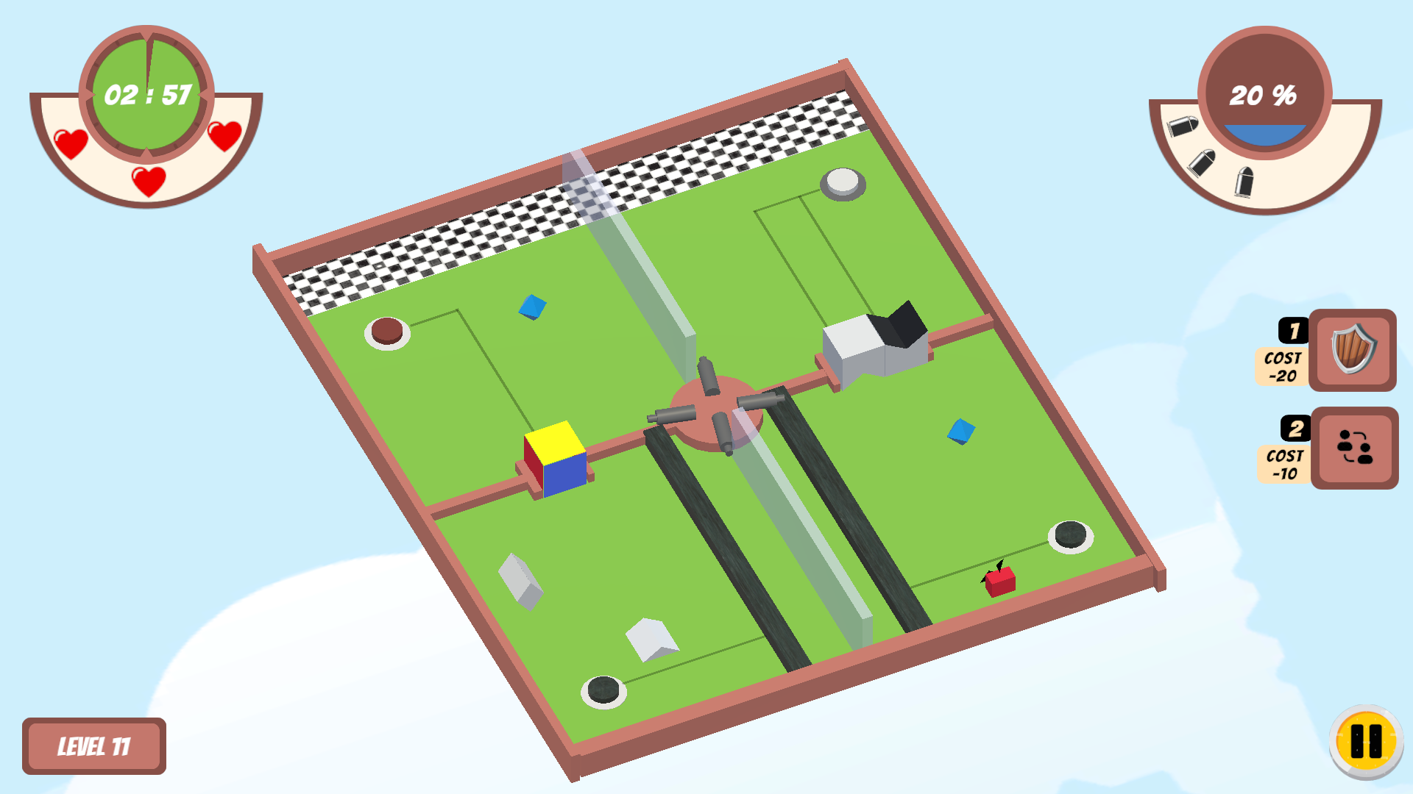

Level 9 has been moved to Level 11 by including more gradual levels in between and introducing new mechanics

**Hypothesis 6: Introducing new game mechanics and multiple solutions to puzzles in future levels will enhance the game's engagement and improve user satisfaction.**

***Evidence:***

*User Feedback:*

* Upon a thorough analysis of the feedback, it was found that when asked about potential improvements to the current game, approximately 22% of the respondents suggested the inclusion of new game mechanics, shape gates/obstacles, or puzzles to enhance the game's appeal and increase its level of difficulty.

Few example comments:

1. “I would like to see new puzzles and mechanics to the game.”
2. “I think the game needs more ways to play. After I know the solution, there is not much variation in gameplay”

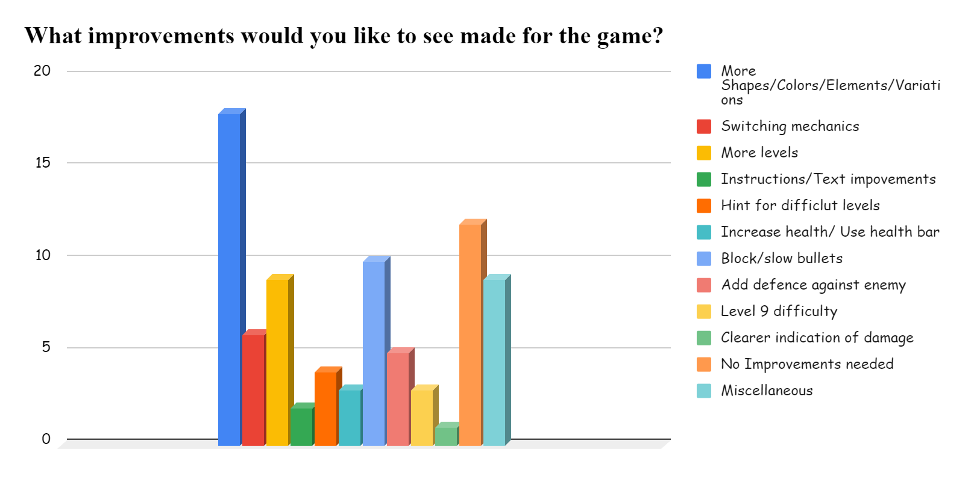

*Analytics Graph:*

* From the analytics graph the level 5 and level 9 puzzle is very tricky, since there is only one way to solve the puzzle: users are finding it hard to figure out a strategy and win. Hence loss rates are high
* Since the mechanics are limited, from level 6-8 the loss rate gradually decreases and quits rates are increasing.



***Solution:***

* Our current game follows this pattern: Levels 1-5 correspond to color blocks and rotating color cubes. Levels 6-9 introduce shapes with the same mechanics as previous levels. introduction of a new mechanism at level 10. Creating multiple paths to reach the finish line by extending or changing the board configuration from level 10
* Add new mechanics like powerups/coins for each level, and by collecting a certain number of coins, the player gains the ability to shield from bullets and teleport to the next stage of the game.
* To increase the scope of the game, we are introducing a gravity component.
* To reuse bullets collected from the shield, we use the bullets collected to destroy glass obstacles and reach the finish line.
* Introducing a swapping mechanism between players. With this, characters in the game can swap and reach the finish line with the help of swapping. This makes the game more interesting.

Status: COMPLETED



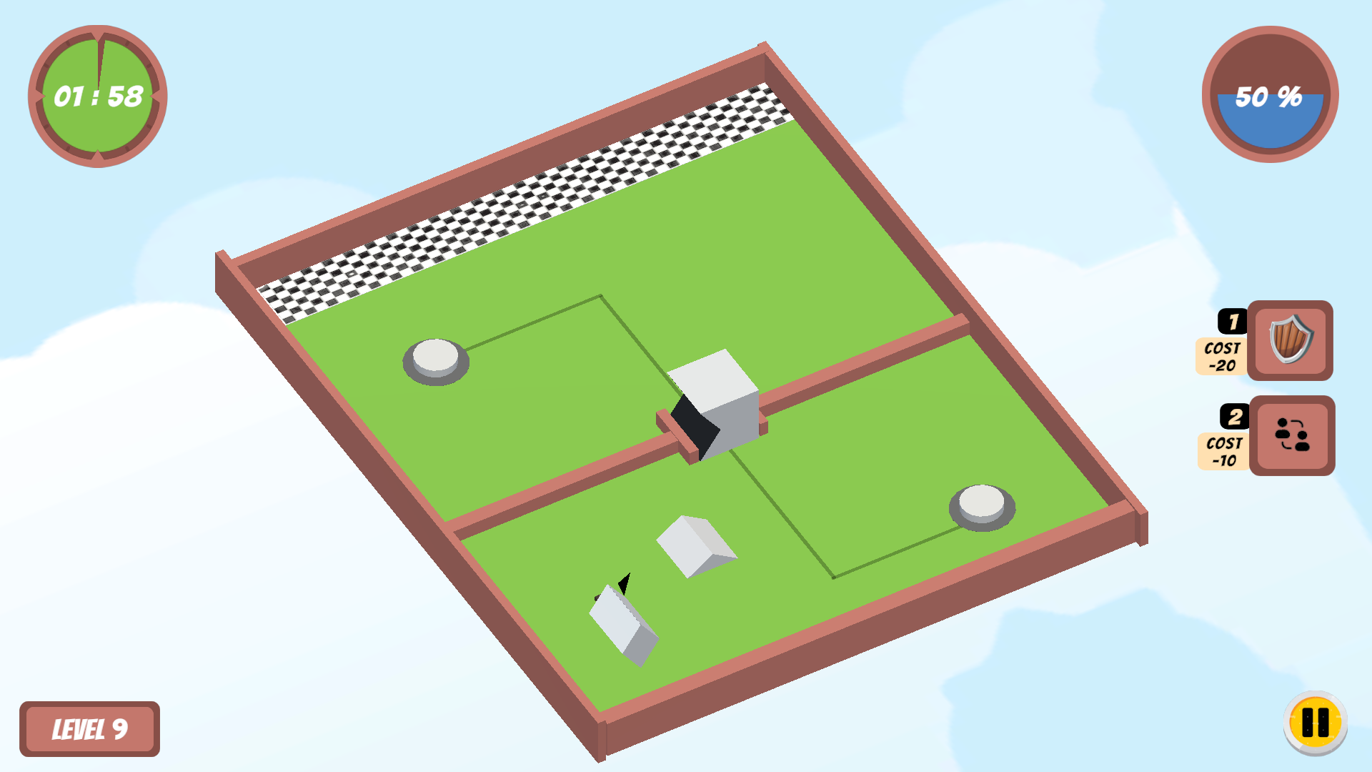

**Hypothesis 7: Most of the players enjoy the shape mechanism more than color.**

***Evidence:***

*User Feedback:*

* Players that like colors are less than the players that like both shapes and colors < Players that like shapes
* Many players commented on levels with more shapes than levels with more colors in the question- what improvements would you like to see made for the game?

A few example comments:

1. “More shapes! "A faster traveling speed can also be helpful to make the game more interesting.”
2. “I really liked using the shapes to fit through the obstacles and the obstacles changing to match the shapes.”



*Analytics Graph:*

* Based on metric 4, the shape player took less time to win the level with the active time of each player as compared to the color player.
* Add different shape obstacles, and make the player combine two characters to pass the gate



***Solution:***

* We will probably make more levels that have more shape mechanisms as compared to color mechanisms.
* While developing future levels, we need to make sure that the shape mechanic is implemented quite often.
* We are going to introduce more shapes like semi-circles and circles.
* Combining shape and color cubes for a different variation to pass through a colored shape gate. Have a shape gate that is colored, so that colored shape characters of the same color can pass through the same colored shape gate. Combine two characters to turn them into a new character by pressing a keyboard key.
* A new swapping mechanism is introduced to the shape characters, so that we can incorporate more shape mechanisms in future levels and reduce monotonicity.
* Add more levels involving shapes.

Status: COMPLETED



**Hypothesis 8: Switching between the players is difficult.**

***Evidence:***

*User Feedback:*

* Out of 150 about frustrating parts/ suggested improvements **12 feedbacks (8%)** suggested that they found switching between the players difficult. It was because either they missed the tutorial levels or they lacked speed while pressing the space button. Also, it's possible that some of the levels like level 9 require the user to switch quite frequently while avoiding the bullets. In such cases the user **couldn't concentrate** enough and lost lives.

A few example comments:

1. “Sometimes switching between players is confusing.”
2. “When there are three characters, I keep accidentally switching to a wrong character using space”
3. “Toggling between three players and trying to not get hurt by the bullets”

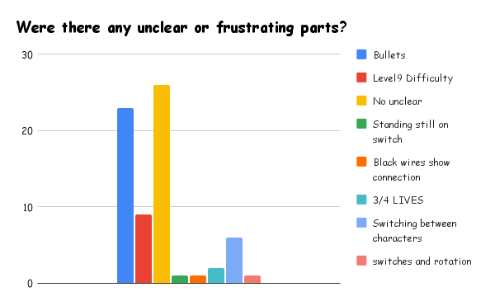

*Analytics Graph:*

* Even the analytics graph shows that the difficulty level is seeing a higher amount of player switches. We can all agree that using the spacebar alone increases player confusion and makes it difficult to concentrate on which character is active when the challenge level increases and there are more than two characters in the game.

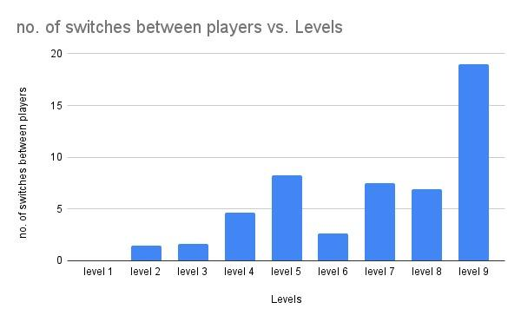

***Solution:***

* We will implement switching between the players using numerical keys on the keyboard. Like pressing '1' to use player 1, press '2' to use player 2. This might make the player's switching more intuitive and easy to handle.
* We will add an overlay that shows all characters, and players can choose one they want.
* Change the UI to incorporate switching, add clear instructions

Status: COMPLETED

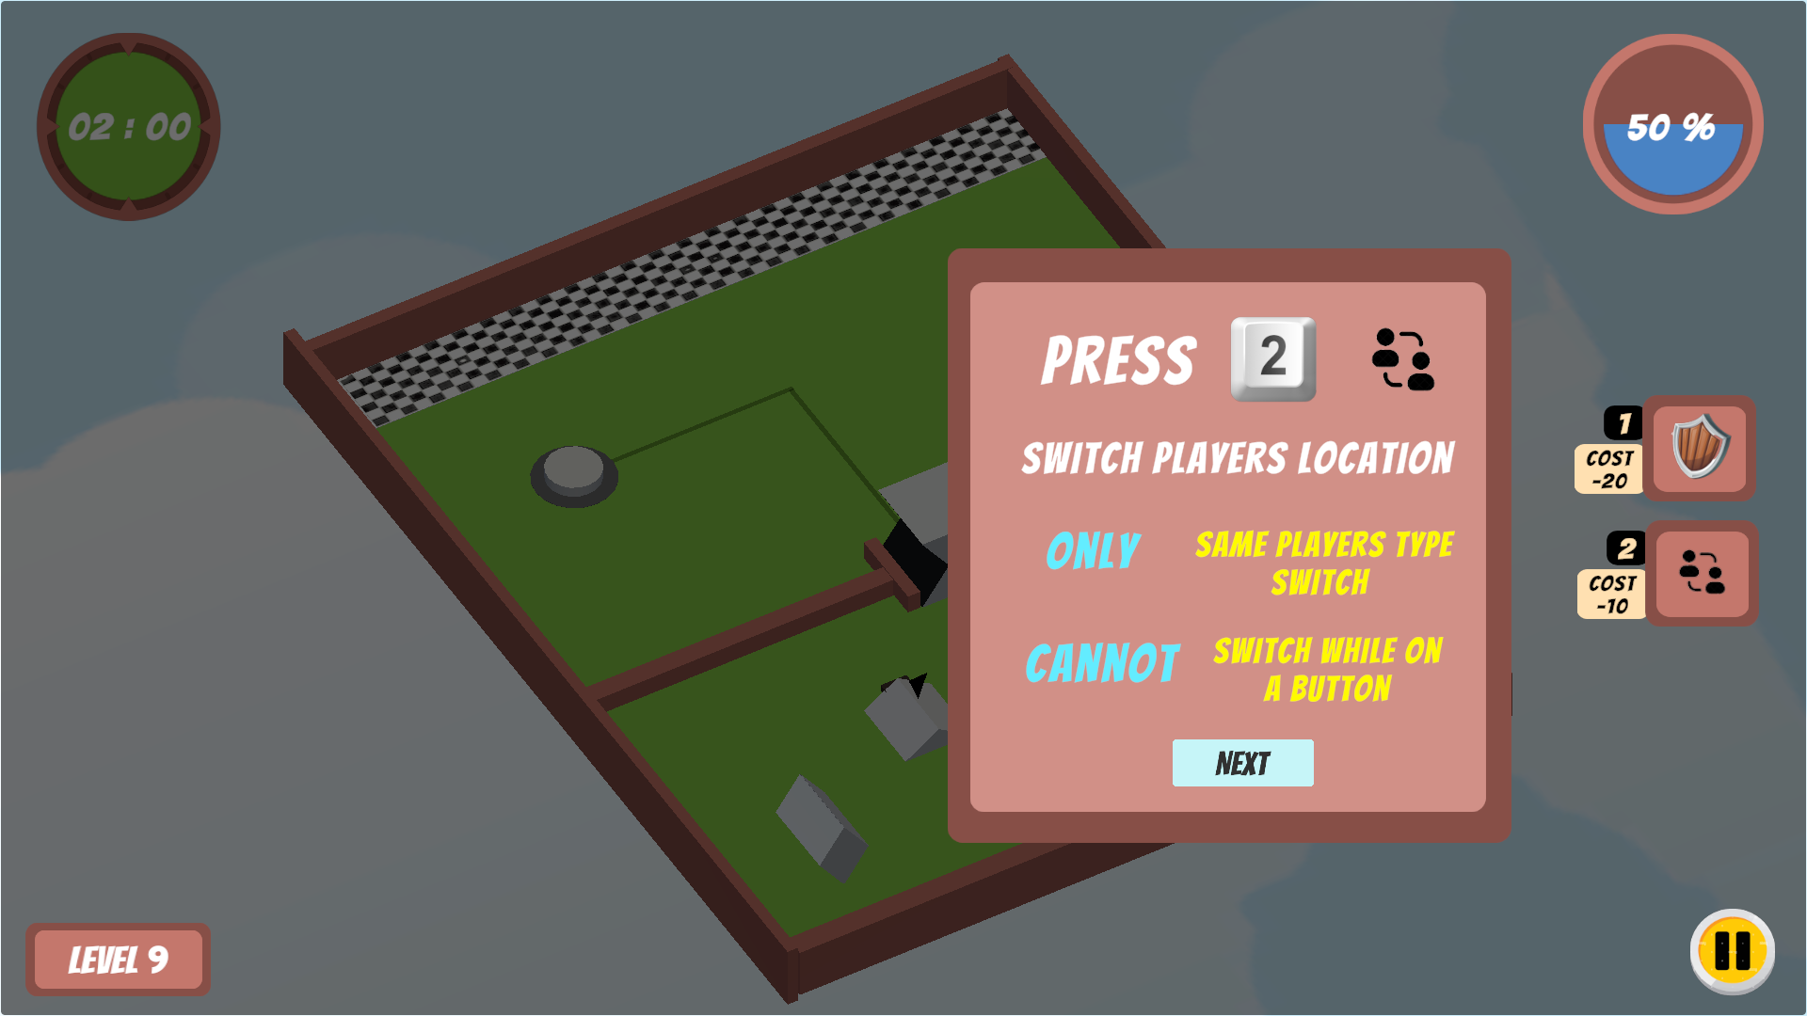

**Hypothesis 9: Make players understand the instructions clearly, reorganize levels based on difficulty, and add a separate screen for tutorial messages.**

***Evidence:***

*User Feedback:*

* **5%** of students raised concern on the **level selection and instructions** pageabout having a separate page pop for instructions and probably adding a separate section for tutorial levels.

A few example comments:

1. “Encountering very easy levels in between difficulty levels disrupts flow. You can add easy levels/tutorial levels in a separate section.”
2. “Cannot read instructions when juggling between countdown time, bullets, and solving puzzles.”

*Analytics Graph:*

* The difficulty of the tutorial levels (Levels 1, 2, 3, 4, and 6) is almost negligible.
* The quit rates are also relatively higher.
* Having tutorial levels in between the actual levels disrupts the flow of difficulty.



***Solution:***

* On the level selection page, all the tutorial levels can be grouped together as separate sections. As we introduce a new mechanism, we can add a tutorial level and build an actual level at the same time so that it will be easier for the player.
* Time and lives can be removed from tutorial levels so players will have sufficient time and unlimited attempts to understand new mechanics.
* display text at specific locations, and the H button displays all the instructions as long as the player presses the screen.
* Display instructions in the form of popups at the beginning of level, so that it forces the player to read through all the instructions before starting the game for the level.

Status: COMPLETED



**Hypothesis 10: Providing more in-game guidance and hints can improve the player experience and success rates, particularly for challenging levels.**

***Evidence:***

*User Feedback:*

* Under the ‘improvements needed’ section, about **6% of** people noted that **providing hints for the challenging/more complex levels** is necessary in the feedback's improvement section.



*Analytics Graph:*

* It is quite clear from the analytics graphs that players are taking longer to complete levels, quitting more frequently at level 9, and dying more frequently at more difficult levels.
* From the graph of players' active time, it is obvious that people spend more time thinking about strategy for difficult levels than for simple ones. This increases the possibility of being shot by a bullet.
* 



***Solution:***

* Each level will have **time checkpoints,** and if the player doesn't get there in the allotted amount of time, a pop-up message with hints will appear. This aids in strategy development and lowers player quit rates.

STATUS: PARTIALLY COMPLETED

Reason: Giving essential and apt hint for the player is difficult for as we can’r track real time progress of player and not know which hint actually a player want. But, we have added hints if the player tries to swap positions while pressing the buttons.



# Weekly Notes

## Week 3

Developed three different prototypes for three different game ideas.

## Week 4

Professor comments

* Game 1 Prototype Comments: Make the game more challenging
* Game 2 Prototype Comments: Reduce the number of rules that a user needs to follow.
* Game 3 Prototype Comments: Take care of the Physics
* Decide with your team on which prototype to proceed with and try to build another prototype to know its feasibility.

Solution:

decided to proceed with the Game 3 prototype and built a playable prototype for the same.

## Week 5

Comments:

Professor

* Assumed player with a gun and checked for firing capability (Not able to do)
* Camera rotation bit challenging
* Fading out effect at the wall obstacle
* Confusion in the colors (Should I need to go with Red?). (Combine the color effect with the obstacles (wipe out things with color related or opposite to the player)

TA

* Decide whether the player will die by falling or not and alter the checkpoint system accordingly.
* Mouse control is overly sensitive - can provide mouse speed adjustments
* Rotating pole going through the player
* Tweak your character controller so that player isn't stuck on stairs

Grader

* Problem with Mouse control
* Fix the camera alignment

## Week 6

Comments:

Professor

* Liked the art and bridge construction in the water
* Make New things in the game. Changing skins won’t be an improvement in the game
* Attempts Vs level is not informative
* No analytics for where people get stuck at.
* Add dummy feedback to the graphs
* Make the game more cohesive

TA

* Movement is still weird
* Make geometry in between you and the character translucent

Grader

* Position it strategically behind the bunny
* No more art until after the midterm
* Clean up your GDD

Issue 1 - Misunderstanding with the player object having firing abilities

* Solution 1 for Issue 1 -

In this game, the player doesn’t have the ability to shoot. A new player object is created to avoid misunderstanding (Week 6)

Issue 2 - Confusion in the Obstacle colors

* Solution 1 for Issue 2 -

A theme based on three elements fire, water, and earth is introduced in the game. All obstacles and platform colors are changed accordingly (Week 6)

Issue 3 - Rotating pole going through the player

* Solution 1 for Issue 3 -

Fixed the rotating pole by increasing the force of rotation. (Week 6)

Issue 4 - Mouse Control is overly sensitive

* Solution 1 for Issue 4 -

Created a mouse speed variable and scripted a handlerotation function to set the target speed as mouse speed and adjust the Tilt and look angle. (Week 6)

* Solution 2 for Issue 4 -

Disabled the mouse control as it creates difficulty playing for the player. Restricted the camera movement to follow the bunny by disabling the camera rotation. (Week 7)

Issue 5 - Camera Alignment (Fading out effect at some obstacles)

* Solution 1 for Issue 5 -

Implemented the lerp function to make the camera follow the player and make the game smooth without fading effects. (Week 6)

* Solution 2 for Issue 6 -

Use an inbuilt camera package called Cinemachine- freelook camera. Resolved the camera-obstacle problem by adding a cinemachine collider - pull camera forward attribute. (Week 7)

Issue 6 - Decide whether the player will die by falling and alter the checkpoint system accordingly.

* Solution 1 for Issue 6 -

The player will be given three lives initially. A life will be deducted each time the player falls from the platform. Once the player loses all 3 lives, then the player will lose the game and the game is over. (Week 6)

Issue 7 - Analytics need to be improved. No Analytics for where the player dies.

* Solution 1 for Issue 7 -

Added analytics for where the player dies using the x and z coordinates of the player. Also, we removed the attempts vs win/lose analytics as it doesn’t provide much valuable information and added new analytics. (Week 7)

.Issue 8 - Make the game more Cohesive

* Solution 1 for Issue 8 -

Removed all the disconnected platforms and made the game cohesive by introducing the elements and themes level-wise. For example, Level 1 is based on the elements water and earth (wood). Also, we implemented a Risk and Reward System in the game. (Week 7)

Optimization (Week 6)

- Analyzed the Editor Log for Build Report and optimized the texture usage from 98% to 76%.

- Reduced the asset sizes from 48 Mbs to 29 Mbs by removing unused textures and compressing existing ones.

- Changed the fps equal to the refresh rate of the screen

## Week 7

Professor:

* Make the walls disappear/ fade
* Don’t want the player to start from the beginning
* Add time constraint for the powerup
* There should be a superior choice over the game.
* There are obstacles without using elements

Player Comments:

* Fall guys vibes
* Thinks wood as chocolate
* Remove the mouse support. Not able to click the try again button
* Not sure about the use of time powerup
* Checkpoints are useful
* Liked the color theme
* Too punishing if a player died, implement checkpoint.
* See where the player losing lives instead of removing the checkpoint

Issues:

- No strategy and twist in the game

- If we remove the elemental skin, its similar to color based game

Solution:

We find that infusing strategy and twist to the current game to be infeasible within the time frame. So, As a team, we decided and came up with altering our game idea as follows,

Game Idea: A 3-D platformer and color-based game where the player needs to reach the finish line strategically satisfying the time and life constraints

Description: The player needs to make all the characters to reach the finish line by thinking of the right strategy. The player can move up, down, right, and left using the arrow keys. The payer can switch between the characters with the help of the space bar. Life will be deducted if the player tries to move through the cube with mismatched/wrong color.

## Week 8

Player 1

* Thinks like a moving object game
* Takes a bit more time to understand the game
* Understands that he needs to shuffle the color at level 3
* Finds some bugs in the controls
* Needs the level to be hard

Player 2

* Wants the instruction from the bottom right corner
* Needs narrow vision
* Add lines from the switch and the corresponding blocks in order to understand it quicker.
* Thinks health is not necessary
* Thinks it’s very intuitive

Professor:

* Confusion due to the space bar image in level 0-2.
* Thinks the gate also to be solid that can be pushed.
* Change is not notified once the player presses the space bar
* Need to instruct that both characters need to reach the finish line
* Life is not relevant in these initial levels

TA:

* Movement controls are weird
* Highlight which box you're turning
* Player should be facilitated to select the Levels
* Highlight the character who is currently moving
* Make the character move faster
* Keep instructions static
* Need a level to show the colors.
* Let the player know how the cube rotates
* need to indicate that the health gets decreased

Grader:

* GDD

- Your GDD should basically be filled out and cleaned. Please delete all extraneous lines from the template

- Update everything to reflect your current game

- Pay attention to the second block of the rubric in the GDD section -- each bullet point corresponds to a section you should fill out

* Analytics

- Remember to delete your old analytics!

- Update your explanations. Metric one explanation still corresponds to the old analytics I think. And it not, you need a better way to justify this metric. Maybe say something about understanding level difficulty progression

- Metric 2 tells you the same thing essentially as metric 1 right? Just times the number of lives?

- Elaborate on metric 3 and tell us about the improvements you make given this metric. If the number is high, what will you do? If the number is low, what will that do?

- Metric 4 and 5 can essentially be one metric

- Be careful -- metric 6 is a blackbox. Can you find a better way to get the same information?

* Game (this is unrelated to midterm grading, but my own comments when playing the game this week)

- I'm not a huge fan of the bump the character has to go over to press the switch, can you make the transition smoother?

- Highlight box you are playing as

- Highlight which box you're turning

- Try to fix the weird behavior when the character is flung away from the turning boxes so that it's maybe a bounce instead of the character being completely thrown away

- Sometimes I can't tell where I am when I am within the box and get stuck. Maybe add transparency?

- Overall, I love all of the work you've put in the game. I'm definitely liking this direction better than your previous one! Maybe play similar games to see how you can innovate more as there are a lot of games character switching genre

| **Issue** | **Solution** |
| --- | --- |
| Doesn’t know which button operates which gate | Lines has been added to show which button operates which gate in the platform |
| Give a player an option to select the levels whenever they want to switch | A home icon is added in each level. When a player clicks this icon it will redirect him to the level selection page |
| Player movement controls need to be altered | The speed of the character movement has been altered. |
| Instructions are not sufficient and static | Static wooden pallets are attached to the platform to instruct the player wherever it’s neccessary |
| Need harder Levels | New levels with enemies and new mechanics has been introduced to make the game more challenging. |
| - Can restrict player moving into wrong gate instead of deducting a life.  - Thinks lives are unnecessary for some levels | Restricted the player from passing inside the wrong colour face of the gate and introduced Enemies shooting bullets to give the player chances lose some lives. Lives has been removed in some of the levels where there is no possibility for the player to lose lives. |
| Life deduction is not notified clearly | A heart will be removed in the top left corner of the UI along with a ‘OUCH’ message above the character. |
| Player who is currently has the controls is not been highlighted | A pointer is been added to the character which is currently active. |
| Characters are not visible when moved inside the gate. | The gate will become transparent once the player passes through it. |
| Level selection is not been done using keyboard | The level selection can also been done through keyboard using the arrow keys to move and space bar to select the level. |
| Weird behavior/movement in the character when go near the gate | The box collider range of the gate is been adjusted and the player movement is been altered. |
| Need some basic levels to understand the new mechanics | Basic levels has been for every new mechanic that is been added. |
| Analytics Changes | All the mentioned changes has been updated under the Analytics section of the GDD. |

## Week 11

Player 1:

* Confetii is awesome
* Fast speed while going through gate
* Not reading msges
* Text not reading because of time
* Standing on button and bullets is frustrated
* Loved ouch
* Die at zero heart
* Level 5 stucked with strategy
* Shapes are satisfactory
* Switching between the players
* Level 8 bullets liked because it's random and not concentrated near switch so player actually focusing on winning the level
* Bullets in level 9 collide with shapes and stays there for some time

Player 2:

* Level 9 , give more lives
* Like the shape and color
* Puzzle thing
* Shooting was difficult - did not like-Level5
* You don’t want me to stand still on switch, found some another way
* Anxiety for bulllets
* Find some another way to make it challenging
* It’s better than more than many puzzle games

Player 3:

* View is weird, the way the game board is represented is bad
* Bullet is not necessary
* Have pattern to bullets
* People liked shapes
* What color the color gate gives next is difficult to find out
* Make more obvious which player is active

Player 4:

* Initial levels are very informative
* Need something to protect the character in Level 5
* There is a bug when a diamond character stands on the button
* There is a dead-end in level 8 (like if the player moves the shape object first across the black gate then he can’t complete the game)
* Black lines are not clear to the player

Works done:

* Improved representation of graphs
* Worked on possible solutions for the hypothesis and finalize one
* Fixed the turrets firing rate

## Week 12

Player 1:

* Understands the black wires
* Telegraph when the canon could fire
* Finds level 5 to be difficult
* Wants 4 hearts instead of 3
* Finds the there is multiple solutions for level 9
* Didn't get the bullet collision. Why the bullet didn't disappear when it hits the black gates?

Player 2:

* Pattern of cannon fire, don't shoot when the player is on switch
* No color mapping with the switch, so kept guessing
* Getting killed multiple times, even before making strategy
* Make shape and colors cohesive in terms of similarity

Player 3:

* Dodgeing the bullets is frustrated
* Solving puzzles is interesting
* -1 change is good

Player 4:

* Didn’t read instructions, didn't realize that the black wires meaning
* Timer not noticable
* add more interesting levels like level 9

| **Issues** | **Solution** |
| --- | --- |
| Level 5 is difficult because of the static turrets | Made the static turrets move dynamically |
| Frequency of turrets firing bullets is higher | The frequency of turrets firing bullets has been altered based on the difficulty of levels |
| Dodgeing the bullets is frustrated and getting | Introduced a new ‘shield’ mechanic to protect the player from bullets for a certain time. |
| Players not reading the instructions (weeks 12 &13) | Made instructions in form of pop-ups at the beginning of the game. |

## Week 13

Player 1:

* Thinks there can be button to select the pause button
* Finds the player switching new mechanism intuitive
* Want the shield mechanics to protect all players

Player 2:

* Likes the instructions
* May be clicking on the spacebar disappear messages
* Notices a bug in Level 9 that diamond player could go over the black gate

Player 3:

* Nice ui.
* Nice feature of shield
* It’s a bug in level 5 shield doesn’t get activated
* It should allow to fire bullets using shield
* It’s a nice feature switching
* Shield is not working for level 9

Professor:

* Pop up’s middle of the screen
* Cursive font might be difficult to read
* Use empty space to scale up information
* Increase the size of the shield.

| **Issues** | **Solution** |
| --- | --- |
| Diamond Player can jump over the black gate in Level 9 | This bug has been fixed by Increasing the collider size along the y-axis for the black gate |
| More empty space in the play screen | Objects size in the play screen has been scaled up to cover the empty spaces and to be more visible to the player |
| Cursive font might be difficult to read | Cursive fonts has been changed to regular fonts to remove the difficulty in reading the instructions. |
| Pop up’s can be in the middle of the screen | Made the general pop-ups be in the middle of the screen |

## Week 14

Player 1:

* Instructions in some levels are not clear
* The game great overall

Player 2

* Instructions are better than before
* Couldn't pass or use a shield effectively in level 5
* Collect bullets using shield instruction is confusing
* Don't understand how to collect bullets and how to fire bullets
* Can't collect mana in level 9
* Multiple shields for multiple players at the same time
* Also something to show that shield will disappear after some time
* Confusing instructions in level 11
* Switching is not working in level 11
* Couldn't understand the meaning of black lines

Player 3

* Space bar to go to next instructions
* Add Instruction for swapping players
* Key 1 and 2 is far to reach, could use other keys
* No need to reduce mana for swapping

| **Issues** | **Solution** |
| --- | --- |
| Instructions are not clear and sufficient | More Instructions are added and image based instructions are also added to make the player understand well |
| Clicking ‘NEXT’ for each instruction is difficult | Player can skip or move to the instruction by pressing spacebar |
| Mana reduction for swapping is higher | Reduced the mana cost for Swapping mechanic |

# Individual Homework

# Tutorial Links

Prototypes

* Prototype 1
  + <https://www.youtube.com/watch?v=Oqajv3vL58k>
  + <https://www.youtube.com/watch?v=UPJqpKqm-RY&t=328s>
  + <https://www.youtube.com/watch?v=w1Y0JwmazVM&t=11823s>
* Prototype 2
  + <https://www.youtube.com/watch?v=Z3tO8FPCM_w>
  + [https://www.youtube.com/watch?v=7wAjJBSQxys](https://www.youtube.com/watch?v=Z3tO8FPCM_w)
  + [https://learn.unity.com/tutorial/controlling-unity-camera-behaviour-2019-3](https://www.youtube.com/watch?v=Z3tO8FPCM_w)
  + [https://learn.unity.com/tutorial/live-session-2d-platformer-character-controller](https://www.youtube.com/watch?v=Z3tO8FPCM_w)
  + [https://www.youtube.com/watch?v=K1xZ-rycYY8](https://www.youtube.com/watch?v=Z3tO8FPCM_w)
* Prototype 3
  + <https://learn.unity.com/tutorial/wander-o5>
  + [https://learn.unity.com/tutorial/evade-er8](https://learn.unity.com/tutorial/wander-o5)
  + [https://learn.unity.com/tutorial/pursuit-d](https://learn.unity.com/tutorial/wander-o5)
  + [https://learn.unity.com/tutorial/creating-a-city-crowd](https://learn.unity.com/tutorial/wander-o5)
  + [https://www.youtube.com/watch?v=cnOdXV7GHrw](https://learn.unity.com/tutorial/wander-o5)
  + [https://youtu.be/4HpC--2iowE](https://learn.unity.com/tutorial/wander-o5)
  + [https://youtu.be/aiTl7B2xTmA](https://learn.unity.com/tutorial/wander-o5)
  + [https://youtu.be/mXtvu-JdpfI](https://learn.unity.com/tutorial/wander-o5)

Advanced Tutorials

* Vishakha Nerkar
  + <https://learn.unity.com/tutorial/profile-cpu-performance-with-superluminal#>
  + [https://learn.unity.com/tutorial/pursuit-d](https://learn.unity.com/tutorial/wander-o5)
  + <https://learn.unity.com/tutorial/working-with-native-plugins-2019-3>
  + <https://learn.unity.com/tutorial/introduction-to-scriptableobjects>
* Shalin Suthar
  + <https://learn.unity.com/project/the-mathematics-of-ai>
  + [https://learn.unity.com/project/working-with-cinemachine-cameras-2019-3](https://learn.unity.com/project/the-mathematics-of-ai)
* Akshay Jain
  + <https://learn.unity.com/tutorial/controlling-unity-camera-behaviour#>
  + <https://learn.unity.com/project/intermediate-gameplay-scripting?uv=2019.3>
  + <https://www.youtube.com/watch?v=4HpC--2iowE&feature=youtu.be>
* Venkatesh Dharmaraj
  + <https://learn.unity.com/tutorial/introduction-to-asset-bundles#>
  + <https://learn.unity.com/tutorial/editor-scripting#>
  + <https://learn.unity.com/tutorial/live-session-2d-platformer-character-controller#>
  + <https://learn.unity.com/project/getting-started-with-playground-with-a-curriculum-guide?uv=2019.3>
* Meghana Putta Swamy

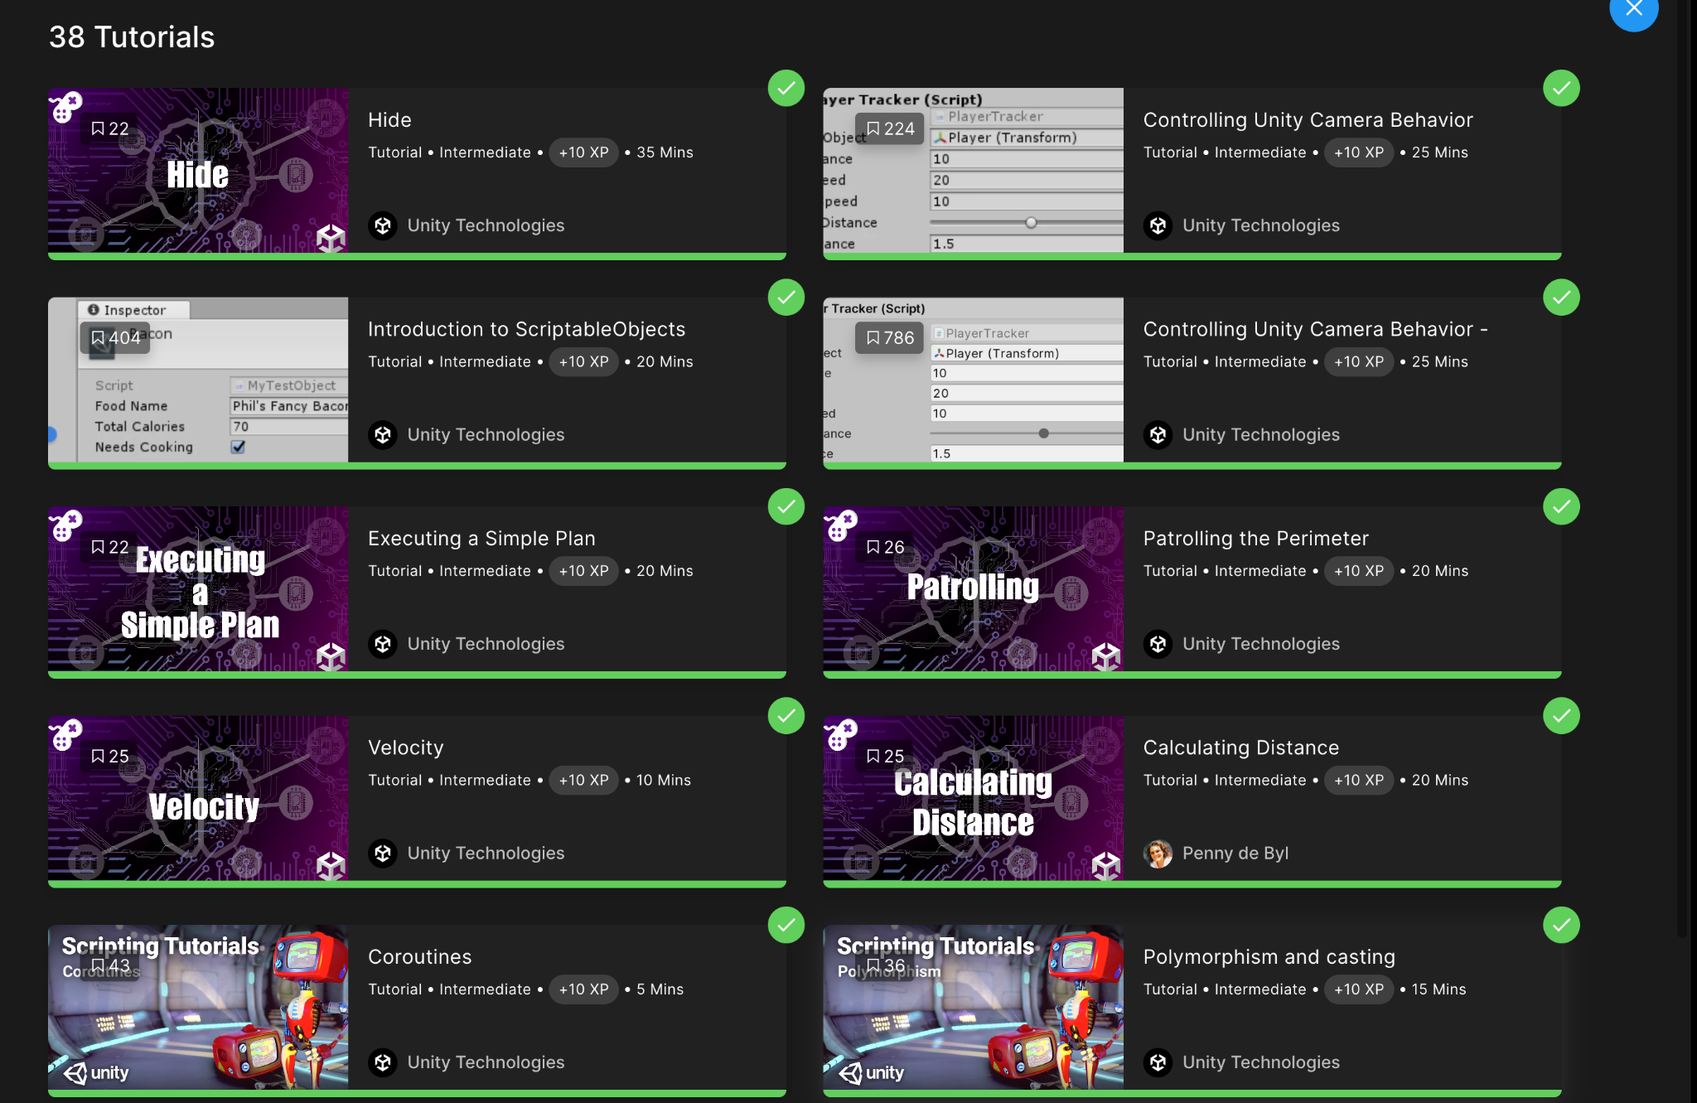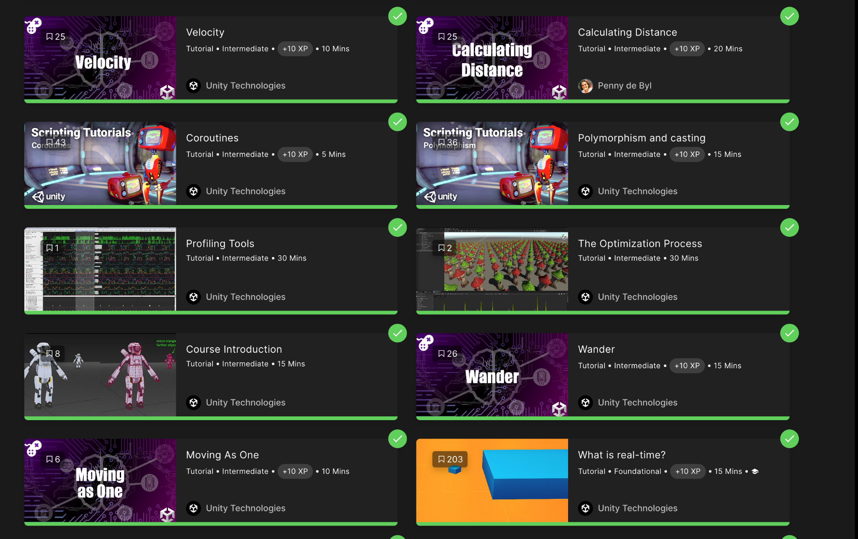

* Sai Gurunadh Pamarthi
  + <https://learn.unity.com/tutorial/wander-o5>
  + [https://learn.unity.com/tutorial/evade-er8](https://learn.unity.com/tutorial/wander-o5)
  + [https://learn.unity.com/tutorial/pursuit-d](https://learn.unity.com/tutorial/wander-o5)
  + [https://learn.unity.com/tutorial/creating-a-city-crowd](https://learn.unity.com/tutorial/wander-o5)
  + [https://learn.unity.com/project/navigation-meshes](https://learn.unity.com/tutorial/wander-o5)
  + [https://learn.unity.com/project/autonomously-moving-agents](https://learn.unity.com/tutorial/wander-o5)
* Vardhan Jekin Shah
  + <https://learn.unity.com/tutorial/ecs-physics-havok-physics-for-unity-and-unity-physics>
  + <https://learn.unity.com/tutorial/ui-navigation-2019-3>
  + <https://learn.unity.com/tutorial/customizing-urp-asset-settings-2019-3>
  + <https://learn.unity.com/tutorial/introduction-to-scriptableobjects>
  + <https://learn.unity.com/tutorial/fixing-performance-problems-2019-3>
  + <https://learn.unity.com/tutorial/controlling-unity-camera-behaviour-2019-3>
  + <https://learn.unity.com/tutorial/creating-hdrp-shadow-fade-distance>
  + <https://learn.unity.com/tutorial/creating-believable-visuals>

Junior Programmer Modules:

All team members completed all the Junior Programmer modules.

# References

* + <https://www.youtube.com/watch?v=Oqajv3vL58k>
  + <https://www.youtube.com/watch?v=UPJqpKqm-RY&t=328s>
  + <https://www.youtube.com/watch?v=w1Y0JwmazVM&t=11823s>
  + <https://www.youtube.com/watch?v=Z3tO8FPCM_w>
  + [https://www.youtube.com/watch?v=7wAjJBSQxys](https://www.youtube.com/watch?v=Z3tO8FPCM_w)
  + [https://learn.unity.com/tutorial/controlling-unity-camera-behaviour-2019-3](https://www.youtube.com/watch?v=Z3tO8FPCM_w)
  + [https://learn.unity.com/tutorial/live-session-2d-platformer-character-controller](https://www.youtube.com/watch?v=Z3tO8FPCM_w)
  + [https://www.youtube.com/watch?v=K1xZ-rycYY8](https://www.youtube.com/watch?v=Z3tO8FPCM_w)
  + <https://learn.unity.com/tutorial/wander-o5>
  + [https://learn.unity.com/tutorial/evade-er8](https://learn.unity.com/tutorial/wander-o5)
  + [https://learn.unity.com/tutorial/pursuit-d](https://learn.unity.com/tutorial/wander-o5)
  + [https://learn.unity.com/tutorial/creating-a-city-crowd](https://learn.unity.com/tutorial/wander-o5)
  + [https://www.youtube.com/watch?v=cnOdXV7GHrw](https://learn.unity.com/tutorial/wander-o5)
  + [https://youtu.be/4HpC--2iowE](https://learn.unity.com/tutorial/wander-o5)
  + [https://youtu.be/aiTl7B2xTmA](https://learn.unity.com/tutorial/wander-o5)
  + [https://youtu.be/mXtvu-JdpfI](https://learn.unity.com/tutorial/wander-o5)

# 

# Appendix

## Misc

## Old Metrics and Graphs

**Metric #1: Won Vs Lost at First Try**

Description: This metric describes the proportion of users who won and lost on their first try of the game at each level. The data whether the player won or lost is collected and visualization in the form of pie chart is designed to show the distribution.

Initial Sketches: (Image)

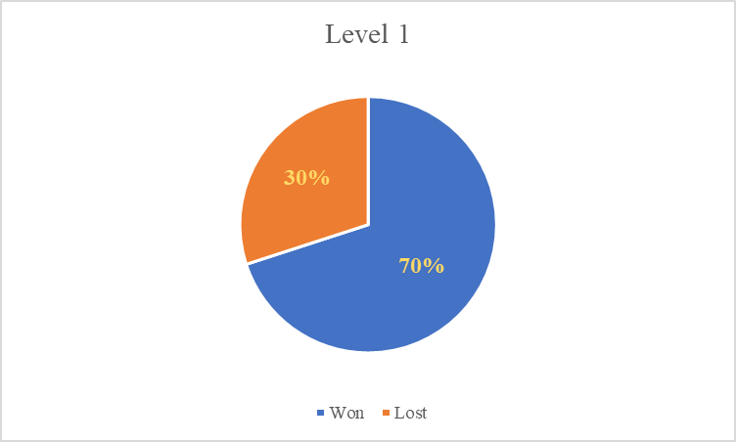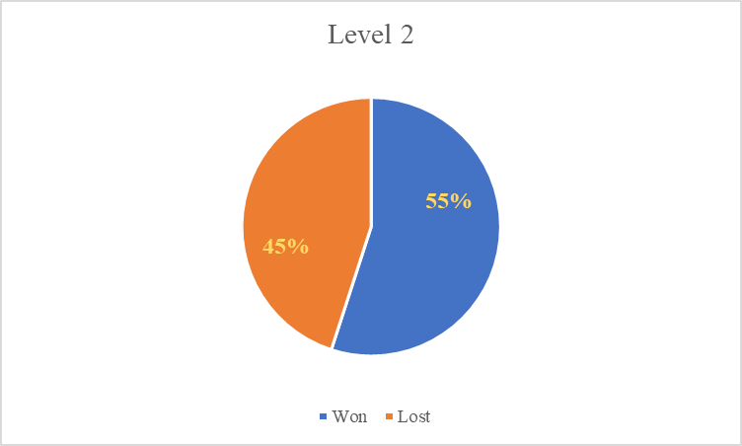

Pre-Midterm Graphs: (Image)

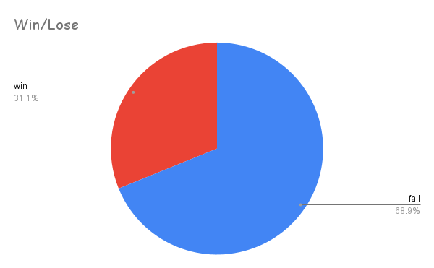

Explanation:

This metric is useful in comparing the difficulties of levels and can be used to design new levels. In the above graph, the win proportion is way much lesser than the lose proportion which is not expected. The game controls and difficulty of the level need to be altered.

**Metric #2: Time Taken by the User**

Description: This metric is used to analyze the average time taken by the user for winning and losing the game. Time taken data to complete each level by each player is collected in google sheets and the average time taken to win and lose is computed from it. Bar Graph is used for visualization.

Initial Sketches: (Image)

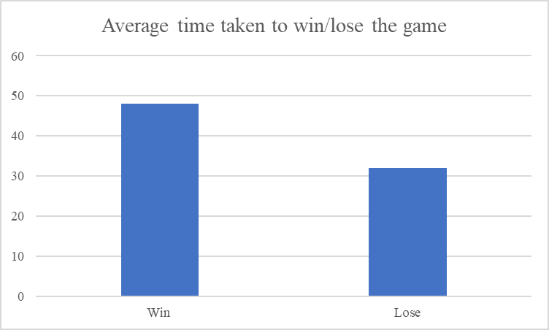

Pre-Midterm Graphs: (Image)

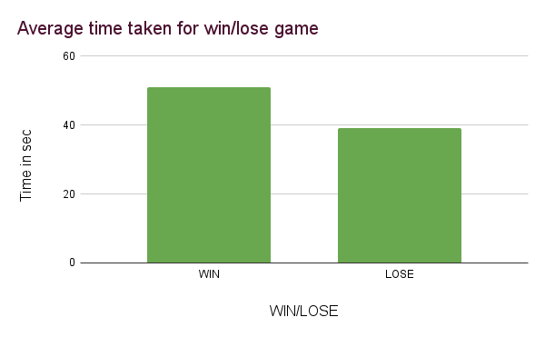

Explanation:

This metric is useful in analyzing the difficulty of each level. It is used to determine the time limit for the levels.

**Metric #3: Time Taken at each checkpoint**

Description: This metric describes the time taken by the player to cross each checkpoint/obstacle in the level

Initial Sketches: (Image)

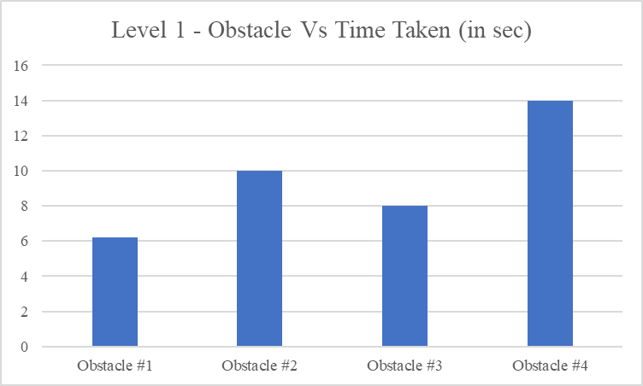

Pre-Midterm Graphs: (Image)

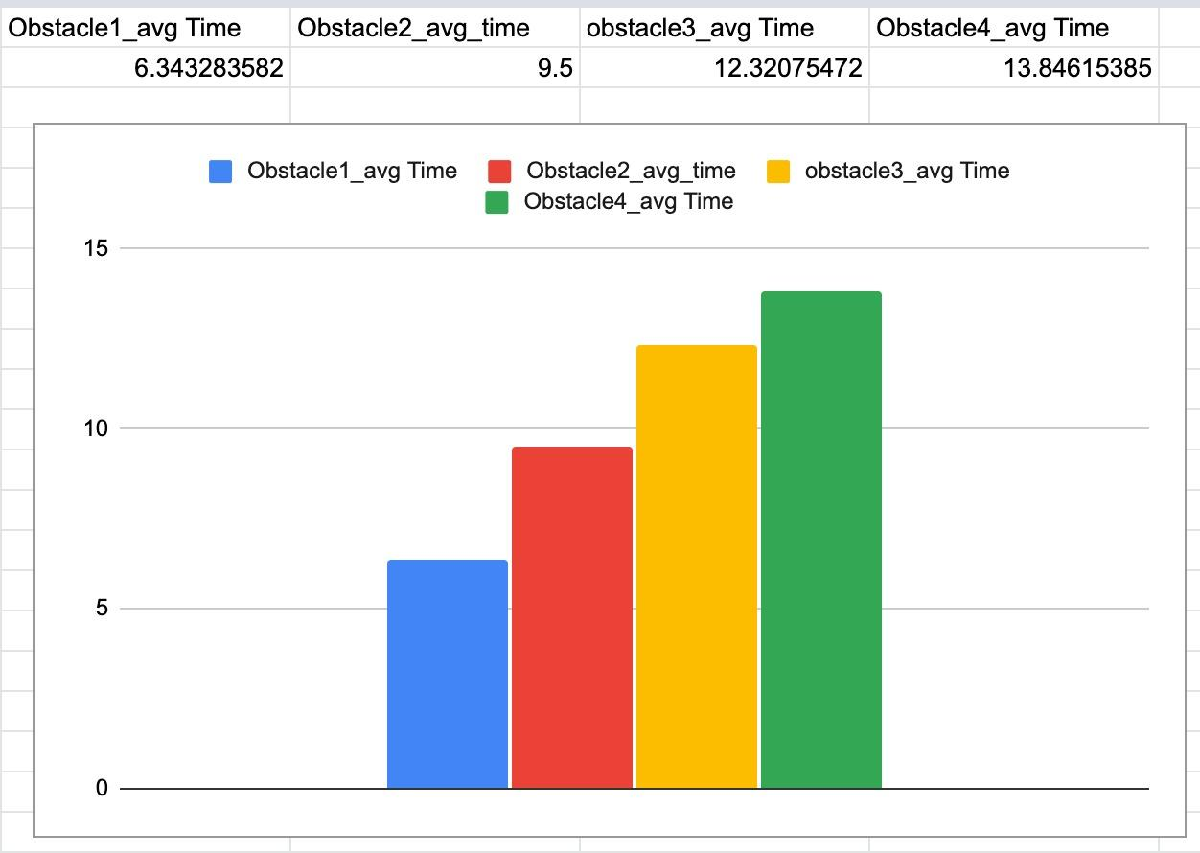

Explanation:

This metric is useful in analyzing the difficulty of obstacles/checkpoints with respect to time. From the above graph, a player takes more time to move across Obstacle 4.

**Metric #4: Location where the player died**

Description: This metric is useful in finding the location where exactly the player died in the game. The x and z coordinate of the player at which they died in the game is collected and visualized as a scatter plot

Initial Sketches: (Image)

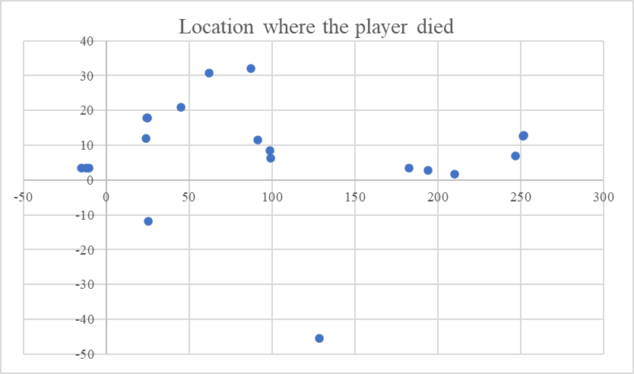

Pre-Midterm Graphs: (Image)

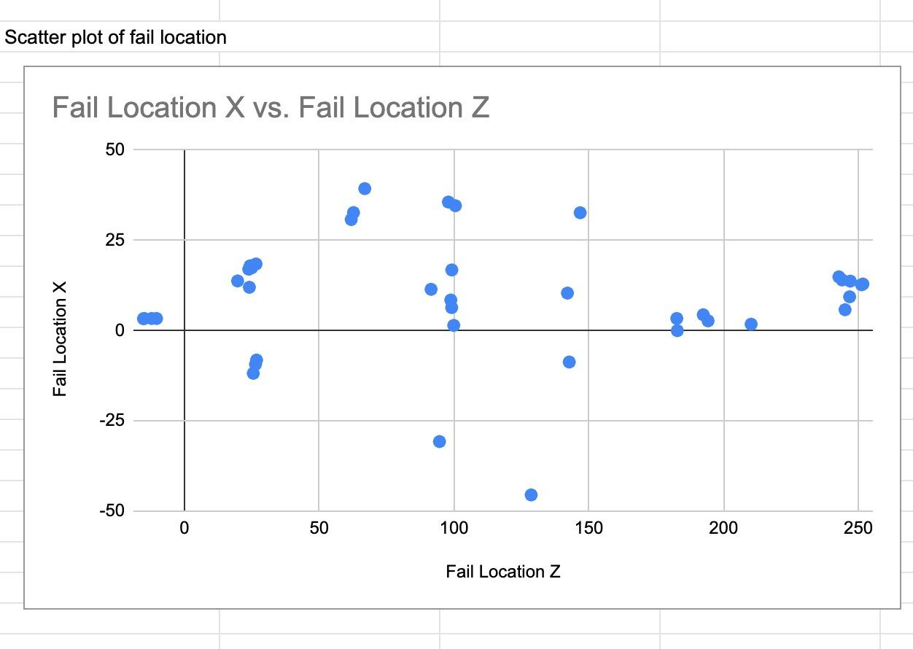

Explanation:

\We can see that the player typically fails at 25, 100, and 250 points in the scatter plot above, where the X-axis with Z coordinates represents the forward direction and the Y-axis with X coordinates represents the left and right movement. This information is utilized to enhance the design of the game and enables us to better understand how to change the obstacle there so that the player doesn't get stuck in certain spots and moves through the game smoothly.

**Metric #5: Distance Vs Level**

Description: *This metric describes the average distance that a user traveled at each level*

Initial Sketches: (Image)

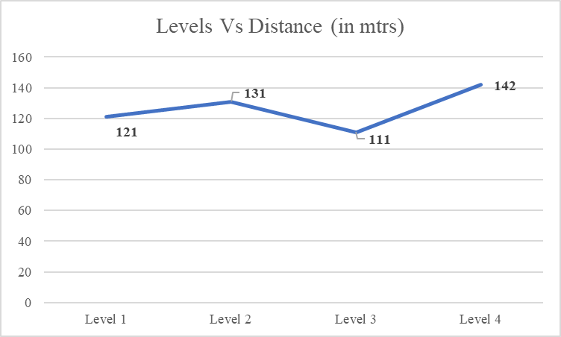

**Metric #6: Distribution of correct Powerups chosen by the user**

Description: *This metric describes the distribution of powerups chosen correctly and wrongly by a user.*

Initial Sketches: (Image)

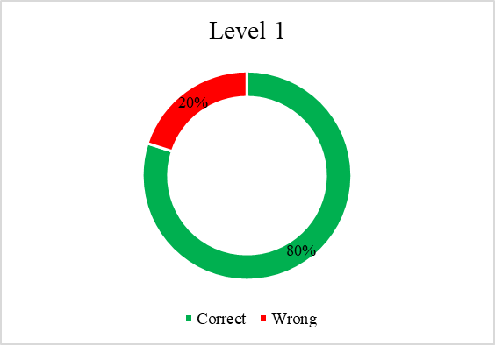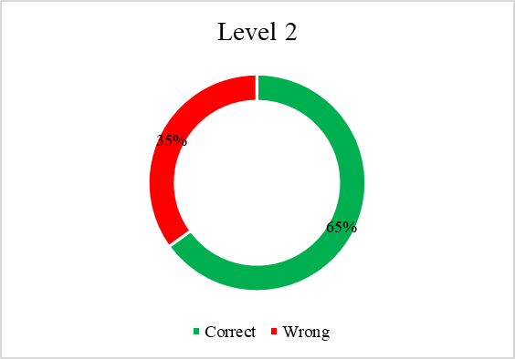

**Sample Game Designs**

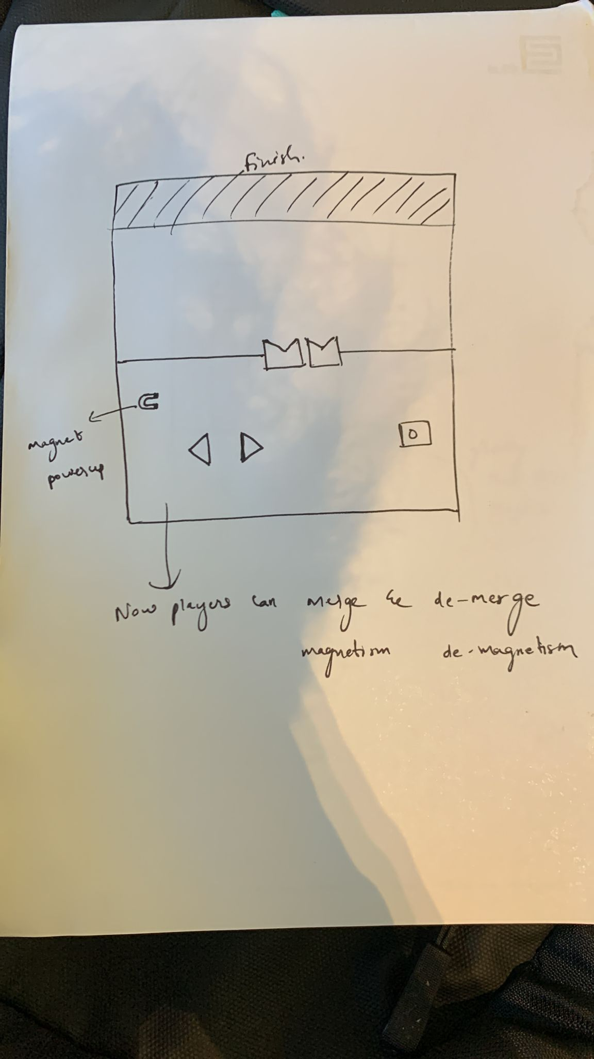 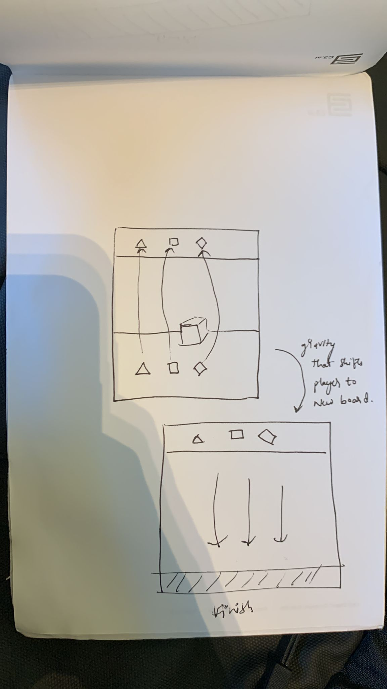

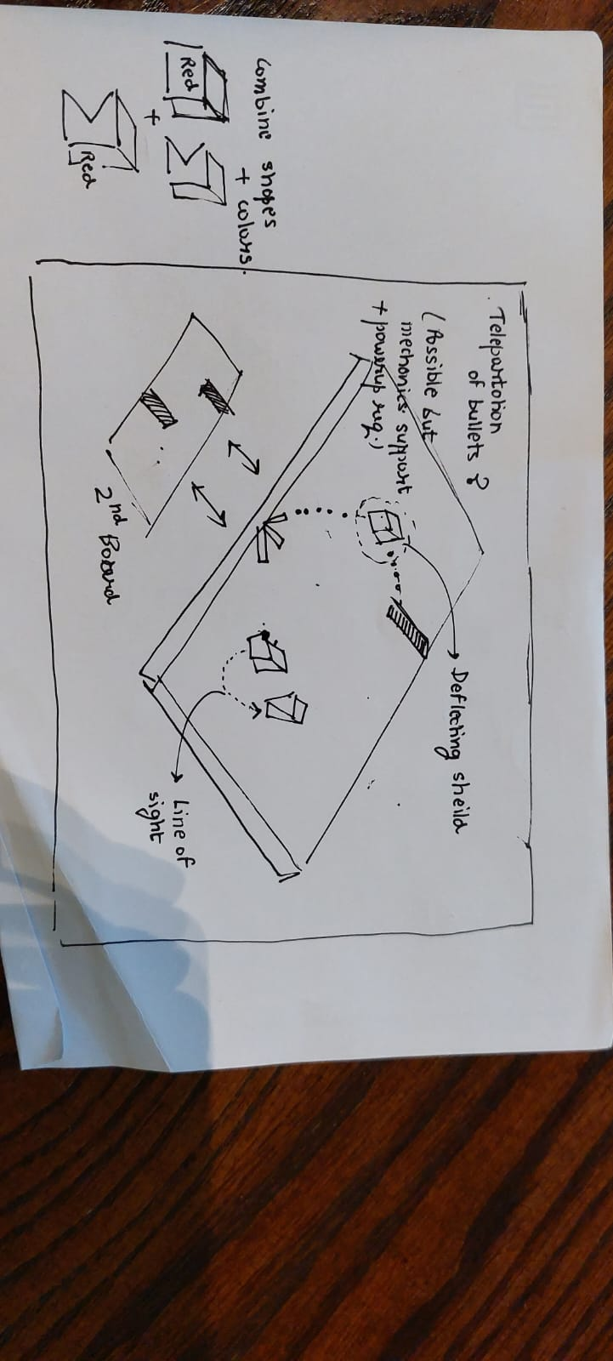

#### Midterm Level Designs

